

OHCHR

REPORTING TEMPLATE

PROJECT: INTEGRATING HUMAN RIGHTS IN UN PEACEBUILDING RESPONSE TO FARMER – HERDER CRISIS IN MIDDLE BELT NIGERIA

REPORTING PERIOD: SEPTEMBER, 2020

REPORTING PARTNER: NATIONAL HUMAN RIGHTS COMMISSION (NHRC)/OHCHR

AREA(S) OF COVERAGE: BENUE STATE

|  |
| --- |
| 1. **OPERATIONAL CONTEXT UPDATES** |
| *(Update on rights abuses/violations, attacks, and other incidents of violence, among others in your areas of coverage)*   1. **AGATU LGA** 2. The OHCHR Monitoring Team on the 4/09/2020 visited the community of Olegechonu-Agatu, the monitor was able to visit 4 households in this river bank community, identified certain issues with the households like poor access to health care, poor nutrition, poor health seeking behavior. The community is gradually coming back to its full population and capacity. 3. The OHCHR Monitoring Team on the 11/09/2020 visited the community of Ocholonya, the monitor was able to visit 9 households in this river bank community, and she identified certain issues with the households like poor access to health care, poor health seeking behavior. The monitor also observed that the community is very peaceful and also that people have started rebuilding their houses. 4. The OHCHR Monitoring Team on the 18/09/2020 and visited Ogbalisho community and the community is in peace there has been no issues from Fulani herdsmen and there has been no inter or intra communal clash, the monitor visited 5 households and there were doing fine although to visit households it has to be in the evening due to the fact that they spend most of their time in their farms. 5. The OHCHR Monitoring Team on the 25th/09/2020 visited Obagaji community and was able to visit 6 households, they were no issues identified with the household visited although the monitor noticed that there is a lack of gender knowledge when she noticed that the girls were made to fetch water for the male members of the house to take their baths and the girls are made to serve their brothers or male members of the household not to mention that the young boys seem beyond reproach by being called providers and men of the house while the girl child is constantly berated for any number of reasons, granted the girl child is not denied education but the idea that the male child is superior to the girl child calls for a need to carry out a Gender and parenting session for the community. 6. **BURUKU LGA** 7. **Ashamena Community:** On the 07/09/2020 the OHCHR monitor visited Ashamena community of Mbayaka Council Ward in Buruku LGA on right abuse/violation monitoring in the council ward. According to report, there is issue of right abuse/violation in the community. Mr. Tersoo Iornav reported that the people of Ashamena are seriously lacking amenities which is affecting their livelihood. According to his report, there are no good roads linking Ashamena with other communities. There is no electricity, no good schools. The people pleaded for government's intervention and support. 8. **Agir Community:** On the 14/09/2020 the OHCHR monitor visited Agir community of Mbayaka Council Ward in Buruku LGA on right abuse/violation monitoring in the council ward. No issue of abuse or violence were reported in the community. The people laments on how the government have forgotten about their existence in the local government. According to report, the government fails to provide the basic amenities for the community like, good roads, schools, electricity, jobs among other things. The people also reported that the community do not have a hall to conduct their council meetings. They pleaded for government's intervention and support. 9. **Mbakumalu Community:** OHCHR monitor visited Mbakumalu community in Mbayaka Council Ward on the 28/09/2020 on right abuse/violation monitoring in the community. Mbakamalu community reported no issues of abuse or violation in the community. Mr. Terhemba Akaanger reported bitterly on the issue of development in the community. According to his report, the people of Mbakamalu are facing serious challenge of transportation because of the state of road in the community especially now that there is rain. People find it difficult to convey their goods to the market, there are also no good schools, hospitals among other amenities. They pleaded for government intervention and support. 10. **Anshav Community:** OHCHR monitor visited Anshav community in Mbayaka Council Ward on the 29/09/2020 on right abuse/violation monitoring in the community. No issues of abuse or violations were reported in Anshav community. The people of Anshav community pleaded with government and individuals to help develop the economic and educational standard of the community to help the people achieve livelihood. 11. **GBOKO LGA**      * + 1. On the 3rd September, 2020, a little boy of 17 years, Master Tersoo Tyo-Apine of Atonko Village in Mbatan, Mbayion opposite FIDEL Polytechnic, smuggled into a Handset repairing shop and made away with an ITEL Phone, when arrested by the vigilante group, the boy confessed committing the crime. He was asked to pay a fine and returned the stolen handset. See his picture at the gallery.         2. On the 2nd September, 2020 some unknown armed men carried an operation in the night at Gboko Central area during which they made away with two (2) plasma television at Bet Tech Shop at the back of Liemen Ihough Bar. Other minor theft and harassment were also recorded. The same gang also smuggled into a shop opposite TERDOOFAN multipurpose house at Gboko Central Market and carried some valuable items with cash. No arrest was made but the police at ‘A’ Division were contacted and investigation is still in progress.         3. On the 2nd September, 2020, some cult members carried an axe into the church premises of St. Francis Catholic Church, Gbko East, to exercise their cult activities after they slapped one of the church security at the gate, the vigilante at Gboko East were contacted and in an attempt to arrest them, they surrendered their axe and run for their safety. No arrest was made but the police at ‘B’ Division were alerted.         4. On the 10th September, 2020, there was a land disput involving the families of Aga Ivungu and Achagh Aga both of Mbadim, Igyorov, Ipav, Gboko Local Government Area over a pice of land, both families were claiming ownership of the land and they almost engage into a communal crash. The District head of Igyorov, Chief Orshi Ugese was contacted and the matter was resolved amicably.         5. On the 8th September, 2020, one of the notorious Kingpin, a famous criminal in the state by named, Terwase Akaza (AKA GANA) was snatched in a government convoy by men of the Nigerian army at MASEJE, check point, Gboko and was later assassinated in Nassarawa State. The said criminal who has been declared wanted by the State Government had on this day responded to the amnesty granted to criminals in the state by the state Governor, Dr. Samuel Ortom. It was after his repentance and submission of ammunition that he was accompanied to the state headquarters by the Catholic Bishop of Gboko Diocese and the 1st class chief of Sankera Axis Chief Abu King-Shuluwa. So he could be given the executive pardon in the state headquarters. The military at the checkpoint however, disrupted the process and defeated the aim of the amnesty in the whole state.         6. On the 17th September, 2020, Mr. Iorlumun Maga (aka Mr. Kune) together with Mr. Mbatyerevde conspired and break into a shop belonging to Mrs. Tami Ayisa Swende at Luga Mbatiav Gboko LG and made away with a gallon of Ogogoro dry gin and other valuables, when arrested by the vigilante at Luga, the victims confessed committing the crime. They regretted committing the crime and promised to pay all the lost items.         7. The proliferation of cult activities in Gboko Town has been so alarming and a major concern to some stakeholders. In the face of this trouble, the attitude of the police to subdue and bring low the activities of these group is quite worrisome. On the 16th September, 2020, Mr. David Kaseun a commander in the vigilante at Adekaa unit in Gboko complained that several times he alerted the police of an incidence of the cult activities, they will rather turn against him, sometimes they forced him to join them and look for cultist if he give any report. He however, appreciated the DPO of ‘B’ Division for always responding promptly to such calls but lament of his boys whose negligence to respond on such matters is highly affecting the community.         8. On the 21st September, 2020, a group of criminals attacked Mkovour Market at Igyorov Ipav, Gboko LG and took some valuable items form different shops, when the matter was investigated, one of the stakeholders in the market was suspected to be among the criminals and was handed over to the police at ‘B’ Division Gboko for investigation and interrogation.         9. On the 25th September, 2020, a young man of about 23 years old Mr. Alema Daniel was arrested at Mbausu Community close to Tse Kucha for alleged vandalization of electric cables, when arrested by the youth in the area, he claimed there are workers with the PHCN and were there for the electrification of the area, when contacted Hon. Terngu Tsegba denied that there was no project of such given in the area at the moment. The young man was taken to the kindred head of Ukpekpe Chief Igbalumun Tsegba, where he denied been a worker with PHCN. The matter was referred to the Police at ‘B’ Division, Gboko LG for proper investigation. 12. **GUMA LGA** 13. On 5th/9/2020, at about 8:00 a.m. 3 suspected herdsmen invaded Haaga community and killed two children belonging to Mr. Orshio. The suspected herdsmen that perpetrated this act were said to run out of the community immediately even though they were chase by few people available. Prior to this attack, the people have been suffering series of harassment by the suspected herdsmen. For couple of months now the socio-economic activities of this community had been on stagnations align to the incessant attacks perpetrating by suspected herdsmen in both their farmlands, community and also their neighboring communities. Some of the community members are gradually packing out while others had already packed out to a more secure place due to the high rate of tension caused by the activities of suspected herdsmen in and within this community. The few available people in this community barely go out to other communities as their inner links road is now dangerous and how unsaved their communities is becoming, align to their previous attacked and constant attack by suspected herdsmen in their community and other distance neighboring communities around them. Farmland belonging to 5 individuals were destroyed. There are 2 cases of unaccompanied children, 3 cases of harassment caused by suspected herdsmen. 2 cases of forced labor, cases of starvation and poor farming activities due to insecurity in the community. The identified cases were being reported to appropriate quarters for proper investigation. 14. On 9/9/2020, Gbajimba IDPs camp Gbajimba community Nzerugh ward. The fence of the camp collapse after incessant rainfall, the fence was already weak and could not withstand this year 2020 raining season. The IDPs are seriously complaining of a particular insect that is terrorizing them and making them uncomfortable in the camp, The Shortage of food supply in the camp is making the IDPs to go out of the camp in search for food. The population of the IDPs is increasing daily due to high rate of tension, attacks and killings in the communities. The people feel the camp is more saver for them. The implication of this act is that the people are leaving their farmlands to a strange land which will invariably lead to subsequence starvation since their farming activities is being impeded by the activities of the suspected herdsmen. As at when this report was taken, stringent measures to reduce risk of transmission to a barely minimum and quality safety awareness in respect to covid-19 pandemic is still yet to be administer to the IDPs; such as how it’s being spread, the symptoms, the risks involved and how it’s being prevented. 9 members of the IDPs complained of starvation. There are also 3 cases of leaky structures, 1 weak structure, and cases of erosion around the camp. 15. On 14th/9/2020, at about 2: pm. in Ayam community there are set of military personnel that are being camp along the road side to help in securing the communities around. These military personnel often instruct bike men passing by to drop from their bike and push the bike while crossing there checking point. So on this day some bike men violated the rules against the military personnel and they were caught and was given punishment to weed the grasses around the military camp, after a while of working the bike men escaped the punishment and ran down to Daudu since they are from Daudu community. Few moment later at about 5:p.m the military came down to Daudu community and went straight to their football field where they suspected the culprits could be. The military started doing a random flogging in the football field and as such, innocent people who knew nothing about What happened earlier were involved or victim of people being flogged. The people angrily took the case to police station but the D.P.O. said he will investigate the issue at this time the people got angrier at the police station again but the D.P.O. Said if they can’t exercise patience then they should take the case to court. At end they left the case for the police to handle so the case is under investigation. The populations in Daudu community increase daily due to insecurity in communities within Daudu community. The people of Daudu are becoming inconvenient with the latest development since strange faces are now dominating their land. Farmland belonging to 7 individuals were destroyed. There are 2 cases of unaccompanied children, 4 cases of child begging, 2 cases of harassment, 2 cases of forced labor, cases of starvation and poor farming activities due to insecurity in the community. The identified cases were being reported to appropriate quarters for proper investigation. 16. On 17/9/2020, Gbajimba IDPs camp Gbajimba community Nzerugh ward. The people are complaining of how flood is now affecting their structures due to the camp fence that collapsed. The IDPs are seriously complaining of a particular insect that is terrorizing them and making them uncomfortable in the camp, The Shortage of food supply in the camp is making the IDPs to go out of the camp in search for food. The population of the IDPs is increasing daily due to high rate of tension, attacks and killings in the communities. The people feel the camp is more saver for them. The implication of this act is that the people are leaving their farmlands to a strange land which will invariably lead to subsequence starvation since their farming activities is being impeded by the activities of the suspected herdsmen. As at when this report was taken, stringent measures to reduce risk of transmission to a barely minimum and quality safety awareness in respect to covid-19 pandemic is still yet to be administer to the IDPs; such as how it’s being spread, the symptoms, the risks involved and how it’s being prevented. 9 members of the IDPs complained of starvation. There are also 4 cases of leaky structures, 1 weak structure, and cases of erosion around the camp. 17. On 20/9/2020, at about 5:50a.m. Armed bandits suspected to be herdsmen invaded Apera community and killed 3 people, one among them was beheaded and his head was taken along by the culprit. The names of the people killed are Job Gbaza, Vincent Agule and one other woman. 5 people were severely injured and are admitted in Makurdi teaching hospital receiving treatment. The people were sleeping in their houses when suspected herdsmen lunched the attacked on them. The attack attracted high tension in Apera community. The socio-economic activities of the community were ceased immediately due to the incident, prior to this attack the people have been complaining of destructions of farmland. The Interlinks road within this community is becoming scary for people to walk freely without being attacked or harassed. The tension in and within this community is alarming. Farmland belonging to 5 individuals were also destroyed. There have been cases of harassment by suspected herdsmen. There were 3 cases of unaccompanied children, 1 case of early marriage, 2 cases of forced labor, cases of starvation and poor farming activities due to insecurity and the activities of suspected herdsmen in the community. The identified cases were being reported to appropriate quarters for proper investigation. 18. On 21/9/2020, in Mbagen community Nzorov ward. Suspected herdsmen invaded the community at about 1 p.m. before their invasion information reached out to the community members shortly before their invasion. The people were said to evacuate from their community using different directions. 2 ladies went missing in process. The alarm was raised by their parents after they discovered that their children missing. Security personnel both military and police went searching for the missing children in the bush and in the process they were found and rescued after long period of time. The people in this community are living in tension right now. Some of them are now scattered in different communities for safety. Virtually all the socio-economic activities in this community are suspended due to the current insecurity issue in the community. Farmland belonging to 2 individuals was destroyed. There was 1 case of unaccompanied children, cases of starvation, 1 case of forced labor and poor farming activities due to insecurity in the community. The identified cases were been reported to appropriate quarters for proper investigation. 19. On 24/9/2020, suspected herdsmen invaded Tomatar community Nzorov ward at about 9:a.m and made attempt to kill the community members. Some of the people fall victim and were injured in the process of the attack. Attached to this report is the picture of a woman who was shoot but escaped death simply because the bullet did not get her on the dangerous part of the body. She is currently receiving treatment. There is high rate of tension in Tomatar community. The community was attacked few weeks ago by same suspected herdsmen and most of the people are yet to recover from the previous attacked. The security personnel are currently investigating the case. 20. On 22/9/2020, Gbajimba IDPs camp in Gbajimba community Nzorov ward, the camp lost 1 of their members Mr. Mbanan Korkor who died after a brief illness, the camp officials wish that the last week collapsed fence is built to enable a more secure environment for the people. The people are complaining about a particular insect that has been causing sleepless nights for both the IDPs and the camp official. They pleaded for any chemical that can be used to fumigate the camp environment to avoid emergence of strange sickness/disease among them. The camp officials further complained of shortage of stock in the clinic and also wish the challenges of insecurity in the communities are well observed by the government to enable the people return to their land. As at when this report was taken, stringent measures to reduce risk of transmission to a barely minimum and quality safety awareness in respect to covid-19 pandemic is still yet to be administered to the IDPs; such as how it’s being spread, the symptoms, the risks involved and how it’s being prevented. The number of the IDPs keeps increasing daily due to the insecurity in the communities. There are also 4 cases of leaky structures and 2 weak structures. 21. On 2nd/9/2020, at about 2:00 p.m. In Ulevkaa and Kulugh Community of both Mbabai council ward. Suspected herdsmen invaded the community and killed 3 people in Ulevkaa community and injured 5 people who are currently receiving treatment in Daudu community and other hospital nearby the community. On the same day the same suspected herdsmen invaded Kulugh community and killed 2 people involving Mr. Kulugh son and 1 other person. The both communities are neighboring communities. The activities of the suspected herdsmen around this community has seriously impeded the socio-economic activities of the people Ulevkaa and Kulugh communities. With the current situations of the communities the people are in good numbers victim of starvation and they fear severe hunger in short time to come since they cannot freely go to their farmland to farm or harvest their crops, the people barely go to farm to develop it as their land is becoming scarier daily due to the activities of some suspected herdsmen, those who could not stand the tension left the communities to join the IDPs camp in Daudu community. The people in and within these communities complained of how dangerous their roads and how unsaved their community is becoming, align to their previous attacked and incessant attacks by suspected herdsmen in their communities and other neighboring communities the people fear further attack by the suspected herdsmen and as result to that, they barely engage themselves in other social activities staring to the development of their communities. There are cases of destructions of farmland belonging to 5 individuals, 5 cases of harassment by the suspected herdsmen. 3 cases of unaccompanied children involving Peter shima of age 6, Dorcas Musa of age 5 and Ukpe Amee, 2 cases of forced labor, cases of starvation and poor farming activities due to insecurity in the community. The identified cases were being reported to appropriate quarters for proper investigation. 22. On 3/9/2020, camp II Daudu community Mbawa council ward. The camp officials are complaining of shortage of food supply in the camp, both the camp officials and the IDPs are living in the hard way. There are cases of children begging for money and food to eat at the entrance of the camp. The population of the IDPs is increasing daily due to high rate of tension, incessant attacks and killings in the communities. The people feel the camp is more saver for them. The implication of this act is that the people are leaving their farmlands to a strange land which will invariably lead to subsequence starvation since their farming activities is being impeded by the activities of the suspected herdsmen. As at when this report was taken, stringent measures to reduce risk of transmission to a barely minimum and quality safety awareness in respect to covid-19 pandemic is still yet to be administer to the IDPs; such as how it’s being spread, the symptoms, the risks involved and how it’s being prevented. 19 members of the IDPs complained of starvation. There are also 7 cases of leaky tents 6 weak tents, and cases of erosion around the camp. 23. On 28/9/2020, at about 2:30p.m. Armed bandits suspected to be Fulani herdsmen attacked some group of Tiv people in Tomatar community. These victims are from Mbagem community who were just passing through Tomatar to Gbajimba community. The victims were 7 in numbers, they were beaten and 4 motorcycles were confiscated from them by the suspected herdsmen. The incident caused tension in both Mbagem and Tomatar community as the people are now avoiding those roads due to fear of further attack. Farmland belonging to 5 individuals were also destroyed. There have been cases of harassment by suspected herdsmen prior to this attack, cases of starvation and poor farming activities due to insecurity and the activities of suspected herdsmen in the community. The identified cases were been reported to appropriate quarters for proper investigation. 24. On 30th/9/2020, in Iordye and Tsegwa community of both Nzorov ward, Armed bandits suspected to be Fulani herdsmen invaded Iordye and Tsegwa community at about 5: pm and started harassing the people in these communities, the attack in these communities started from 30th September 2020 to 1st October 2020, the people in this communities evacuated from their communities overnight, some people were displaced, families were scattered while trying to escape. Some people were met in their farmlands and were told by the suspected herdsmen to leave immediately or they will be killed. Since the suspected herdsmen are well armed the people had to leave for the herdsmen to graze on their farmland. Many people in these communities were traumatized in process of this attack, many of them ran to Gbajimba IDPs camp for safety, there in the camp some are seriously worried about their missing family members as they patiently wait to see them. Attached to this report are pictures of many of the victims who are running looking for a more secure place to reside for a considerable period of time. Farmland belonging 8 individuals was destroyed. There are 4 cases of unaccompanied children, 3 cases of early marriage, several cases of starvation emanated from the suspected herdsman attack, 2 case of forced labor and poor farming activities due to insecurity in the community. The identified cases were being reported to appropriate quarters for proper investigation. 25. On 30th/9/2020, in Kulimi community, Nzorov Council Ward, at about 6:00pm, suspected herdsmen invaded the community and harassed the people with small arms. The people were literally chased out of their community. The attacked lasted for hours, so the people had to leave their land even though there was no case of killing or injuries but they were been deprived of their own comfort zone to a strange land for safety. Most of the victims ran to Gbajimba IDPs camp for safety. 26. **GWER EAST LGA** 27. On 02/09/2020, at about 3:55pm, SOLOMON UBI of Mbaamandev community in Ikwe council ward and KWAGHBEE AGBATSE of Mbakyu community in Mbasombo council ward attacked an Army personnel PHILIP EKWO at Ikpayongo on his way to Makurdi. according to information gathered, the army personnel was severely beaten and injured by three youths two arrested and one still at large. when asked why perpetrate such act, the two youths arrested by vigilante explained that, the army man was driving reckless on the road hence, the need to teach him a lesson. 28. On 2/09/2020, at about 4:30pm, the incident was reported to the police station at Ikpayongo but was referred to police headquarters Makurdi. However, on reaching Makurdi the army personnel who was the driver of the vehicle drove straight to NASME army barracks makurdi. the arrested young men have since been in custody of the army. 29. On 08/09/2020, at about 12:55pm, SESUGH ORTSEGA age 11 of Mbatsada community in Mbalom sexually abused and had anal sex with a seven-year-old girl CYNTHIA BUTE of Mbatsada community in Mbalom council ward. according to information gathered, the child was rushed to the hospital, and the parents of the boy agreed to pay for all the medical bills of the victim. 30. On 08/09/2020, at about 1:20pm, the incident was reported to vigilante at Ikpayongo but was referred to police. 31. On 18/09/2020, at about 7:10pm, one MSUGHVE TARCHIN of Mbanem, Mbasombo council ward who visited his sister at Mbakya, Mbabur council ward committed suicide by hanging during a downpour. however, no clear reason has been identifying to justify his actions. his corps has since been deposited at St Gregory Hospital Ikpayongo. the incident was reported to the vigilante and police at Ikpayongo. 32. On 15/09/2020, at about 1:20pm, one ANARGBA GUMA of Mbaagir community of Mbasombo council ward harassed and beat up one JIRYILA ISAAC of the same address. according to information gathered, ANARGBA GUMA gave the sum of N76,000 to JIRYILA ISAAC to purchase rice for him, instead he made away with the money without buying the rice. on seeing him that faithful afternoon, he decided to pour out his anger by beating and harassing him, however the incident was reported to vigilante at Ikpayongo. 33. On 23/09/2020, at about 5:00pm, one TARTENGER GABRIEL who hails from Mbalom council ward of Gwer East LGA was arrested by men of the Benue state vigilante group central Mase and handed over to the police at Aliade command for interrogation. According to information gathered, TARTENGER GABRIEL who claimed to be Military personnel has been harassing, beating people and encouraging youths to smoke Indian hemp publicly. Among those harassed, beaten and injured by the impersonator includes (1) JACOB ORJIME who is a member of vigilante group mase (2) MOSES GUM (3) FAGA WAYO both of mase community. 34. On 14/09/2020, at about 1:20pm, one AONDONA TARNONGE of Cheadu community, Mbabur Council Ward in Gwer East LGA, forcefully took away HEMBAFAN UZUAKWAGH of Ugondo community, Fiidi Council Ward in Makurdi LGA. According to information gathered, the lady was forcefully taken away by the perpetrator against her wish and consent. the case has since been reported to the vigilante. 35. On 28/09/2020, at about 5:00pm, a boy of 12 years TERTSEA TERER who hails from Mbachor community of Ikyonov council ward in Gwer East LGA was beaten and injured on the head by his father ANOR TERER. according to information gathered, the father alleged that the son has not been sleeping at home and had suddenly develop some bad habits. the injured boy was rushed to the hospital and the father arrested by men of the vigilante group. 36. On 28/09/2020, at about 5:00pm, the incident was reported to the vigilante at mbachor. 37. **GWER WEST LGA** 38. In Ikyaghev Council Ward, one Atom Francis of Tse Torleke lured a 14 years old Benita Begi into the bush and raped her. The matter was reported to the police, Atom was arrested but later bailed upon pleads and understanding between the two families to go and settle at home. 39. **KATSINA-ALA LGA** 40. In the reporting week, no news of attacks by armed militia men was recorded. It was learnt that the security men of the operation whirl stroke deployed in the LGA through their activities have been largely able to curtail the movement and attacks by armed militia men. And this has restored relative peace in the LGA within the week being reported. 41. On the **4/9/2020**, Ngibo community in Ikyurav Tiev I ward was visited by the NHRC monitor. The visit was carried out to examine and identify human rights abuses/violations, possible attacks and other violent incidences. The cases identified are reported in the respective sections of the reporting template.   **Report on the Failed Amnesty Program for Repentant Bandits in Katsina Ala LGA**   1. In the reporting week, it was gathered that there had been a Sankera Stakeholders Peace Meeting that held on the **1st August, 2020** at the Multipurpose Hall, College of Education Katsina Ala. The meeting was summoned by the Tor Sankera (Abu King Shuluwa) in collaboration with the political leadership of the area. Participants of the meeting were exclusively political, religious, traditional and select youth leaders from the zone. The zone is made up of **3** LGAs; Ukum, Logo and Katsina Ala Local Government Areas. 2. At the meeting, it was learnt the stakeholders resolved that the state government be approached with the view of considering a second amnesty program for the armed militia men of the zone, allegedly headed by Terwase Agwaza alias Gana. 3. Following the above development, news came on the **8th September, 2020** in the morning that the state government had considered and set aside the day to grant amnesty for all the militia group members in the zone who had surrendered. It was further learnt that the militia groups from each of the LGAs would assemble at Akume Atongo Township Stadium Katsina Ala where they would be received by the Tor Sankera and afterwards conveyed to Makurdi and handed over to the state government. 4. As at **1:0pm** on the stated date above, all the surrendered militia men had assembled at the stadium and were received accordingly. Numerically, there were a total of **150** militia men who surrendered; **42** from Logo LGA, **26** from Ukum LGA and **82** from Katsina Ala LGA. 5. After the surrendering and receiving event at the stadium, the militia men led by some stakeholders left Katsina Ala and headed for Makudi the state capital where they were billed to be formally received as arranged. However, it was later learnt that, their convoy was ambushed by soldiers deployed under the code name ‘’Exercise Ayem a Kpatuma III’’ which led to the seizure and murder of Gana and some of the surrendered militia men at about **6:10pm** same day. 6. Nonetheless, the worry remains that over **100** of the surrendered militia men were not captured by the military and left to return to their various abode which has not been traced or known as at the moment. And given the present circumstance of things, there has been serious tension across the LGA as residents wait curiously of what may happen next. 7. On the **11/9/2020,** Afaakaacommunity in Ikyurav Tiev I Ward, was visited to monitor and identify human rights abuses as well as the security situation in the area. The issues identified are captured I the relevant sections of the reporting template below. 8. Following the killing of Gana and some militia men who surrendered with him last week **(8th September 2020),** the military had made robust deployment of its men to the LGA in order to reinforce a detachment that was already in the field. Presently, there is nearly a detachment of soldiers in major settlements especially in the Shitile axis where the late Gana hailed from. The Katsina Ala-Zaki Biam road has several check points mounted by the military. In Katsina Ala Township, the first few days of the soldiers in the town were not friendly to the residents as some persons were being harassed by the soldiers. As at the moment, the hostile posture of the soldiers has been a bit calm but residents are not allowed to move beyond 8:00pm. 9. On the **18/09/2020**, Anber community in Ikyurav Tiev I was visited to examine the human rights situation in the area and also check if there were issues of insecurity. It was found that there were no specific security concerns in the community apart from the general apprehension in the LGA as a result of the murder of the late militia gang leader. Other rights issues identified are reported below accordingly. 10. On **26/9/2020**, Abo Community in Ikyurav Tiev II ward was visited to assess the extent of human rights abuses/violations in the area and also check whether or not there were security breaches in there. While in the community, it was learnt that there were no attacks on the community. However, some rights violations were identified and referred to respective bodies for handling. 11. **KWANDE LGA** 12. **Waya Community (Destruction of Farm Lands):** In a fresh visit to Jato Aka on the 2nd/09/2020 an encounter with two indigenes of Waya community in Moon Council Ward in Kwande Local Government Area, Mr. /Mrs. Agida Nege. The two narrated on an attack on their farm lands and crops. They said in as much as there are still threats of insecurity in their community, they still manage to go to their farms and cultivates their crops in other to have something to fall on to eat as the year runs round. They alleged that on 29th/08/2020, they went to inspect their farms and on reaching there, they saw that their rice/yam farms and other farms were completely destroyed by suspected Fulani herdsmen and their cows leaving them with little or nothing to depend on in the time of harvest. At the moment they said attacks are mostly on their farms. Since they deserted the communities to seek refuge in other communities. They call on the government to come to their aid and find a permanent solution to long-run crisis since they have nowhere else to go to. 13. **Ikyogen (Ikyurav-Ya):** On 8th/9/2020, the team visited Ikyogen community. We had and encounter with one Akaha Igbudu, an indigene of the community. In our discussion, he narrated to us the high increase in drug abuse in the community. He said that youth in the area have been taken over by substance abuse. Youth who were seen openly smoking and sniffing substance suspected to illicit drugs. The vigilante in the area also confirmed that these youngsters did confessed that whenever they drink these substances, they can stay long on the farm without food and yet not feel exhausted. They admitted that the substance gives them extra ego/strength that makes them want to go extra miles in anything they are doing without been weighed down. Terkaa Kucha who was caught by men of the vigilant in community said, telling him to stop taking his ‘coded drink’ is as good as taking his life. He added that aside the unusual strength that gets from the ‘coded drink’ he gets sense and varying degrees of ideas to innovate and do things in a way that always makes him better every blessed day. When he was summoned before the head of the community, the paramount ruler admonished him to look for other things that he can take to motivate him do much more than continuing to take these drugs that are forbidden in the society. The chief emphasized that, sometimes when they take the chemicals and illicit drugs they are moved to do things that they shouldn’t ordinarily do but under the influence of the substance they have taken, they go about stealing, harassing people thereby causing unrest in the society. The chief mandated the vigilante that when they find someone in possession hard drugs, they should first talk and advise such a person and if they resist, they should be punished so as to deter others. 14. **Mbakunu Community:** Fresh attack on the people of Mbakunu**,** Shangev-ya on the 09th/09/2020 by suspected militia of the Ugep community of Cross River State. In our meeting with one Tyoakaa Ataer of Mbakunu community on our 14th/09/2020 visit to the community, he Said, the attacked victim by name Terkaa Tyogba was ambushed and gruesomely murdered by the suspected neighboring Ugep Community of Cross River State while he was returning from a visit to a friend’s house in the evening of that fateful day. The remains have since been deposited at the mortuary while the family makes burial arrangements. 15. **Mbakunu Community:** Our team visited Mbakunu community again on the 21st/09/2020 for more verification of the crisis between the people of Mbakunu Community of Shangev-Ya and the people of Ugep Community in Cross River State. In our encounter with one Akange Shoja, an indigene of Mbakunu Community, we were made to understand that there was a fresh attack on the Community again in the morning of Thursday 17th/09/2020 while the majority of the community members went to pay their last respect to Terkaa Tyogba whom was previously killed by suspected Ugep militia in less than two weeks. One Akpenkaan Mbakighir was ambushed and murdered by the alleged same suspected Ugep Community militia while he (Akpenkaan) was working on his farm. There is tension in the community while the people of the community crave for a lasting solution to these attacks on their community. The corps had since been deposited in the mortuary. At the moment there has been high tensions rising. 16. **LOGO LGA** 17. **MAKURDI LGA** 18. **Police Headquarters Community:** The OHCHR Monitoring Team on the 31/08/2020 and 01 /09/2020 visited Police Headquarters community area in Central/South Mission council ward, to create synergy among the people stating the need for peaceful coexistence. Child hawking are still toping the human right abuse cases in the State capital, and the security personnel’s have totally neglected but all these did not take the spot light of this week’s report as the team spoke to Some candidates who successfully completed the police online recruitment registration and proceeded for physical screening have been left stranded after Benue State Police Command suspended and threatened to cancel the process.The team gathered that the affected candidates from Ogbadibo Local Government Area were stopped from participating in the screening. It was learnt that the police authority who did not give any reason for the act vowed not to screen candidates from the local govt. The officers tear-gassed and chased out applicants from the venue. Most of them who came from other states such as Lagos, Abuja, Kano, Port Harcourt and a host of other states are now stranded in the state. 19. **Tyomu Community:** The OHCHR Monitoring Team on the 02/09/2020 and 03/09/2020 visited Tyomu community area in Central/South Fiidi, to build synergy among the people. This area that has had serious issues of crises in the recent past still has the effects of the crises lingering on the community. Most of the houses remain deserted and some few people come in during the day time to do some farm work. Why the little people that live around live in perpetual fear, and for some since the deserted the community they have not returned for their belonging. Some houses are broken into and some valuables have lost their value as a result of the rains, which is the season now. The team however spoke to some few persons about the security situation in the area, who said though there is current security treats in the area but there are remorse that, the worse is yet to come and the government have not followed up the past incidence of crises in the area to boast their confidence that there will be no future occurrence. The team spoke also to Mr. Raphael Tule who said because of the crises he has a land he wants to sell in the area but people are not showing interest even though he has all the required papers. This is a sign that people have actually lost interest in coming to settle in the area for security reasons. 20. **Modern Market Community:** The OHCHR Monitoring Team on the 07/09/2020 and 11/09/2020 visited Modern market community in Modern market ward, to create synergy among the people stating the need for peaceful coexistence in the wake of this global pandemic as the state. The citizens of the State have continued with their look worn attitude towards the virus and it is a measure concern, the preventive measures are being neglected by most of the citizens of the state capital. The team took on the Modern market community on an outreached, with people organized in little numbers and were asked to wear face mask and maintain social distancing so as to ensure the activities do not contradict with the protocol of prevention and control of the pandemic. The people in the area complained of untold hardship that the present of this pandemic has caused them. With most households complaining that their means of lively hood has been cut off by this lock down. Speaking to Mrs. Hwande Doris who told us about a case where a nanny took off with the baby she is babysitting, the woman’s identified was concealed by her friend who insisted that the woman has not been maltreating the nanny. Before she went to the bathroom, she promised to beat the nanny and as she went in to dress. The nanny took the baby and flee she got to the park and boarded for Gboko, they arrive late and she didn’t know her way around since it was night. So the children went to pass a night at the driver’s and it was when the nanny went in to have her bath that the little girl narrated what had happened to the driver to took them to the police station in Gboko and handed them over to the police who transported them to the headquarters, where she paid some amount and brought them back home. In other developments as the team continues to monitor events around the community involving Human rights violation, the cases of child hawking has continued to trend unchecked. This is a major call for concern, with the security operatives doing absolutely nothing about these cases. The system as we have it does not cater for issues involving child hawking, child begging as many security personnel’s don’t even know how to comment on cases of child hawking talk less of making a case out of it. Many cases of child hawking where identified and none was reported. Another issue worthy of is that this has been the cry of people in the state capital who have lost their jobs as a result of the pandemic; their pledge is for the government, nongovernmental organization and well-meaning and capable individuals to come to their aid. The area recorded few cases of human rights violation and most were conflict arising from the lock down. 21. **Low Level Communities:** The NHRC project monitor visited low level community on 14/09/2020 and 15/09/2020 to enlighten the people in the area on human rights and the need for peaceful living and the basic concept of human rights and review to them what constitute human rights violation. And has it has become in the recent past eminent to sensitize them on the basic covid-19 protocol and the need to observe them. A lot has gone all since the first case was recorded in Benue State and the fear and the panic for the virus infection has disappeared in the cause of the stay of the infection in the State mostly the State Capital. Speaking to Infanyi Eze who is a resident of the area said “they heard of the dreaded corona virus but when it got to the State capital it was less dreadful as the fatality rate in the State was very low the only person reported to have died of the virus was the vice chairman of the task force for covid-19, which was the only concern the rest of the people were just reported to have the virus, and treated in their homes. The isolation centres were never used, so even if the disease was there it was nothing compared to the hardship that we went through so people began to ignore the presence of the virus. So weather it was there or not the record have began going down, so weather it was there or not the media are in a better position to explain their findings”. That was not all there was in the area the team came across a case of theft in the area the lead to the closure of a Catholic Church The Catholic Bishop of Makurdi Diocese, Most Rev. Wilfred Anagbe, has suspended all pastoral activities at St. Peter’s Parish. The church is located in the Low-Level area of Makurdi, the state capital. The cleric cited desecration of the Holy Eucharist and looting of sacred vessels. Rev. Fr. James Utav, the Diocesan Deputy Director of Communication, confirmed the development to the NHRC project monitor said the suspension, which took effect on September 15, followed attacks on the Parish on August 13, and September 13. The Chapel of Perpetual Adoration of the Blessed Sacrament and the main Church building were breached. “The decree sanctioning the suspension states that the Parish will be closed from the celebration of Holy Mass and all other pastoral activities in line with Canon 1211 with effect from 15 September 2020 until further notice,” Utav added. The Diocesan explained that the closure will enable preparation for penance in order to repair the injury the profanation did to the sacred body of Christ. 22. **High Level Communities:** In the week under review, the OHCHR Monitoring Team visited High level community on the 16/09/2020 and 17/09/2020 to sensitize the people on the need for peaceful co-existence, human rights protection and also seek synergy with the community for creating flexible channels for reporting crime and rights violation/abuse in the community. The fight against the spread of covid-19 in the State capital is still ongoing and with the announcement of resumption of schools on the 21st September 2020 has caused mixed reaction in the State capital, as many households complained of lack of funds to pay school fees and tuition to their wards as schools has resumed. Speaking to Mr. Msugh Toryila who said that “this is the first time that schools have resume when he does not have an ideal how to come up with school fees for the children, despite the scraping off of the third term. The whole society has resolve to just survival as the only approach to life in the aftermath of the lock-down. So with schools resuming now it is afflicting to the already depressing burden of survival on parents who have lost their source of livelihood, even with the ease of the lock-down things are not the same. Business is not moving everything is just stagnant, we have not got back to our feet to feed the family talk less of addressing the issue of sending them to school”. 23. **Tigir communities:** The NHRC project monitor visited Tigir community on 21/09/2020 and 22/09/2020 to enlighten the people in the area on human rights and the need for peaceful living and the basic concept of human rights and review to them what constitute human rights violation. And to guide the people in the community on the protocols of covid-19. There was a case in the area and we interviewed the parents of the victim who insisted not to proceed with the case if the health of the victim is taken care of. A victim of rape a five old identified as Mbafan Akem, who reside at Tigir layout behind owner occupier estate Makurdi, the daughter of Selumun Akem who narrated to the case in the company of his wife Mrs. Mnena Akem, said the suspect who is a retired police man leaves with her daughters are their neighbors, and she became familiar with the daughter of the suspect who she identified as Daniel Torkwase. So any time she is going to the market she will take the children Mbafan Akem and Tersoo Akem the younger brother to the victim, who is one year and nine months old to the daughter of the suspect to help her watch the children. So on the 9th day of September, 2020 the father of the victim said he notice some liquid discharging from the Mbafan Akem’s private part and ask the mother to see to it, and when she took it to a nurse who lives in the nieghbour hood to ascertain what it could be, she told them that there was a force entry in her private part but they should wait and confirm with the doctor who also lives in the nieghbour hood who also confirmed the situation. It was then that the family of the victim asked the little girl who said that it is Atorough Ityo who has being putting hands in her private part. The little girl has always told the mother repeatedly of her ordeal, and after the parents were convinced that it was rape they took the case to Mike Igila who is the community leader, and when the accused was approached for the case, he gave the sum of ₦10,000 to the community leader who gave the money to the family. The family took the five-year-old to Federal Medical Centre. Where the test conducted confirm the fact that she was raped. The family is not having money for treatment and is crying for justice for the Mbafan Akem. We scheduled to meet with the family the next day to refer the case before the father called to tell us that the family has agreed with the accused to treat the child and they are not willing to make any case against the accused. We however advice that the facts of the case should incase there is bleach in their arrangement. 24. **Low-cost Housing Communities:** In the week under review, the OHCHR Monitoring Team visited Low-cost Housing Estate community on the 16/09/2020 and 17/09/2020 to sensitize the people on the need for peaceful co-existence, human rights protection and also seek synergy with the community for creating flexible channels for reporting crime and rights violation/abuse in the community. The monitoring team came across a case that someone caught in the act of theft was put to death by a angry mob an eye witness who decline his name on print narrated thus “ it was a bad day for the thief as he collected bike form a motor-cyclist popularly known as okada at gun point and unlucky for him as he left the owner behind another okada who witness the robbery took the one that was robbed and they went after the one that took the bike with a loud voice calling out for help, and as many as heard the voice joined the pursuit and as the crowed became large the thief abandon the bike at Low-cost Housing Estate and ran into one of the churches around. The mob ran after him and went into the church the security man on duty tried to stop them, but as they started breaking the glasses of the church. He opened the door and the angry mob went in and stoned him to death in the church, the police were called and the body was removed from the church premises. As at the time of filing this report no arrest have be made to that regard. Also we spoke to other residents of the area and many complained of difficulties as schools have resumed, speaking to Mrs Shidoo Tsenongo said she and her husband have to admit their children into a new on account that the other school they went was too expensive for them and even with this one the money is not there. For many feeding for survival is the only goal of the family and resumption is just another factor to add to their frustrations. 25. **OGBADIBO LGA** 26. **Coverage Summary:** The week one, month of September 2020 activities were carried out in communities of Ogbadibo Local Government and the focus was on Orokam Ward I, Headed by Chief. John Ohemu with contact number 08136715595. The following communities were covered in the monitoring exercise. 27. Ipole Iyiru Community headed by Chief. Omale Ogwuche with the contact number 07052330107 and 28. Okpadigbo Community headed by Chief. Michael Ugina with the contact number 08035283066.   **Case Summary:** In the reporting week, in the reporting week no Human right case or violence and forms of abuse where recorded.   1. **Coverage Summary:** The week Two, month of September 2020 activities were carried out in communities of Ogbadibo Local Government and the focus was on Orokam Ward II, Headed by Chief. John Ohemu with contact number 08136715595. The following communities were covered in the monitoring exercise. 2. Imeyito Community headed by Chief. Patrick Idoko with the contact number 07067982855 and 3. Ocheje Community headed by Chief. Edwin Okoh with the contact number 07057420257.   **Case Summary**: It was reported that there is a land dispute between Imeyito and Ocheje boundary in the reporting month, however inquiries were made from Orokam ward II chief and he said the case is in progress at the moment and by God grace the crisis would be settled amicably between the two the communities.   1. **Coverage Summary**   The week Three, month of September 2020 activities were carried out in communities of Ogbadibo Local Government and the focus was on Orokam Ward II, Headed by Chief. John Ohemu with contact number 08136715595. The following communities were covered in the monitoring exercise.saa   1. Orupu/Ipole-Adum Community headed by Chief. Emmanuel Idoko Achanyi with the contact number 08151739099 and 2. Adum-Oko Community headed by Chief. Joseph Abah with the contact number 08072103006.   **Case Summary**: Anonymous (Refused to give their names) community members reported that Fulani herders have been bringing cattle’s to graze on their farms and destroy their crops from the two communities visited in the reporting week, and it has come to their notice that even the Fulani herders have bribed the chief’s and anytime a case is reported nothing is done about it. They requested that the human rights agency should come to their aid before they are completely invaded by herdsmen.   1. **OJU LGA** 2. This is a case of domestic violence which resulted to stabbing of Mr. Edor Aloga (M), 30 years of Oju, Oju Council Ward, on the left shoulder and head on the 17th August 2020 which led to his death in the hospital where he was hospitalized. It all started as a domestic quarrel between the victim and his wife. Two suspects have been arrested by the Police in connection with the matter. The other suspect is still at large. Investigation is still on. 3. This is a report on torture of an accused person Mr. Daniel Omenka 22 years of Obi-Oruru, Ainu Council Ward Oju LGA by the Vigilante Group members for alleged theft of a handset belonging to his master by name Eka Otega of Uchenyi, Ibilla Council Ward on the 14/9/20. 4. This is report is on the abuse of one Michael Odu a 10-year-old school pupil of All Saint Primary School Umoada by his parents. The boy’s parents involved him hawking of satchet water otherwise known as “pure water” in Ihiejwo Market in Oju LGA on the 21/9/2020. This is child abuse and is contrary to The Child Right Act of Benue state. 5. This is a report on the abduction of a 14-year-old girl Miss Onwanyi Abigail Opewu of Ojenya-Oju Council ward by Mr Eddy Dennis Ogah (M) a commercial motorcycle rider based in Oju LGA on the 6th September 2020. The case was reported to the Social Welfare Office Oju on the 28th September 2020 and is been investigated. Meanwhile the said girl is still with her abductor. 6. **OTUKPO LGA** 7. The people of Odaubi 2 community of Ugboju Otahe ward have continued to live with the menace of the activities Fulani herdsmen with their cattle grazing and destroying farmlands. Despite the several meetings with the leadership of the Fulani herdsmen to control their cattle to avoid the destruction of crops, these appeals have always fallen on deaf ears as the cattle have continued with their open grazing undeterred thereby destroying farmlands. According to the Community Head Chief Agwu Benjamin, the Council of Elders led by him had approached the Fulani herdsmen and asked them to vacate the area since they could not control their cattle. This has however been ignored by the herdsmen. Three (3) cases of destruction of crops and farmlands were reported to the Police Station at Ogobia but no action has far been taken to address the issue. 8. On the 1st September, 2020 cattle belonging to Fulani herdsmen damaged cassava and yam farms belonging to Ogili Mathew, male, 30 years; the cattle also destroyed yam and cassava farms belonging to Ogili Odenyi, male, 45 years as well as grazed and destroyed yams and cassava farms belonging to Audu Idul, male, 35 years. On the 2nd September, 2020, cattle belonging to the Fulani herdsmen destroyed yams and cassava on farms belonging to Friday Sunday, male, 45 years. Also on the 2nd September, 2020 cattle belonging to the herdsmen grazed on yam and cassava farms owned by Pa Agwu Bejamin, male, 62 years and also destroyed yam and cassava belonging to Audu Ali, male, 40 years. On the 4th September, 2020 cattle belonging to the Fulani herdsmen grazed and damaged yam and cassava farms belonging to Agbo Francis, male, 55 years. The community members reported that the cattle usually grazed and destroy the crops in the evenings when the farmers must have left the farms. 9. In Odaubi 1 community of Ugboju Otahe ward, there has been no reported cases of communal clashes/herdsmen attack in the community as at the time of writing this report. 10. There have been reports of cattle grazing and destroying food crops belonging to farmers in Okwundu community of Ugboju Otahe ward. The cattle are said to come from neighboring Ohimini LGA into the community where they graze, destroy crops and return to their base. Previous attempts made through dialogue to make the herdsmen stop their cattle from from grazing on farm lands have so far proved abortive. The Community Head Chief Eche Agbo and his council of Elders had invited the Fulani herdsmen for a meeting to find a solution to the destruction crops on farmlands by their cattle while grazing but they did not honor the invitation. According to the community spoke person Mr. Michael Adikwu, male, 42 years, they reported several cases of destruction of crops on farmlands by cattle belonging to the Fulani herdsmen to the Idekpa police station in Ohimini LGA but so far the Police have not taken action on any of the reported cases. 11. On 12th September, 2020 cattle belonging to Fulani herdsmen grazed and destroyed yams and cassava farms belonging to Igboidu Igoddy, male, 30 years as well as yams and cassava belonging to Odiba Oko, male, 42 years. On the 13th September 2020, cattle belonging to Fulani herdsmen grazed and destroyed a cassava farm belonging to Ogolewa Okodeji, male, 40 years. On the 14th September 2020 cattle belonging to Fulani herdsmen grazed on yam farm owned by Samuel Eche, male, 55 years. On the 16th September 2020 cattle belonging to Fulani herdsmen grazed and destroyed yams and cassava on the farm belonging to Mr. ThankGod Idio, male, 41 years. The same 16th September 2020 cattle belonging to the Fulani herdsmen grazed and damaged yam and cassava belonging to Omale Samuel, male, 53 years. 12. **TARKA LGA** 13. On 2/9/2020, Mrs. Mwuese Kpenbeen of Ukyo community was beaten and wounded by her husband Mr. Terdoo Kpenbeen who had abandoned her for another women for 2years now 14. On 8/9/2020, unidentified criminals break into Mrs. Mwuese Kpenbeen’s house at Gyakpo, Ukyo community 15. On 6/9/2020, Mrs. Terkumbur Timothy of Yohol community was severely beaten by her late husband’s brother, Isaka Aganyi. 16. On 1st September 2020, Aondoungwa Mfo, Terngu Nyaku, Tordue Naga, Kwagkaa Shirkua, Lubem Naga and Aondona Shirkua of Aki community were arrested and detained at police division, Wannune by Mkaan Jato of yaagh. 17. On 16 September 2020, Terkumbur Anyanku was beaten and chased away by her husband Mr. Terngu Anyanku. 18. On 12th September 2020, Shieza Nenge and Zaki Aondongu Nenge both of Aki community’s farms (yam, cassava and onions farm lands) were destroyed by pigs and goats. 19. On 22th September, 2020, Mama Mbasuen Anvur and Terese Anvur both of Ibuyo community’s Yam farms of about one and half hectare was destroyed by pigs and sheep that belongs to Mr. Sughve Anyande and Ago Ibu of the same community. 20. On the 2nd September, 2020, Anshua Nguveren of Tse-Agirigi was attacked and beaten by Ibyer and Mbahunan Tsehemba of the neighboring Gbe community. 21. On the 1st day of September, 2020, Mrs. Becky Abo of Antiev community’s Soya-beans farm (1hectare) was destroyed by Mkav Abo (her late husband’s younger brother) over land dispute. 22. **UKUM LGA** 23. On 01/09/20, Mrs. Comfort Shipine from Adamawa community in Azendeshi ward stole fish worth N2,800 and was caught by one of the fish sellers, Mr. Tersoo Nyaga; who was watching from a distance. She was beaten by the youths around the market and handed over to the vigilante. 24. On 02/09/20, Mrs.Doolumun Hanmefa was seen trekking with her 6 months old baby and belongings towards Zaki-biam yam market in Uyam ward. Mr. Denis Hanmefa of Alabar community in Kundav ward sent his wife away and she was going back to her parent’s house in Gbeji community, Tsaav ward 25. On 03/09/20, Mrs. Tyotsume Dooshima took N3,000 that belonged to her husband Mr. Tyotsume Daniel Terfa after a serious argument and quietly left the house to stay with her friend Memshima Iamegh for over 2 months at Saaor community in Lumbur ward. Her husband later found and went to Miss Memshima Iamegh’s house, where he had another argument with his wife again and this time, he beat and injured his wife, Mrs. Tyotsume Dooshima. Youths in the area intervened and Mr. Tyotsume Daniel Terfa left after Memshima Iameh also asked him to leave her house. 26. On 05/09/20, His Excellency Governor Samuel Ortom and Senator Gabriel Suswam commissioned Zaki-biam - Afia road. The construction of the road was started by former Governor of Benue State Senator Gabriel Suswam and completed by Governor Samuel Ortom. 27. On 06/09/20, Mr. Terwase Usar (24 years old) was forced to marry Miss Iveren Adi (19 Years old) for impregnating her from Mbawar community in Azendeshi ward. When her parents discovered she was 2 months pregnant, she told them that Mr. Terwase was responsible for the pregnancy. However, Iveren Adi was sent out the house by her parents to go and live with Mr. Terwase Usar after confronting him and his family. Instead, Terwase Usar beat her and she had a miscarriage. She was rushed to the Hospital (Iveren Clinic at Kyado) due to haemorrhage 28. On 08/09/20, as a follow up to the security meeting held at College of Education, Katsina- ala by the Sankera (Katsina-ala, Logo and Ukum) sons and their traditional rulers, many militants including Terwase Agwaza alias GANA from these 3 LGAs came out and surrendered their weapons for amnesty at Akume- Atongo Stadium in Katsina-ala LGA. Those present at the meeting included: HRH Ter-Ukum Arc. Orkaa Kaave, Ter-Katsina Ala, Ter-Logo, Ter-Sankara and many other sons from Sakara. 29. On 07/09/20, Livestock guards were going round the communities, capturing animals that were not contained and left roam about freely in the community. They had announced earlier that community members should contain their goats, sheep, cattle, pigs and chickens as free range is causing harm to farmers. 30. On 08/09/20, armed robbers attacked Anglican settlement I in Uyam ward. Igbabee Gbagyu, one of the tenants in the compound was macheted, phones and money were collected from them. As the robbers moved to another compound, the police were informed on the phone by one of the tenants. When they arrived, the robbers ran and one of them left his shoes. 31. On 09/09/20, there was an operation by armed robbers at Kefe II in Uyam Ward. The robbers collected a motorcycle from Terdue Orngu that had little fuel inside. On their way, they met Special Forces who interrogated them and in the process, the owner of the motorcycle (Terdue Orngu) appeared on the scene. One of the robbers ran into the bush, the other was captured by the police. 32. On 09/09/20, Ngohile Aguma of Akuur Community in Uyam ward, married to Isaac Uwua and they have a child. Her husband, Mr. Isaac Uwua left her took another wife. Ngohile Aguma’s child got sick and she had no money to take her child to the hospital, so she went and reported to social welfare. 33. On 10/09/20, Armed robbers attacked Igbawua Hor compound in Uvaa community in Bokyo Ward, they collected N22,000 and mobile phones. Oryina Igbawua, one of Mr Igbawua’s children was macheted. 34. On 11/09/20, Armed robbers attacked people’s houses at Tse-Atoo community in Kundav ward. They made away with 2 motorcycles. 35. On 12/09/20, some unknown men broke into a store belonging to Maduka Okafor at Afia Mbaduem community in Tsaav ward and took provisions and cash of N210,000.   On 13/09/20, unknown gunmen shot and killed Tyolanga Auve at Tse-Kuan in Azendeshi ward.   1. On 14/0920, Operation Zenda arrested Bunde Orjime and Terfa Ushalam at about 10pm around court-one area in Zaki-biam on their way back home from where they went to watch Chelsea football match that night. According to Terfa Ushalam, he and Bunde Orjime were put in their patrol truck and on their way to the station, they jumped out of the truck and Terfa broke his left leg but Bunde Orjime was able to run away. The Police stopped their vehicle and when they saw that Terfa was injured; they left him on the road that night and drove away. 2. On 15/09/20, Mr. Jude Dagu was seriously beaten by the vigilante at Kyado community in Mbazun ward for stealing 3 bags of cement at a site where he was employed to work. Mr. Jude Dagu was one of the 23 workers employed by Eng. James Samson on contract basis to build a house in Kyado. Mr. Jude Dagu was in charge of taking out cement bags from the store for the workers to work daily. He was caught by Eng. James Samson trying to hide the 3 bags of cement in the bush and he called the vigilante who came and took him to their office. 3. On 17/09/20, Mr. Kaalu Raphael of Tse-Hembe in Uyam ward travelled and was informed that his wife Mrs. Nguemo Promise was at Kimbis Hotel in Zaki-biam with a boyfriend. He came back and went to the hotel with the police who arrested the two of them. Mr. Kaalu requested for their release after two days. When he went out the following day, Mrs. Nguemo called a taxi driver and packed all her belongings into the car, before she would leave, Mr. Kaalu Raphael got back and asked the taxi driver to bring offload the luggage but he refused and Mr. Kaalu destroyed the car. He broke the windshield, headlights, backlights and side mirrors and was also threatening to burn the car but the Taxi driver quickly reported the case to the police. 4. On 18/09/20, Mr. Akusu Eric Tema of Mbawaar Community of Azendeshi ward had a serious quarrel with his wife and is demanding for a divorce after two weeks of marriage, because his wife, Mrs. Doowuese Vivian refused to serve visitors with the food she reserved for her husband and herself after the mother in-law requested that she should serve the visitors. According to Mr. Akusu Eric Tema, his wife has been rude to his mother. On Thursday 17th September, they had visitors and the mother-in-law asked her daughter-in-law to get food for the visitors but she complained that the food they had left was for her and her husband and that it wasn’t enough to go round. Mrs. Akusu went and dished the food herself but Mrs. Doowuese rudely collected the plate from her hands and poured the food back in the pot. She got angry and slapped her daughter-in-law; who retaliated and slapped her mother-in-law back. 5. On 19/09/20, Mr. Timothy Akegher (23 years) wanted to get married to Vera Vaakaa both of Tse – Gbande in Kendev ward for over a year but his in-laws required an elderly person from his family to the accompany him to the house for the payment of the bride price but his uncle, Tersen Akegher is his only relative alive and has refused to go with him all this while because he does not like his nephew. Timothy’s parents are late and according to him, he has been hustling to survive on his own since at the age of 14 when he lost his mother and his paternal uncle has not been taking care of him since. Vera Vaakaa was tired of waiting and she moved in without the marriage rights performed, her father got angry and thought Timothy eloped with his daughter so he called the police and they went to his house and arrested him. 6. On 20/09/20, as a result of Tiv-Jukum crises in Taraba State, communicant members at NKST Abem and Gborgbeha from Wukari LGA in Taraba had their holy communion at NKST Melabu in Mbayenge Ward on the 13th and 20th respectively. it was also reported that communicant members from NKST in Gasou LGA and Wukari LGA had their holy communion at Pev Kyaa in Mbayenge ward on the 13th and 20th respectively. 7. On 21/09/20, it was earlier reported that livestock guards announced in the communities that people should control their livestock and now they go from house to house looking for goats to capture and take back to their station, most times they capture the goats and the kids, they ask their owners to pay between 1,500 – 2,000 naira to bail their goats. A goat belonging to Mr. Verem Oryima of Mbade-Gbagin community of Tyulugh ward was captured and taken to the station, when he came to collect his goat he was told to 3,000 naira for his goat or he would be beaten 6 strokes of the cane as a stroke costs 500 naira. He didn’t have up to the amount so he paid for 3 strokes and was beaten the remaining 3 strokes of the cane to complete 6 strokes. His goat was released to him and he left. 8. On 21/09/20, livestock guards went into the house of Mrs. Dorothy Mbaume straight up to her goat pen and captured all her goats in New city community of Uyam ward. The goats were taken to the station because she didn’t tie them. Mrs. Dorothy went to their office and paid the sum of six thousand naira for the release of her goats. 9. On 22/09/20, it was reported that boys came with 2 Toyota Carina E cars and motorcycles in Mbagbeer community, Bokyo ward, knocking on the doors and collecting bags of groundnut seeds that the villagers had prepared to take to the market for sell. 10. On 23/09/20, it was reported that Daniel Terkula of Mbakpoghul community in Kendev ward impregnated Miss Dorcas Iorfa of Zaki-biam, Uyam ward. Daniel owns a barbing saloon business at Zaki-biam so he asked Dorcas to go and stay with his mother in his village while he hustles to take care of her and his unborn baby but she refused to go the village and instead stayed with him at Zaki-biam. Anytime Miss Dorcas asks him for money he gets angry and sometimes even beat her. He has not been taking care of her and is nott ready to give her money for antenatal. Miss Dorcas got fed up and decided to drink poison (sniper insecticide). 11. On 23/09/20, Mr. Stephen Iorkula was attacked in his house at Mbaagande community of Kendev ward by unknown gunmen and they collected the sum of one hundred and twenty-three thousand naira. According to report, he won one hundred and fifty thousand naira from bet9ja and when the money was given to him he was attacked later that night. 12. On 26/09/20, Mrs. Ngule Liambee of Mbadam community of Mbazun ward collected a loan of forty thousand naira from Lapo Microfinance to start up a business but she was attacked by Ortsega James and his friend Luper Ushahemba (25 years) when she got home with the money. They didn’t have any weapons so Mrs Ngule started shouting but Ortsega James quickly snatched the money when he heard people coming and ran. 13. On 26/09/20, it was reported that Iorwuese Elizabeth Doose (10 years) from Mbawar community in Azendeshi ward went to the stream to fetch water with her younger sister and she slipped and fell into the stream. Her younger sister was scared and she ran back to run for a long distance to tell people to come and help get her sister out of the water. Iorwuese Elizabeth Doose could not swim so before her younger sister could get help she had already drowned. In discussion a with the mother, she asked her daughter Elizabeth to grind pepper but there was no water at home so she went to get water and the incident occurred. Help got to her but it was too late, they rushed her to Comprehensive Health Care but was confirmed dead. 14. On 29/09/20, during a family meeting between Mr. Ugba, his son (Sughnen) and two of his wives (Dooyum and Shipinen as first and second wife respectively) of Mbagen community in Atereyange Ward. This was as a result of an argument that resulted between Sughnen and his father while they were discussing about the ownership of a piece of land Mr Ugba had. Sughnen got angry that his father gave the land to his step-mother Shipinen instead of him been the first son. |

|  |  |  |  |  |  |  |  |  |  |  |  |  |  |
| --- | --- | --- | --- | --- | --- | --- | --- | --- | --- | --- | --- | --- | --- |
|  | **DEMOGRAPHICS** | | | | | | | | |  |  |  |  |
| **LOCATION (*add additional column as required)*** | | **<1 year** | | **1-5years** | | **6-17years** | | **18-59 years** | | **>60years** | | **Total HHs** | **Total Individuals** |
| M | F | M | F | M | F | M | F | M | F |
| 1. **AGATU LGA** | |  |  |  |  |  |  |  |  |  |  |  |  |
| Olegechonu community | | 0 | 0 | 4 | 3 | 6 | 5 | 8 | 2 | 2 | 1 | 4 | 31 |
| *ocholonya* community | | 3 | 2 | 5 | 3 | 2 | 5 | 10 | 4 | 1 | 0 | 9 | 31 |
| Ogbalisho community | | 0 | 0 | 4 | 6 | 10 | 9 | 20 | 12 | 6 | 4 | 5 | 76 |
|  | | 0 | 0 | 4 | 6 | 10 | 16 | 9 | 12 | 1 | 0 | 6 | 58 |
| **TOTAL** | | **3** | **2** | **17** | **18** | **28** | **35** | **47** | **30** | **10** | **5** | **24** | **196** |
| 1. **BURUKU LGA** | |  |  |  |  |  |  |  |  |  |  |  |  |
| A visit to Ashamena community, Mbayaka on 07/09/2020 | | 8 | 15 | 34 | 37 | 43 | 48 | 50 | 32 | 40 | 44 | 31 | 351 |
| A visit to Agir community, Mbayaka on 14/09/2020 | | 12 | 17 | 35 | 41 | 32 | 38 | 54 | 48 | 51 | 43 | 42 | 371 |
| A visit to Mbakamalu community, on 28/09/2020 | | 10 | 11 | 33 | 28 | 41 | 37 | 45 | 58 | 50 | 60 | 40 | 373 |
| A visit to Anshav community, Mbayaka on 29/09/2020 | | 12 | 22 | 19 | 45 | 29 | 48 | 32 | 39 | 41 | 54 | 40 | 341 |
| **TOTAL** | | **42** | **65** | **121** | **151** | **145** | **171** | **181** | **177** | **182** | **201** | **153** | **1436** |
| 1. **GBOKO LGA** | |  |  |  |  |  |  |  |  |  |  |  |  |
| Gboko Souwth Tomatar 01.09/2020. | | - | - | - | - |  |  | 13 | - | 2 | 1 | 15 | 16 |
| Agyako Community. 02/09/2020. | |  |  | 3 | 2 | 4 | 1 | 8 | 6 | 9 | 5 | 12 | 38 |
| Nguembi Community. 03/09/2020 | | 2 |  | 3 | 1 | 14 | 6 | 5 | 18 | 4 | 4 | 16 | 57 |
| Antsa Community | | 1 |  |  |  |  | - | 13 | 10 | - | - | 23 | 23 |
| Gboko Central Market/Abagu Roundabout | | - | - | - | - | 17 | 6 | 11 | 9 | - | 2 | 17 | 35 |
| Genger/GRA, Gboko. 09/09/2020. | | - | - | 3 | 4 | 11 | 20 | 5 | 7 | - | 2 | 19 | 50 |
| ADZER NOR VILLAGE, Gboko East. 14/09/2020 | |  |  |  |  |  |  | 15 | - | - | - | 15 | 15 |
| Adebee Community, Gboko West. 15/09/2020 | |  |  |  |  | 8 | 6 | 13 | - | 9 | - | 8 | 36 |
| Ahungwa Community. 16/09/2020 | |  | 2 | - | - | 8 | 5 | 17 | 15 | - | - | 11 | 47 |
| ANYIMAN COMMUNITY, Gboko West. 17-18/09/2020 | |  | 4 | 6 | - | 17 | 14 | 10 | 13 | 3 | 1 | 30 | 68 |
| Gboko West 21/09/2020 | |  |  |  |  |  |  | 16 | - | - | 2 | 18 | 18 |
| Rice mill, Gbko West. 22/09/2020 | |  |  |  |  | 6 | 6 | 4 | 18 | - | - | 10 | 34 |
| Atonko village, Gboko West. 23/09/2020 | |  |  |  |  | 6 | 5 | 9 | 3 | - | - | 7 | 23 |
| NKST Primary School, Yua | |  |  | 10 | 6 | 16 | 19 | 1 | 8 | - | - | 30 | 60 |
| **TOTAL** | | **3** | **6** | **25** | **13** | **107** | **88** | **140** | **107** | **27** | **17** | **231** | **520** |
| 1. **GUMA LGA** | |  |  |  |  |  |  |  |  |  |  |  |  |
| Haaga community Mbabai council Ward on 5th/9/2020, | | 1 | 1 | 2 | 9 | 23 | 20 | 31 | 27 | 11 | 9 | 24 | 134 |
| Gbajimba Camp Nzerugh ward 9/9/2020 | | 2 | 3 | 10 | 17 | 19 | 40 | 34 | 42 | 15 | 21 | 14 | 203 |
| Daudu community Mbawa council Ward on 14/9/2020, | | 4 | 5 | 10 | 18 | 24 | 29 | 54 | 62 | 26 | 30 | 58 | 262 |
| Gbajimba Camp Nzerugh ward 17/9/2020, | | 1 | 2 | 4 | 11 | 14 | 27 | 32 | 30 | 13 | 18 | 14 | 152 |
| Apera Community Nzorov Ward on 20/9/2020, | | - | 1 | 2 | 3 | 10 | 12 | 27 | 20 | 6 | 4 | 20 | 85 |
| Mbagen Community, Nzorov ward on 21/9/2020, | | 1 | 1 | 1 | 3 | 6 | 16 | 31 | 24 | 9 | 8 | 25 | 100 |
| Tomatar community Nzorov ward on 24/9/2020 | | 2 | 2 | 4 | 3 | 15 | 18 | 22 | 19 | 8 | 3 | 23 | 96 |
| Gbajimba Camp Nzorov ward on 22/9/2020 | | 4 | 3 | 14 | 17 | 26 | 22 | 37 | 39 | 14 | 9 | 10 | 185 |
| Ulevkaa and Kulugh Community of both Mbabai council Ward on 2nd/9/2020, | | 2 | 2 | 17 | 21 | 32 | 26 | 43 | 39 | 25 | 18 | 38 | 225 |
| Camp II Daudu Mbawa ward 3rd/9/2020 | | 7 | 6 | 27 | 30 | 41 | 43 | 47 | 60 | 38 | 25 | 50 | 367 |
| Mbagem Community Nzorov Ward, on 28/9/2020, | | 2 | - | 1 | 4 | 8 | 24 | 30 | 37 | 18 | 14 | 23 | 138 |
| Iordye Community, Nzorov ward, on 30/9/2020, | | 3 | 2 | 3 | 7 | 11 | 13 | 24 | 22 | 5 | 12 | 27 | 102 |
| Kulimi community Nzorov ward, on 30th/9/2020 | | - | 2 | 4 | 5 | 21 | 18 | 26 | 19 | 11 | 9 | 28 | 115 |
| **TOTAL** | | **32** | **34** | **111** | **166** | **287** | **345** | **508** | **519** | **235** | **213** | **379** | **2493** |
| 1. **GWER EAST LGA** | |  |  |  |  |  |  |  |  |  |  |  |  |
| Hege, Gbemacha Ward 01/09/2020 | | 2 | 3 | 3 | 4 | 3 | 3 | 3 | 4 | 4 | 3 | 5 | 31 |
| Hege, Gbemacha Ward 02/09/2020 | | 3 | 2 | 2 | 3 | 3 | 4 | 4 | 3 | 5 | 4 | 5 | 33 |
| Ikpayongo, Mbasombo Ward 03/09/2020 | | 3 | 2 | 2 | 2 | 3 | 4 | 4 | 5 | 4 | 4 | 5 | 33 |
| Hege, Gbemacha Ward 04/09/2020 | | 2 | 3 | 3 | 2 | 3 | 4 | 4 | 3 | 3 | 4 | 6 | 32 |
| Mbatsada, Mbalom Ward 08/09/2020 | | 2 | 3 | 3 | 4 | 3 | 3 | 3 | 4 | 4 | 3 | 5 | 31 |
| Mbatsada, Mbalom Ward 09/09/2020 | | 3 | 2 | 2 | 3 | 3 | 4 | 4 | 3 | 5 | 4 | 5 | 33 |
| Mbatsada, Mbalom Ward 10/09/2020 | | 3 | 2 | 2 | 2 | 3 | 4 | 4 | 5 | 4 | 4 | 5 | 33 |
| Mbatsada, Mbalom Ward 11/09/2020 | | 2 | 3 | 3 | 2 | 3 | 4 | 4 | 3 | 3 | 4 | 6 | 32 |
| Mbakya, Mbabur Ward 14/09/2020 | | 2 | 2 | 2 | 4 | 3 | 4 | 3 | 4 | 4 | 4 | 6 | 32 |
| Mbakya, Mbabur Ward 15/09/2020 | | 2 | 3 | 3 | 4 | 3 | 3 | 3 | 4 | 4 | 3 | 5 | 31 |
| Mbakya, Mbabur Ward 16/09/2020 | | 3 | 2 | 2 | 3 | 3 | 4 | 4 | 3 | 5 | 4 | 5 | 33 |
| Mbakya, Mbabur Ward 17/09/2020 | | 3 | 2 | 2 | 2 | 3 | 4 | 4 | 5 | 4 | 4 | 5 | 33 |
| Mbakya, Mbabur Ward 18/09/2020 | | 2 | 3 | 3 | 2 | 3 | 4 | 4 | 3 | 3 | 4 | 6 | 32 |
| Mase, Ikwe Ward 21/09/2020 | | 3 | 2 | 2 | 4 | 4 | 4 | 5 | 4 | 2 | 4 | 6 | 34 |
| Mase, Ikwe Ward 22/09/2020 | | 3 | 2 | 3 | 4 | 3 | 4 | 3 | 4 | 5 | 3 | 5 | 33 |
| Mase, Ikwe Ward 23/09/2020 | | 3 | 3 | 2 | 3 | 4 | 4 | 4 | 5 | 5 | 4 | 5 | 37 |
| Mase, Ikwe Ward 24/09/2020 | | 3 | 2 | 3 | 2 | 3 | 5 | 4 | 5 | 3 | 4 | 5 | 34 |
| Mase, Ikwe Ward 25/09/2020 | | 2 | 3 | 3 | 2 | 3 | 4 | 4 | 3 | 4 | 4 | 6 | 33 |
| Mbachor, Ikyonov Ward 28/09/2020 | | 2 | 3 | 2 | 4 | 5 | 4 | 5 | 5 | 3 | 4 | 6 | 34 |
| Mbachor, Ikyonov Ward 29/09/2020 | | 3 | 4 | 3 | 2 | 3 | 4 | 3 | 3 | 5 | 5 | 5 | 33 |
| Mbachor, Ikyonov Ward 30/09/2020 | | 2 | 3 | 2 | 3 | 4 | 3 | 4 | 5 | 4 | 4 | 5 | 37 |
| **TOTAL** | | **12** | **63** | **63** | **73** | **80** | **97** | **94** | **97** | **99** | **97** | **135** | **825** |
| 1. **GWER WEST LGA** | | - | - | - | - | - | - | - | - | - | - | - | - |
| 1. **KATSINA-ALA LGA** | |  |  |  |  |  |  |  |  |  |  |  |  |
| On the **4/9/2020**, Ngibo community in Ikyurav Tiev I ward was visited to examine and identify human rights abuses/violations. | | 3 | 4 | 7 | 6 | 10 | 13 | 11 | 15 | 7 | 9 | 20 | 85 |
| On the **18/09/2020,** Anber community in Ikyurav Tiev I was visited to examine the human rights situation. | | 1 | 4 | 5 | 4 | 7 | 10 | 15 | 19 | 5 | 3 | 15 | 73 |
| On the 26/9/2020, Abo Community in Ikyurav Tiev II ward was visited to assess the extent of human rights abuses/violations in the area. | | 6 | 2 | 5 | 9 | 12 | 7 | 14 | 17 | 4 | 8 | 24 | 84 |
| **TOTAL** | | **13** | **17** | **25** | **25** | **41** | **44** | **54** | **67** | **23** | **28** | **82** | **337** |
| 1. **KWANDE LGA** | |  |  |  |  |  |  |  |  |  |  |  |  |
| Waya Communities on 3rd/09/2020 | | 3 | 6 | 9 | 10 | 12 | 15 | 18 | 11 | 1 | 2 | 2 | 88 |
| Ikyogen Community on 8th/09/2020 | | 6 | 5 | 10 | 18 | 13 | 19 | 9 | 19 | 6 | 9 | 4 | 114 |
| Mbakunu Community on 14th/09/2020 | | 7 | 3 | 6 | 11 | 20 | 13 | 11 | 7 | 6 | 2 | 15 | 86 |
| Mbakunu Community on 21st/09/2020 | | - | - | - | - | - | - | - | - | - | - | - | - |
| **TOTAL** | | **16** | **14** | **25** | **39** | **45** | **47** | **38** | **37** | **13** | **13** | **21** | **288** |
| 1. **LOGO LGA** | | - | - | - | - | - | - | - | - | - | - | - | - |
| 1. **MAKURDI LGA** | |  |  |  |  |  |  |  |  |  |  |  |  |
| Police Head quarters Community on the 31/08/2020 and 01/09/2020 | | 4 | 3 | 7 | 6 | 21 | 18 | 31 | 22 | 5 | 3 | 58 | 120 |
| Tyomu community on the 02/09/2020 and 03/09/2020 | | 2 | 4 | 9 | 7 | 19 | 15 | 24 | 18 | 4 | 2 | 49 | 104 |
| Behind Modern community on the 7/09/20 and 11/09/20 | | 3 | 2 | 6 | 2 | 18 | 14 | 32 | 23 | 18 | 14 | 63 | 132 |
| Low level community on the 14/09/2020 and 15/09/2020 | | 1 | 3 | 5 | 3 | 23 | 16 | 31 | 24 | 9 | 7 | 56 | 122 |
| High level community on the 16/09/2020 and 17/09/2020 | | 2 | 2 | 4 | 2 | 24 | 14 | 28 | 21 | 11 | 6 | 48 | 114 |
| Tigir community on the 21/09/2020 and 22/09/2020 | | 3 | 3 | 4 | 2 | 25 | 17 | 29 | 23 | 7 | 6 | 41 | 119 |
| Low-cost Estate community on the 23/09/2020 and 24/09/2020 | | 2 | 4 | 3 | 2 | 23 | 14 | 27 | 20 | 9 | 5 | 39 | 109 |
| **TOTAL** | | **17** | **21** | **38** | **24** | **153** | **108** | **202** | **151** | **64** | **44** | **350** | **820** |
| 1. **OGBADIBO LGA** | |  |  |  |  |  |  |  |  |  |  |  |  |
| Ipole Iyiru Community | | 10 | 11 | 10 | 9 | 12 | 12 | 10 | 13 | 10 | 10 | 10 | 107 |
| Okpadigbo Community | | 15 | 13 | 26 | 14 | 17 | 18 | 14 | 23 | 8 | 6 | 12 | 154 |
| Ipole Iyiru Community | | 11 | 10 | 9 | 8 | 11 | 9 | 10 | 12 | 8 | 10 | 11 | 98 |
| Okpadigbo Community | | 12 | 11 | 24 | 12 | 15 | 16 | 12 | 21 | 8 | 6 | 14 | 137 |
| Ipole Iyiru Community | | 15 | 10 | 19 | 18 | 11 | 19 | 10 | 12 | 18 | 10 | 21 | 142 |
| Okpadigbo Community | | 12 | 11 | 24 | 12 | 15 | 16 | 12 | 21 | 8 | 6 | 24 | 137 |
| **TOTAL** | | **75** | **66** | **112** | **73** | **81** | **90** | **68** | **102** | **60** | **48** | **92** | **775** |
| 1. **OJU LGA** | |  |  |  |  |  |  |  |  |  |  |  |  |
| Oju, Oju Council Ward | | 8 | 9 | 13 | 14 | 16 | 14 | 24 | 27 | 11 | 11 | 25 | 147 |
| Uchenyi Ibilla, Ibilla Council Ward Oju L.G.A. | | 5 | 6 | 10 | 11 | 13 | 14 | 21 | 19 | 10 | 7 | 18 | 116 |
| Ihiejwo Market, Okpa Ainu Ette Council Ward of Oju L.G.A. | | 4 | 4 | 8 | 11 | 18 | 16 | 26 | 28 | 7 | 6 | 19 | 128 |
| Ojenya-Oju Council Ward, Oju LGA. | | 6 | 7 | 12 | 14 | 21 | 19 | 28 | 30 | 9 | 7 | 23 | 153 |
| **TOTAL** | | **23** | **26** | **43** | **50** | **68** | **63** | **99** | **104** | **37** | **31** | **85** | **544** |
| 1. **OTUKPO LGA** | |  |  |  |  |  |  |  |  |  |  |  |  |
| Odaubi 2 Community, of Ugboju Otahe Ward on 5/09/2020 | | 10 | 12 | 13 | 21 | 27 | 35 | 52 | 59 | 7 | 9 | 45 | 245 |
| Okwundu Community, of Ugboju Otahe Ward on 18/09/2020 | | 8 | 11 | 12 | 21 | 24 | 31 | 49 | 56 | 8 | 5 | 36 | 225 |
| **TOTAL** | | **26** | **36** | **40** | **61** | **76** | **102** | **151** | **173** | **21** | **22** | **124** | **709** |
| 1. **TARKA LGA** | |  |  |  |  |  |  |  |  |  |  |  |  |
| Ukyo Community (Mbachaverikyondu Council Ward) on 07/09/2020 | | 1 | 3 | 2 | 2 | 5 | 4 | 4 | 9 | 2 | 1 | 9 | 33 |
| Tse-Yohol Community (Mbachaverikyondu Council Word)  11/09/2020 | | 2 | 1 | 1 | 3 | 2 | 3 | 3 | 4 | 3 | 2 | 6 | 30 |
| Aki Community (Mbachaverikyondu Council Ward) on 14/09/2020 | | 2 | 2 | 2 | 4 | 2 | 3 | 4 | 6 | 3 | 3 | 6 | 31 |
| Yaagh Community (Mbachaverikyondu Council Word)  18/09/2020 | | 1 | 2 | 1 | 4 | 1 | 4 | 5 | 3 | 3 | 4 | 5 | 27 |
| Mbaboo Community (Mbagba Council Ward) on 21/09/2020 | | 1 | 2 | 3 | 1 | 2 | 5 | 2 | 4 | 6 | 2 | 5 | 28 |
| Ibuyo Community (Mbagba Council Word)  24/09/2020 | | 2 | 3 | 3 | 6 | 3 | 4 | 5 | 6 | 7 | 5 | 7 | 44 |
| Tse-Agirigi Community (Mbajirakaa Council Word)  4/09/2020 | | 3 | 3 | 1 | 2 | 3 | 4 | 7 | 5 | 3 | 6 | 6 | 36 |
| **TOTAL** | | **14** | **17** | **15** | **25** | **21** | **32** | **38** | **39** | **33** | **26** | **53** | **260** |
| 1. **UKUM LGA** | |  |  |  |  |  |  |  |  |  |  |  |  |
| Adamawa community in Azendeshi ward on 01/09/20 | | 4 | 3 | 9 | 6 | 18 | 15 | 23 | 28 | 3 | 1 | 23 | 110 |
| Anglican settlement I in Uyam ward on 08/09/20 | | 8 | 6 | 15 | 17 | 23 | 21 | 30 | 28 | 3 | 2 | 29 | 153 |
| Akuur Community in Uyam Ward on 09/09/20 | | 3 | 2 | 12 | 9 | 14 | 17 | 23 | 18 | 1 | 4 | 20 | 103 |
| Uvaa community in Bokyo ward on 10/09/20 | | 1 | 3 | 9 | 7 | 11 | 9 | 14 | 13 | 1 | 1 | 16 | 69 |
| Tse-Hembe in Uyam ward on 17/09/20 | | 3 | 1 | 4 | 7 | 14 | 16 | 12 | 18 | 1 | 3 | 16 | 79 |
| Tse – Gbande in Kendev ward on 19/09/20 | | 2 | 2 | 3 | 2 | 12 | 11 | 13 | 13 | 2 | 3 | 14 | 63 |
| Mbade-Gbagin community of Tyulugh ward on 21/09/20 | | 1 | 1 | 4 | 2 | 14 | 18 | 21 | 14 | 1 | 1 | 16 | 77 |
| Mbadam community of Mbazun on 26/09/20 | | 3 | 2 | 3 | 2 | 12 | 18 | 22 | 14 | 3 | 1 | 18 | 80 |
| Mbawar community in Azendeshi ward on 26/09/20 | | 4 | 1 | 5 | 3 | 11 | 17 | 16 | 22 | 2 | 3 | 14 |  |
| **TOTAL** | | **31** | **23** | **70** | **58** | **141** | **156** | **193** | **183** | **18** | **20** | **182** | **809** |
| **GRAND TOTAL** | | **359** | **390** | **702** | **776** | **1274** | **1378** | **1806** | **1786** | **819** | **764** | **1917** | **10,006** |

|  |  |  |  |  |  |  |  |  |
| --- | --- | --- | --- | --- | --- | --- | --- | --- |
| **3.** | | **SUMMARY OF WEEKLY RIGHTS ISSUES/VIOLATIONS IDENTIFIED** | | | | | | |
| CASE TYPE (COMMUNITY & INIDIVIDUAL-LEVEL) | | | | | # OF CASES IDENTIFIED FOR THE PERIOD | | # OF CASES REFERRED | TOTAL NUMBER OF CASES MANAGED |
| TREND IN SECURITY INCIDENTS/RISKS *(physical violence, tensions within community, arrest/detention, cases of extra-judicial killings by security personnel, vigilantes and other state actors, killings by farmers and herders, harassment, trafficking, destruction of property, destruction of farmlands/livestock, attacks on communities, etc.)* | | | | | | | | |
| 1. **AGATU LGA** | | | | |  | |  |  |
| Physical Violence | | | | | 0 | | 0 | - |
| Tension within community | | | | | 0 | | 0 | 0 |
| Arrest/Detention | | | | | 0 | | 0 | 0 |
| Extra-judicial killings by security personnel/vigilantes | | | | | - | | - | - |
| Killings by farmers/herders | | | | | 0 | | 0 | 0 |
| Harassment | | | | | 0 | | 0 | 0 |
| Trafficking | | | | | - | | - | - |
| Destruction of property | | | | | 0 | | 0 | 0 |
| Destruction of farmlands/livestock | | | | | - | | - | - |
| Attacks on communities | | | | | - | | - | - |
| **TOTAL** | | | | | **0** | | **0** | **0** |
| 1. **BURUKU LGA** | | | | |  | |  |  |
| Physical Violence | | | | | 0 | | 0 | 0 |
| Tension within community | | | | | 0 | | 0 | 0 |
| Arrest/Detention | | | | | 0 | | 0 | 0 |
| Extra-judicial killings by security personnel/vigilantes | | | | | 0 | | 0 | 0 |
| Killings by farmers/herders | | | | | 0 | | 0 | 0 |
| Harassment | | | | | 0 | | 0 | 0 |
| Trafficking | | | | | 0 | | 0 | 0 |
| Destruction of property | | | | | 0 | | 0 | 0 |
| Destruction of farmlands/livestock | | | | | 0 | | 0 | 0 |
| Attacks on communities | | | | | 0 | | 0 | 0 |
| **TOTAL** | | | | | **0** | | **0** | **0** |
| 1. **GBOKO LGA** | | | | |  | |  |  |
| Physical Violence | | | | |  | |  |  |
| Tension within community | | | | |  | |  |  |
| Arrest/Detention | | | | | 3 | | 3 | **3** |
| Extra-judicial killings by security personnel/vigilantes | | | | | 1 | | 1 | 1 |
| Killings by farmers/herders | | | | |  | |  |  |
| Harassment | | | | | 1 | | 1 | 1 |
| Trafficking | | | | |  | |  |  |
| Destruction of property | | | | | 1 | | 1 | 1 |
| Destruction of farmlands/livestock | | | | |  | |  |  |
| Attacks on communities | | | | |  | |  |  |
| **TOTAL** | | | | | **6** | | **6** | **6** |
| 1. **GUMA LGA** | | | | |  | |  |  |
| Physical Violence | | | | | 9 | | 7 | 7 |
| Tension within community | | | | | 13 | | 13 | 13 |
| Arrest/Detention | | | | | - | | - | - |
| Extra-judicial killings by security personnel/vigilantes | | | | | - | | - | - |
| Killings by farmers/herders | | | | | 10 | | 10 | 10 |
| Harassment | | | | | 24 | | 14 | 14 |
| Trafficking | | | | | - | | - | - |
| Destruction of property | | | | | - | | - | - |
| Destruction of farmlands/livestock | | | | | 37 | | 27 | 27 |
| Attacks on communities | | | | | 8 | | 8 | 4 |
| **TOTAL** | | | | | **101** | | **79** | **75** |
| 1. **GWER WEST LGA** | | | | |  | |  |  |
| Physical Violence | | | | | - | | - | - |
| Tension within community | | | | | - | | - | - |
| Arrest/Detention | | | | | - | | - | - |
| Extra-judicial killings by security personnel/vigilantes | | | | | - | | - | - |
| Killings by farmers/herders | | | | | - | | - | - |
| Harassment | | | | | - | | - | - |
| Trafficking | | | | | - | | - | - |
| Destruction of property | | | | | - | | - | - |
| Destruction of farmlands/livestock | | | | | - | | - | - |
| Attacks on communities | | | | | - | | - | - |
| 1. **GWER EAST LGA** | | | | |  | |  |  |
| Physical Violence | | | | | 5 | | 5 | 0 |
| Tension within community | | | | | 0 | | 0 | 0 |
| Arrest/Detention | | | | | 0 | | 0 | 0 |
| Extra-judicial killings by security personnel/vigilantes | | | | | 0 | | 0 | 0 |
| Killings by farmers/herders | | | | | 1 | | 1 | 0 |
| Harassment | | | | | 1 | | 1 | 0 |
| Trafficking | | | | | 0 | | 0 | 0 |
| Destruction of property | | | | | 0 | | 0 | 0 |
| Destruction of farmlands/livestock | | | | | 0 | | 0 | 0 |
| Attacks on communities | | | | | 0 | | 0 | 0 |
| **TOTAL** | | | | | **7** | | **7** | **0** |
| 1. **KATSINA-ALA LGA** | | | | |  | |  |  |
| Physical Violence | | | | | - | | - | **-** |
| Tension within community | | | | | 2 | | 2 | **2** |
| Arrest/Detention | | | | | - | | - | **-** |
| Extra-judicial killings by security personnel/vigilantes | | | | | - | | - | **-** |
| Killings by farmers/herders/Militia | | | | | - | | - | **-** |
| Harassment | | | | | - | | - |  |
| Trafficking | | | | | - | | - | **-** |
| Destruction of property | | | | | - | | - | **-** |
| Destruction of farmlands/livestock | | | | | - | | - | **-** |
| Attacks on communities | | | | | - | | - | **-** |
| **TOTAL** | | | | | **2** | | **2** | **2** |
| 1. **KWANDE LGA** | | | | |  | |  |  |
| Physical Violence | | | | | 2 | | 2 | - |
| Tension within community | | | | | 2 | | 2 | - |
| Arrest/Detention | | | | | - | | - | - |
| Extra-judicial killings by security personnel/vigilantes | | | | | - | | - | - |
| Killings by farmers/herders | | | | | 2 | | 2 | - |
| Harassment | | | | | - | | - | - |
| Trafficking | | | | | - | | - | - |
| Destruction of property | | | | | - | | - | - |
| Destruction of farmlands/livestock | | | | | 5 | | - | - |
| Attacks on communities | | | | | - | | - | - |
| **TOTAL** | | | | | **11** | | **6** | **-** |
| 1. **LOGO LGA** | | | | | - | | - | **-** |
| 1. **MAKURDI LGA** | | | | |  | |  |  |
| Physical Violence | | | | | 22 | | 13 | 8 |
| Tension within community | | | | | 9 | | 8 | 6 |
| Arrest/Detention | | | | | 22 | | 14 | 8 |
| Extra-judicial killings by security personnel/vigilantes | | | | | - | | - | - |
| Killings by farmers/herders | | | | | - | | - | - |
| Harassment | | | | | 6 | | 5 | 3 |
| Trafficking | | | | | - | | - | - |
| Destruction of property | | | | | 3 | | 2 | 2 |
| Destruction of farmlands/livestock | | | | | - | | - | - |
| Attacks on communities | | | | | - | | - | - |
| **TOTAL** | | | | | **62** | | **42** | **27** |
| 1. **OGBADIBO LGA** | | | | |  | |  |  |
| Physical Violence | | | | | - | | - | - |
| Tension within community | | | | | - | | - | - |
| Arrest/Detention | | | | | - | | - | - |
| Extra-judicial killings by security personnel/vigilantes | | | | | - | | - | - |
| Killings by farmers/herders | | | | | - | | - | - |
| Harassment | | | | | - | | - | - |
| Theft | | | | | - | | - | - |
| Trafficking | | | | | - | | - | - |
| Destruction of property | | | | | - | | - | - |
| Destruction of farmlands/livestock | | | | | 5 | | - | - |
| Attacks on communities | | | | | - | | - | - |
| **TOTAL** | | | | | **5** | | **-** | **-** |
| 1. **OJU LGA** | | | | |  | |  |  |
| Physical Violence | | | | | - | | - | - |
| Tension within community | | | | | - | | - | - |
| Arrest/Detention | | | | | 1 | | - | 1 |
| Extra-judicial killings by security personnel/vigilantes | | | | | - | | - | - |
| Killings by farmers/herders | | | | | - | | - | - |
| Harassment | | | | | - | | - | - |
| Trafficking | | | | | - | | - | - |
| Destruction of property | | | | | - | | - | - |
| Destruction of farmlands/livestock | | | | | - | | - | - |
| Attacks on communities | | | | | - | | - | - |
| **TOTAL** | | | | | **1** | | **-** | **1** |
| 1. **OTUKPO LGA** | | | | |  | |  |  |
| Physical Violence | | | | | - | | - | - |
| Tension within community | | | | | - | | - | - |
| Arrest/Detention | | | | | - | | - | - |
| Extra-judicial killings by security personnel/vigilantes | | | | | - | | - | - |
| Killings by farmers/herders | | | | | - | | - | - |
| Harassment | | | | | - | | - | - |
| Trafficking | | | | | - | | - | - |
| Destruction of property | | | | | - | | - | - |
| Destruction of farmlands/livestock | | | | | 12 | | 3 | 6 |
| Attacks on communities | | | | | - | | - | - |
| **TOTAL** | | | | | **12** | | **3** | **6** |
| 1. **TARKA LGA** | | | | |  | |  |  |
| Physical Violence | | | | | 1 | | - | - |
| Tension within Community | | | | | - | | - | - |
| Arrest/Detention | | | | | 2 | | - | - |
| Extra-judicial killings by security personnel/vigilantes | | | | | - | | - | - |
| Killings by farmers/herders | | | | | - | | - | - |
| Harassment | | | | | 1 | | 1 | - |
| Trafficking | | | | | - | | - | - |
| Destruction of property | | | | | - | | - | - |
| Destruction of farmlands/livestock | | | | | 5 | | 3 | - |
| Attacks on communities | | | | | - | | - | - |
| **TOTAL** | | | | | **9** | | **4** | **-** |
| 1. **UKUM LGA** | | | | |  | |  |  |
| Physical Violence | | | | | 8 | | 6 | 3 |
| Tension within community | | | | | 11 | | 8 | 2 |
| Arrest/Detention | | | | | 0 | | 0 | 0 |
| Extra-judicial killings by security personnel/vigilantes | | | | | 0 | | 0 | 0 |
| Killings by farmers/herders | | | | | 0 | | 0 | 0 |
| Harassment | | | | | 0 | | 0 | 0 |
| Trafficking | | | | | 0 | | 0 | 0 |
| Destruction of property | | | | | 1 | | 1 | 0 |
| Destruction of farmlands/livestock | | | | | 0 | | 0 | 0 |
| Attacks on communities | | | | | 0 | | 0 | 0 |
| **Total** | | | | | **12** | | **9** | **2** |
| CHILD PROTECTION *CASES (unaccompanied/separate children in need (including orphans and child-headed households), child forced labor, child begging/hawking, child abuse, child recruitment by armed group, etc.)* | | | | | | | | |
| 1. **AGATU LGA** | | | | |  | |  |  |
| Unaccompanied/Separate children | | | | | - | | - | - |
| Child forced labour | | | | | - | | - | - |
| Child begging/hawking | | | | | 0 | | 0 | 0 |
| Child abuse | | | | | 0 | | 0 | 0 |
| Child recruitment by armed group | | | | | - | | - | - |
| **TOTAL** | | | | | **0** | | **0** | **0** |
| 1. **BURUKU LGA** | | | | |  | |  |  |
| Unaccompanied/Separate children | | | | | 0 | | 0 | 0 |
| Child forced labour | | | | | 0 | | 0 | 0 |
| Child begging/hawking | | | | | 0 | | 0 | 0 |
| Child abuse | | | | | 0 | | 0 | 0 |
| Child recruitment by armed group | | | | | 0 | | 0 | 0 |
| **TOTAL** | | | | | **0** | | **0** | **0** |
| 1. **GBOKO LGA** | | | | |  | |  |  |
| Unaccompanied/Separate children | | | | | 3 | | 3 | 3 |
| Child forced labor | | | | |  | |  |  |
| Child begging/hawking | | | | | 6 | | 6 | 6 |
| Child abuse | | | | |  | |  |  |
| Child recruitment by armed group | | | | |  | |  |  |
| Child Headed Household | | | | | 5 | | 5 | 5 |
| **TOTAL** | | | | |  | |  |  |
| 1. **GUMA LGA** | | | | |  | |  |  |
| Unaccompanied/Separate children | | | | | 15 | | 11 | 11 |
| Child forced labor | | | | | 11 | | 7 | 7 |
| Child begging/hawking | | | | | 4 | | 4 | 4 |
| Child abuse | | | | | - | | - | - |
| Child recruitment by armed group | | | | | - | | - | - |
| **TOTAL** | | | | | **30** | | **22** | **22** |
| 1. **GWER EAST LGA** | | | | |  | |  |  |
| Unaccompanied/Separate children | | | | | 0 | | 0 | 0 |
| Child forced labour | | | | | 0 | | 0 | 0 |
| Child begging/hawking | | | | | 0 | | 0 | 0 |
| Child abuse | | | | | 1 | | 1 | 0 |
| Child recruitment by armed group | | | | | 0 | | 0 | 0 |
| **TOTAL** | | | | | **0** | | **0** | **0** |
| 1. **GWER WEST LGA** | | | | |  | |  |  |
| Unaccompanied/Separate children | | | | | - | | - | - |
| Child forced labour | | | | | - | | - | - |
| Child begging/hawking | | | | | - | | - | - |
| Child abuse | | | | | - | | - | - |
| Child recruitment by armed group | | | | | - | | - | - |
| **TOTAL** | | | | | - | | - | - |
| 1. **KATSINA-ALA LGA** | | | | |  | |  |  |
| Unaccompanied/Separate children | | | | | - | | - | - |
| Child forced labour | | | | | 5 | | 5 | 5 |
| Child begging/hawking | | | | | - | | - | - |
| Child abuse | | | | | 2 | | 2 | 2 |
| Child recruitment by armed group | | | | | - | | - | - |
| **TOTAL** | | | | | **7** | | **7** | **7** |
| 1. **KWANDE LGA** | | | | |  | |  |  |
| Unaccompanied/Separate children | | | | | - | | - | - |
| Child forced labour | | | | | - | | - | - |
| Child begging/hawking | | | | | 8 | | - | - |
| Child abuse | | | | | - | | - | - |
| Child recruitment by armed group | | | | | - | | - | - |
| **TOTAL** | | | | | **8** | | **-** | **-** |
| 1. **LOGO LGA** | | | | | - | | - | - |
| 1. **MAKURDI LGA** | | | | |  | |  |  |
| Unaccompanied/Separate children | | | | | - | | - | - |
| Child forced labour | | | | | 3 | | 1 | 1 |
| Child begging/hawking | | | | | 30 | | 2 | 2 |
| Child abuse | | | | | 1 | | 1 | 1 |
| Child recruitment by armed group | | | | | - | | - | - |
| **TOTAL** | | | | | **34** | | **4** | **4** |
| 1. **OGBADIBO LGA** | | | | |  | |  |  |
| Unaccompanied/Separate children | | | | | 0 | | 0 | 0 |
| Child forced labour | | | | | 0 | | 0 | 0 |
| Child begging/hawking | | | | | 0 | | 0 | 0 |
| Child abuse | | | | | 0 | | 0 | 0 |
| Child recruitment by armed group | | | | | 0 | | 0 | 0 |
| **TOTAL** | | | | | **0** | | **0** | **0** |
| 1. **OJU LGA** | | | | |  | |  |  |
| Unaccompanied/Separate children | | | | | - | | - | - |
| Child forced labor | | | | | - | | - | - |
| Child begging | | | | | - | | - | - |
| Child hawking | | | | | 1 | | - | - |
| Child abuse | | | | | - | | - | - |
| Child recruitment by armed group | | | | | - | | - | - |
| **TOTAL** | | | | | **1** | | **-** | **-** |
| 1. **OTUKPO LGA** | | | | |  | |  |  |
| Unaccompanied/Separate children | | | | | - | | - | - |
| Child forced labour | | | | | - | | - | - |
| Child begging/hawking | | | | | - | | - | - |
| Child abuse | | | | | - | | - | - |
| Child recruitment by armed group | | | | | - | | - | - |
| **TOTAL** | | | | | **-** | | **-** | **-** |
| 1. **TARKA LGA** | | | | |  | |  |  |
| Unaccompanied/Separate children | | | | | 4 | | - | - |
| Child forced labor | | | | | - | | - | - |
| Child begging/hawking | | | | | 2 | | - | - |
| Child abuse | | | | | - | | - | - |
| Child recruitment by armed group | | | | | - | | - | - |
| Orphans | | | | | 4 | |  |  |
| **TOTAL** | | | | | **10** | | **-** | **-** |
| 1. **UKUM LGA** | | | | |  | |  |  |
| Unaccompanied/Separate children | | | | | 1 | | 1 | - |
| Child forced labour | | | | | - | | - | - |
| Child begging/hawking | | | | | - | | - | - |
| Child abuse | | | | | - | | - | - |
| Child recruitment by armed group | | | | | - | | - | - |
| **TOTAL** | | | | | **1** | | **1** | **-** |
| WOMEN PROTECTION ISSUES *(rape/sexual abuse, sexual exploitation, sex for food, physical violence, forced/early marriage, domestic violence/neglect, harassment, security threats against women/girls, etc.)* | | | | | | | | |
| 1. **AGATU LGA** | | | | |  | |  |  |
| Rape/Sexual abuse/sexual exploitation | | | | | 0 | | 0 | 0 |
| Sex for food | | | | | - | | - | - |
| Physical violence | | | | | 0 | | 0 | 0 |
| Forced/early marriage | | | | | - | | - | - |
| Domestic violence/neglect | | | | | - | | - | - |
| Harassment | | | | | - | | - | - |
| Security threats against women/girls | | | | | - | | - | - |
| **TOTAL** | | | | | **0** | | **0** | **0** |
| 1. **BURUKU LGA** | | | | |  | |  |  |
| Rape/Sexual abuse/sexual exploitation | | | | | 0 | | 0 | 0 |
| Sex for food | | | | | 0 | | 0 | 0 |
| Physical violence | | | | | 0 | | 0 | 0 |
| Forced/early marriage | | | | | 0 | | 0 | 0 |
| Domestic violence/neglect | | | | | 0 | | 0 | 0 |
| Harassment | | | | | 0 | | 0 | 0 |
| Security threats against women/girls | | | | | 0 | | 0 | 0 |
| **TOTAL** | | | | | **0** | | **0** | **0** |
| 1. **GBOKO LGA** | | | | |  | |  |  |
| Rape/Sexual abuse/sexual exploitation | | | | | - | | - | - |
| Sex for food | | | | | - | | - | - |
| Physical violence | | | | | - | | - | - |
| Forced/early marriage | | | | | - | | - | - |
| Domestic violence/neglect | | | | | - | | - | - |
| Harassment | | | | | - | | - | - |
| Security threats against women/girls | | | | | 5 | | 5 | 5 |
| **TOTAL** | | | | | **5** | | **5** | **5** |
| 1. **GUMA LGA** | | | | |  | |  |  |
| Rape/Sexual abuse/sexual exploitation | | | | | - | | - | - |
| Sex for food | | | | | - | | - | - |
| Physical violence | | | | | 14 | | 10 | 10 |
| Forced/early marriage | | | | | 4 | | 3 | 3 |
| Domestic violence/neglect | | | | | - | | - | - |
| Harassment | | | | | 16 | | 13 | 13 |
| Security threats against women/girls | | | | | 11 | | 11 | 11 |
| **TOTAL** | | | | | **45** | | **37** | **37** |
| 1. **GWER EAST LGA** | | | | |  | |  |  |
| Rape/Sexual abuse/sexual exploitation | | | | | 1 | | 1 | 0 |
| Sex for food | | | | | 0 | | 0 | 0 |
| Physical violence | | | | | 0 | | 0 | 0 |
| Forced/early marriage | | | | | 2 | | 2 | 0 |
| Domestic violence/neglect | | | | | 0 | | 0 | 0 |
| Harassment | | | | | 0 | | 0 | 0 |
| Security threats against women/girls | | | | | 0 | | 0 | 0 |
| **TOTAL** | | | | | **2** | | **2** | **0** |
| 1. **GWER WEST LGA** | | | | |  | |  |  |
| Rape/Sexual abuse/sexual exploitation | | | | | 1 | | 1 | 1 |
| Sex for food | | | | | - | | - | - |
| Physical violence | | | | | - | | - | - |
| Forced/early marriage | | | | | - | | - | - |
| Domestic violence/neglect | | | | | - | | - | - |
| Harassment | | | | | - | | - | - |
| Security threats against women/girls | | | | | - | | - | - |
| **TOTAL** | | | | | **1** | | **1** | **1** |
| 1. **KATSINA-ALA LGA** | | | | |  | |  |  |
| Rape/Sexual abuse/sexual exploitation | | | | | - | | - | - |
| Sex for food | | | | | - | | - | - |
| Physical violence | | | | | 1 | | 1 | 1 |
| Forced/early marriage | | | | | - | | - | - |
| Domestic violence/neglect | | | | | 3 | | 3 | 3 |
| Harassment | | | | | 1 | | 1 | 1 |
| Security threats against women/girls | | | | | - | | - | - |
| **TOTAL** | | | | | **1** | | **1** | **1** |
| 1. **KWANDE LGA** | | | | |  | |  |  |
| Rape/Sexual abuse/sexual exploitation | | | | | 1 | | 1 | 1 |
| Sex for food | | | | | - | | - | - |
| Physical violence | | | | | - | | - | - |
| Forced/early marriage | | | | | - | | - | - |
| Domestic violence/neglect | | | | | - | | - | - |
| Harassment | | | | | - | | - | - |
| Security threats against women/girls | | | | | - | | - | - |
| **TOTAL** | | | | | **1** | | **1** | **1** |
| 1. **LOGO LGA** | | | | | - | | - | - |
| 1. **MAKURDI LGA** | | | | |  | |  |  |
| Rape/Sexual abuse/sexual exploitation | | | | | 4 | | 2 | 2 |
| Sex for food | | | | | - | | - | - |
| Physical violence | | | | | 2 | | 2 | 1 |
| Forced/early marriage | | | | | - | | - | - |
| Domestic violence/neglect | | | | | 20 | | 2 | 1 |
| Harassment | | | | | 1 | | 1 | - |
| Security threats against women/girls | | | | | - | | - | - |
| **TOTAL** | | | | | **27** | | **7** | **4** |
| 1. **OGBADIBO LGA** | | | | |  | |  |  |
| Rape/Sexual abuse/sexual exploitation | | | | | 0 | | 0 | 0 |
| Sex for food | | | | | 0 | | 0 | 0 |
| Physical violence | | | | | 0 | | 0 | 0 |
| Forced/early marriage | | | | | 0 | | 0 | 0 |
| Domestic violence/neglect | | | | | 0 | | 0 | 0 |
| Harassment | | | | | 0 | | 0 | 0 |
| Security threats against women/girls | | | | | 0 | | 0 | 0 |
| **TOTAL** | | | | | **0** | | **0** | **0** |
| 1. **OJU LGA** | | | | |  | |  |  |
| Rape/Sexual abuse/sexual exploitation | | | | | - | | - | - |
| Sex for food | | | | | - | | - | - |
| Physical violence | | | | | - | | - | - |
| Forced/early marriage | | | | | - | | - | - |
| Domestic violence/neglect  This report is a case of domestic violence which led to the stabbing and death of Mr. Edor Aloga of Oju, Oju Council Ward by his wife. | | | | | 1 | | - | -The police in Oju are still investigating the case following the arrest of two persons. |
| Harassment | | | | | - | | - | - |
| Security threats against women/girls | | | | | - | | - | - |
| **TOTAL** | | | | | **1** | |  |  |
| 1. **OTUKPO LGA** | | | | |  | |  |  |
| Rape/Sexual abuse/sexual exploitation | | | | | - | | - | - |
| Sex for food | | | | | - | | - | - |
| Physical violence | | | | | - | | - | - |
| Forced/early marriage | | | | | - | | - | - |
| Domestic violence/neglect | | | | | 23 | | 8 | 15 |
| Harassment | | | | | - | | - | - |
| Security threats against women/girls | | | | | - | | - | - |
| **TOTAL** | | | | | **23** | | **8** | **15** |
| 1. **TARKA LGA** | | | | |  | |  |  |
| Rape/Sexual abuse/sexual exploitation | | | | | - | | - | - |
| Sex for food | | | | | - | | - | - |
| Physical violence | | | | | 3 | | - | - |
| Forced/early marriage | | | | | - | | - | - |
| Domestic violence/neglect | | | | | 4 | | - | - |
| Harassment | | | | | 2 | | - | - |
| Security threats against women/girls | | | | | - | | - | - |
| **TOTAL** | | | | | **9** | | **-** | **-** |
| 1. **UKUM LGA** | | | | |  | |  |  |
| Rape/Sexual abuse/sexual exploitation | | | | | - | | - | - |
| Sex for food | | | | | - | | - | - |
| Physical violence | | | | | 3 | | 1 | 2 |
| Forced/early marriage | | | | | - | | - | - |
| Domestic violence/neglect | | | | | 4 | | 4 | 4 |
| Harassment | | | | | - | | - | - |
| Security threats against women/girls | | | | | - | | - | - |
| **TOTAL** | | | | | **7** | | **5** | **6** |
| PERSONS WITH SPECIFIC NEEDS *(PSN that are not SGBV or CP related for example pregnant and lactating mothers, persons with disability, elderly, etc. Please specify)* | | | | | | | | |
| 1. **AGATU LGA** | | | | |  | |  |  |
| Female Headed Households | | | | | - | | - | - |
| Pregnant and lactating mothers | | | | | - | | - | - |
| Persons with disabilities | | | | | - | | - | - |
| Elderly | | | | | - | | - | - |
| Serious medical condition | | | | | - | | - | - |
| **TOTAL** | | | | | **-** | | **-** | **-** |
| 1. **BURUKU LGA** | | | | |  | |  |  |
| Female Headed Households | | | | | 0 | | 0 | 0 |
| Pregnant and lactating mothers | | | | | 0 | | 0 | 0 |
| Persons with disabilities | | | | | 0 | | 0 | 0 |
| Elderly | | | | | 0 | | 0 | 0 |
| Serious medical condition | | | | | 0 | | 0 | 0 |
| **TOTAL** | | | | | **0** | | **0** | **0** |
| 1. **GBOKO LGA** | | | | |  | |  |  |
| Female Headed Households | | | | | 15 | | 15 | 15 |
| Pregnant and lactating mothers | | | | |  | |  |  |
| Persons with disability | | | | | 2 | | 2 | 2 |
| Elderly | | | | | 3 | | 3 | 3 |
| Serious medical condition | | | | |  | |  |  |
| **TOTAL** | | | | | **20** | | **20** | **20** |
| 1. **GUMA LGA** | | | | |  | |  |  |
| Female Headed Households | | | | | 31 | | 12 | 12 |
| Pregnant and lactating mothers | | | | | 19 | | 9 | 9 |
| Persons with disabilities | | | | | - | | - | - |
| Elderly | | | | | 30 | | 10 | 10 |
| Serious medical condition | | | | | - | | - | - |
| **TOTAL** | | | | | **80** | | **31** | **31** |
| 1. **GWER EAST LGA** | | | | |  | |  |  |
| Female Headed Households | | | | | 14 | | 11 | 0 |
| Pregnant and lactating mothers | | | | | 16 | | 10 | 5 |
| Persons with disabilities | | | | | 5 | | 5 | 0 |
| Elderly | | | | | 20 | | 25 | 10 |
| Serious medical condition | | | | | 0 | | 0 | 0 |
| **TOTAL** | | | | | **55** | | **51** | **15** |
| 1. **GWER WEST LGA** | | | | |  | |  |  |
| Female Headed Households | | | | | - | | - | - |
| Pregnant and lactating mothers | | | | | - | | - | - |
| Persons with disabilities | | | | | - | | - | - |
| Elderly | | | | | - | | - | - |
| Serious medical condition | | | | | - | | - | - |
| **TOTAL** | | | | | - | | - | - |
| 1. **KATSINA-ALA LGA** | | | | |  | |  |  |
| Female Headed Households | | | | | 7 | | 6 | 6 |
| Pregnant and lactating mothers | | | | | 8 | | 8 | 8 |
| Persons with disabilities | | | | | - | | - | - |
| Elderly | | | | | 8 | | 5 | 5 |
| Serious medical condition | | | | | - | | - | - |
| **TOTAL** | | | | | **23** | | **19** | **19** |
| 1. **KWANDE LGA** | | | | |  | |  |  |
| Female Headed Households | | | | | 2 | | - |  |
| Pregnant and lactating mothers | | | | | 8 | | - | - |
| Persons with disabilities | | | | | 1 | | - | - |
| Elderly | | | | | - | | - | - |
| Serious medical condition | | | | | - | | - | - |
| **TOTAL** | | | | | **11** | |  |  |
| 1. **LOGO LGA** | | | | | - | | - | - |
| 1. **MAKURDI LGA** | | | | | - | | - | - |
| Female Headed Households | | | | | 14 | | - | - |
| Pregnant and lactating mothers | | | | | 13 | | - | - |
| Persons with disabilities | | | | | 7 | | - | - |
| Elderly | | | | | 13 | | - | - |
| Serious medical condition | | | | | 2 | | - | - |
| **TOTAL** | | | | | **46** | | **-** | **-** |
| 1. **OGBADIBO LGA** | | | | |  | |  |  |
| Female Headed Households | | | | | 125 | | 0 | 0 |
| Pregnant and lactating mothers | | | | | 0 | | 0 | 0 |
| Persons with disabilities | | | | | 12 | | 0 | 0 |
| Elderly | | | | | 0 | | 0 | 0 |
| Serious medical condition | | | | | 23 | | 0 | 0 |
| **TOTAL** | | | | | **160** | | **0** | **0** |
| 1. **OJU LGA** | | | | |  | |  |  |
| Female Headed Households | | | | | - | | - | - |
| Pregnant women | | | | | - | | - | - |
| Persons with disabilities | | | | | - | | - | - |
| Elderly | | | | | - | | - | - |
| Serious medical condition | | | | | - | | - | - |
| Lactating mothers | | | | | - | | - | - |
| **TOTAL** | | | | |  | |  |  |
| 1. **OTUKPO LGA** | | | | |  | |  |  |
| Female Headed Households | | | | | 35 | | 35 | - |
| Pregnant and lactating mothers | | | | | 14 | | 14 | - |
| Persons with disabilities | | | | | 13 | | 7 | 6 |
| Elderly | | | | | 9 | | 9 | - |
| Serious medical condition | | | | | 6 | | 6 | - |
| **TOTAL** | | | | | **77** | | **71** | **6** |
| 1. **TARKA LGA** | | | | |  | |  |  |
| Female Headed Households | | | | | 28 | | - | - |
| Pregnant and lactating mothers | | | | | 14 | | - | - |
| Persons with disabilities | | | | | 5 | | - | - |
| Elderly | | | | | 30 | | - | - |
| Serious medical condition | | | | | 6 | | - | - |
| **TOTAL** | | | | | **19** | | **-** | **-** |
| 1. **UKUM LGA** | | | | |  | |  |  |
| Female Headed Households | | | | | - | | - | - |
| Pregnant and lactating mothers | | | | | - | | - | - |
| Persons with disabilities | | | | | - | | - | - |
| Elderly | | | | | - | | - | - |
| Serious medical condition | | | | | - | | - | - |
| **TOTAL** | | | | | **-** | | **-** | **-** |
| ACCESS TO JUSTICE (*court cases, arrest and detention, documentation, Housing land and property, remedy, etc).* | | | | | | | | |
| 1. **AGATU LGA** | | | | |  | |  |  |
| Court Case | | | | | - | | - | - |
| Documentation | | | | | - | | - | - |
| Arrest &Detention | | | | | - | | - | - |
| Housing Land & Property | | | | | - | | - | - |
| **TOTAL** | | | | | **-** | | **-** | **-** |
| 1. **BURUKU LGA** | | | | |  | |  |  |
| Court Case | | | | | 0 | | 0 | 0 |
| Documentation | | | | | 0 | | 0 | 0 |
| Arrest &Detention | | | | | 0 | | 0 | 0 |
| Housing Land & Property | | | | | 0 | | 0 | 0 |
| **TOTAL** | | | | | **0** | | **0** | **0** |
| 1. **GBOKO LGA** | | | | |  | |  |  |
| Court Case | | | | | 2 | | 2 | 2 |
| Documentation | | | | |  | |  |  |
| Arrest &Detention | | | | | 4 | |  |  |
| Housing Land & Property | | | | |  | |  |  |
| **TOTAL** | | | | | 2 | | 2 | 2 |
| 1. **GUMA LGA** | | | | |  | |  |  |
| Court Case | | | | | - | | - | - |
| Documentation | | | | | - | | - | - |
| Arrest &Detention | | | | | - | | - | - |
| Housing Land & Property | | | | | - | | - | - |
| **TOTAL** | | | | |  | |  |  |
| 1. **GWER EAST LGA** | | | | |  | |  |  |
| Court Case | | | | | 0 | | 0 | 0 |
| Documentation | | | | | 0 | | 0 | 0 |
| Arrest &Detention | | | | | 5 | | 0 | 0 |
| Housing Land & Property | | | | | 0 | | 0 | 0 |
| **TOTAL** | | | | | **0** | | **0** | **0** |
| 1. **GWER WEST LGA** | | | | |  | |  |  |
| Court Case | | | | | - | | - | - |
| Documentation | | | | | - | | - | - |
| Arrest &Detention | | | | | 2 | | - | - |
| Housing Land & Property | | | | | - | | - | - |
| **TOTAL** | | | | | **-** | | **-** | **-** |
| 1. **KATSINA-ALA LGA** | | | | |  | |  |  |
| Court Case | | | | | - | | - | - |
| Documentation | | | | | - | | - | - |
| Arrest & Detention | | | | | - | | - | - |
| Housing Land & Property | | | | | - | | - | - |
| **TOTAL** | | | | | **-** | | **-** | **-** |
| 1. **KWANDE LGA** | | | | |  | |  |  |
| Court Case | | | | | - | | - | - |
| Documentation | | | | | - | | - | - |
| Arrest &Detention | | | | | - | | - | - |
| Housing Land & Property | | | | | - | | - | - |
| **TOTAL** | | | | | **-** | | **-** | **-** |
| 1. **LOGO LGA** | | | | | - | | - | - |
| 1. **MAKURDI LGA** | | | | |  | |  |  |
| Court Case | | | | | - | | - | - |
| Documentation | | | | | - | | - | - |
| Arrest &Detention | | | | | - | | - | - |
| Housing Land & Property | | | | | 3 | | 3 | 2 |
| **TOTAL** | | | | | **3** | | **3** | **2** |
| 1. **OGBADIBO LGA** | | | | |  | |  |  |
| Court Case | | | | | - | | - | - |
| Documentation | | | | | - | | - | - |
| Arrest &Detention | | | | | - | | - | - |
| Housing Land & Property | | | | | - | | - | - |
| **TOTAL** | | | | | - | | - | - |
| 1. **OJU LGA** | | | | |  | |  |  |
| Court Case | | | | | - | | - | - |
| Documentation | | | | | - | | - | - |
| Arrest &Detention | | | | | - | | - | - |
| Housing Land & Property | | | | | - | | - | - |
| **TOTAL** | | | | |  | |  |  |
| 1. **OTUKPO LGA** | | | | |  | |  |  |
| Court Case | | | | | - | | - | - |
| Documentation | | | | | - | | - | - |
| Arrest &Detention | | | | | 2 | | - | - |
| Housing Land & Property | | | | | - | | - | - |
| **TOTAL** | | | | |  | |  |  |
| 1. **TARKA LGA** | | | | |  | |  |  |
| Court Case | | | | | 1 | | - | - |
| Documentation | | | | | - | | - | - |
| Arrest &Detention | | | | | 2 | | - | - |
| Housing Land & Property | | | | | - | | - | - |
| **TOTAL** | | | | | **3** | | **-** | **-** |
| 1. **UKUM LGA** | | | | | - | | - | - |
| Court Case | | | | | - | | - | - |
| Documentation | | | | | - | | - | - |
| Arrest &Detention | | | | | 5 | | - | - |
| Housing Land & Property | | | | | - | | - | - |
| **TOTAL** | | | | | **-** | | **-** | **-** |
| Others (Specify) | | | | | **-** | | - | - |
| 1. **DETAILS OF RIGHTS VIOLATION ISSUES IDENTIFEID ABOVE** | | | | | | | | |
| RIGHTS VIOLATION ISSUES/CONCERNS | | | | | Response provided | | Gap/challenges identified | Recommendations |
| TREND IN SECURITY INCIDENTS/RISKS *(physical violence, tensions within community, arrest/detention, harassment, trafficking, destruction of property, destruction of farmlands/livestock, attacks on communities, etc.)* | | | | |  | |  |  |
| 1. **AGATU LGA** | | | | |  | |  |  |
| 1. The OHCHR Monitoring Team on the 4/09/2020 visited the community of olegechonu-Agatu, the monitor was able to visit 4 households in this river bank community, identified certain issues with the households like poor access to health care, poor nutrition, poor health seeking behavior. The community is gradually coming back to its full population and capacity. | | | | |  | |  |  |
| 1. The OHCHR Monitoring Team on the 11th/09/2020 *visited the community of ocholonya, the monitor was able to visit 9 households in this river bank community, and she identified certain issues with the households like poor access to health care, poor health seeking behavior. The monitor also observed that the community is very peaceful and also that people have started rebuilding their houses.* | | | | |  | |  |  |
| 1. The OHCHR Monitoring Team on the 18/09/2020 and visited ogbalisho community and the community is in peace there has been no issues from Fulani herdsmen and there has been no inter or intra communal clash, the monitor visited 5 households and there were doing fine although to visit households it has to be in the evening due to the fact that they spend most of their time in their farms. | | | | |  | |  |  |
| 1. The OHCHR Monitoring Team on the 25th/09/2020 visited Obagaji community and was able to visit 6 households, they were no issues identified with the household visited although the monitor noticed that there is a lack of gender knowledge when she noticed that the girls were made to fetch water for the male members of the house to take their baths and the girls are made to serve their brothers or male members of the household not to mention that the young boys seem beyond reproach by being called providers and men of the house while the girl child is constantly berated for any number of reasons, granted the girl child is not denied education but the idea that the male child is superior to the girl child calls for a need to carry out a Gender and parenting session for the community. | | | | |  | |  |  |
| 1. **BURUKU LGA** | | | | |  | |  |  |
| 1. **Ashamena Community:** On the 07/09/2020 the OHCHR monitor visited Ashamena community of Mbayaka Council Ward in Buruku LGA on right abuse/violation monitoring in the council ward. According to report, there is issue of right abuse/violation in the community. Mr. Tersoo Iornav reported that the people of Ashamena are seriously lacking amenities which is affecting their livelihood. According to his report, there are no good roads linking Ashamena with other communities. There is no electricity, no good schools. The people pleaded for government's intervention and support. | | | | | Other communities have been benefiting all sort of amenities but Ashamena community is neglected. | | A monitoring team should be formed to go round villages to know whether amenities granted to villages are properly executed. | The government should provide social amenities to rural areas too to make life meaningful to rural dwellers. |
| 1. **Agir Community:** On the 14/09/2020 the OHCHR monitor visited Agir community of Mbayaka Council Ward in Buruku LGA on right abuse/violation monitoring in the council ward. No issue of abuse or violence were reported in the community. The people laments on how the government have forgotten about their existence in the local government. According to report, the government fails to provide the basic amenities for the community like, good roads, schools, electricity, jobs among other things. The people also reported that the community do not have a hall to conduct their council meetings. They pleaded for government's intervention and support. | | | | | Other communities have been benefiting all sort of amenities but Agir community is neglected. | | A monitoring team should be formed to go round villages to know whether amenities granted to villages are properly executed. | The government should provide social amenities to rural areas too to make life meaningful to rural dwellers. |
| 1. **Mbakumalu Community:** OHCHR monitor visited Mbakumalu community in Mbayaka Council Ward on the 28/09/2020 on right abuse/violation monitoring in the community. Mbakamalu community reported no issues of abuse or violation in the community. Mr. Terhemba Akaanger reported bitterly on the issue of development in the community. According to his report, the people of Mbakamalu are facing serious challenge of transportation because of the state of road in the community especially now that there is rain. People find it difficult to convey their goods to the market, there are also no good schools, hospitals among other amenities. They pleaded for government intervention and support. | | | | | Other communities have been benefiting all sort of amenities but Mbakamalu is neglected. | | A monitoring team should be formed to go round villages to inspect whether amenities granted to villages are properly executed. | The government should provide amenities to rural areas too to make life meaningful to rural dwellers. |
| 1. **Anshav Community:** OHCHR monitor visited Anshav community in Mbayaka Council Ward on the 29/09/2020 on right abuse/violation monitoring in the community. No issues of abuse or violations were reported in Anshav community. The people of Anshav community pleaded with government and individuals to help develop the economic and educational standard of the community to help the people achieve livelihood. | | | | | Other communities have been benefiting all sort of amenities but Anshav community is neglected. | | A monitoring team should be formed to go round villages to inspect whether amenities granted to villages are properly executed. | The government should provide amenities to rural areas too to make life meaningful to rural dwellers. |
| 1. **GBOKO LGA** | | | | |  | |  |  |
| On the 3rd September, 2020, a little boy of 17 years Master Tersoo Tyo-Apine of Atonko Village of Matan, Mbayion opposite FIDEL Polytechnic, smuggled into a Handset repairing shop and made away with an ITEL Phone, when arrested by the vigilante group, the boy confessed committing the crime. He was asked to pay a fine and returned the stolen handset. | | | | | The vigilante were contacted and arrest was made and the young boy was asked to pay back the stolen item. | |  | Security agencies should be put in place at all times to respond to the security needs of the people. |
| 1. On the 8th September, 2020, one of the notorious Kingpin, a famous criminal in the state by named, Terwase Akaza (AKA GANA) was snatched in a government convoy by men of the Nigerian army at MASEJE, check point, Gboko and was later assassinated in Nassarawa State. The said criminal who has been declared wanted by the State Government had on this day responded to the amnesty granted to criminals in the state by the state Governor, Dr. Samuel Ortom. It was after his repentance and submission of ammunition that he was accompanied to the state headquarters by the Catholic Bishop of Gboko Dioces and the 1st class chief of Sankera Axis Chief Abu King-Shuluwa. So he could be given the executive pardon in the state headquarters. The military at the checkpoint however, disrupted the process and defeated the aim of the amnesty in the whole state. | | | | | The Governor of the state and the Federal Government has been contacted of the said development | | It was on the snatching of the criminal that took place in Gboko but the general view of the people is that, amnesty as a process of making peace in the land cannot work in Benue again with this scenario. | The Government should respond appropriately. |
| 1. On the 17th September, 2020, Mr. Iorlumun Maga (aka Mr. Kune) together with Mr. Mbatyerevde conspired and break into a shop belonging to Mrs. Tami Ayisa Swende at Luga Mbatiav Gboko LG and made away with a gallon of Ogogoro dry gin and other valuables, when arrested by the vigilante at Laga, the victims confessed committing the crime. They regretted committing the crime and promised to pay all the lost items. | | | | | The vigilante at Luga and zonal headquarters, Gboko were contacted. | |  | There should enough security agencies in the Local Government to handle crime |
| 1. The proliferation of occultist activities in Gboko Town has been so alarming and a major concern to some stakeholders. In the face of this trouble, the attitude of the police to subdue and bring low the activities of these group is quite worrisome. On the 16th September, 2020, Mr. David Kaseun a commander in the vigilante at Adekaa unit in Gboko complained that several times he alerted the police of an incidence of the cult activities, they will rather turn against him, sometimes they forced him to join them and look for cultist if he give any report. He however, appreciated the DPO of ‘B’ Division for always responding promptly to such calls but lament of his boys whose negligence to respond on such matters is highly affecting the community. | | | | | No response yet. | | It’s quite challenging even to report the matter to the DPO since his men will not be happy with the report. | The DPO should be contacted as well as other relevant a authority will explain the police within the community. |
| 1. On the 21st September, 2020, a group of criminals attacked Mkovour Market at Igyorov Ipav, Gboko LG and took some valuable items form different shops, when the matter was investigated, one of the stakeholders in the market was suspected to be among the criminals and was handed over to the police at ‘B’ Division Gboko for investigation and interrogation. | | | | | The police at ‘B’ Division Gboko were contacted. | | Security agencies are not always in place to secure lives and property in major places. | Security agencies should be put in place and be proactive in major areas of the Local Government to monitor and control crimes wave in the local government. |
| 1. On the 25th September, 2020, a young man of about 23 years old Mr. Alema Daniel was arrested at Mbausu Community close to Tse Kucha for alleged vandalization of electric cables, when arrested by the youth in the area, he claimed there are workers with the PHCN and were there for the electrification of the area, when contacted Hon. Terngu Tsegba denied that there was no project of such given in the area at the moment. The young man was taken to the kindred head of Ukpekpe Chief Igbalumun Tsegba, where he denied been a worker with PHCN. The matter was referred to the Police at ‘B’ Division, Gboko LG for proper investigation. | | | | | The Traditional leader of Ukpekpe and chief Tsegba and the police at ‘B’ Division were contacted. | | There is no proper provision to watch over Government facilities in the locality. | Proper provision should be made and if possible, security agencies to look after Government facilities to safeguard them. |
| 1. **GUMA LGA** | | | | |  | |  |  |
| On 5/9/2020, suspected herdsmen killed 2 people, there is tension, there are cases of destruction of farmlands, and cases of harassment by suspected herdsmen in Haaga community. | | | | | The cases were being reported to the security personnel and Investigation is currently ongoing to curtail the identified cases. | | Insecurity, Lack of understanding, peace and cordial relationship between the farmers and herders. Slow response from the security personnel. | Since it is apparently becoming impossible for the farmers and herders to live close to themselves, then there should be distance and strict boundaries among them. Measures should be taken to foster peace between the two parties. Security modalities within the communities should be intensified. |
| 1. On 14/9/2020, military personnel and Daudu community few members are currently having little misunderstand, there are cases of destruction of farmlands, and cases of harassment by suspected herdsmen in Daudu community. | | | | | The cases were being reported to the security personnel and Investigation is currently ongoing to curtail the identified cases. | | Insecurity, Lack of understanding, peace and cordial relationship between the farmers and herders. Slow response from the security personnel. | Since it is apparently becoming impossible for the farmers and herders to live close to themselves, then there should be distance and strict boundaries among them. Measures should be taken to foster peace between the two parties. Security modalities within the communities should be intensified. |
| 1. On 20/9/2020, suspected herdsmen killed 3 people and injured 5 in Apera community Nzorov ward. There were cases of destruction of farmlands, physical violence, high rate of tension and cases of harassment by herdsmen. 2. On 21/9/2020, suspected herdsmen are causing tension in Mbagen community. 3. On 24/9/2020, suspected herdsmen injured 1 person in Tomatar community Nzorov ward. | | | | | The cases were being reported to the security personnel and Investigation is currently ongoing to curtail the identified cases. | | Insecurity, Lack of understanding, peace and cordial relationship between the farmers and herders. Slow response from the security personnel. | Since it is apparently becoming impossible for the farmers and herders to live close to themselves, then there should be distance and strict boundaries among them. Measures should be taken to foster peace between the two parties. Security modalities within the communities should be intensified. |
| 1. On 2nd/9/2020, Suspected herdsmen killed 3 in Ulevklaa community and 2 in Kulugh community. Same suspected herdsmen are causing tension in Ulevkaa and Kulugh communities, there are also cases of destruction of farmlands, and cases of harassment by same suspected herdsmen in both communities. | | | | | The cases were being reported to the security personnel and Investigation is currently ongoing to curtail the identified cases. | | Insecurity, Lack of understanding, peace and cordial relationship between the farmers and herders .Slow response from the security personnel. | Since it is apparently becoming impossible for the farmers and herders to live close to themselves, then there should be distance and strict boundaries among them. Measures should be taken to foster peace between the two parties. Security modalities within the communities should be intensified. |
| 1. On 28/9/2020, suspected herdsmen confiscated 4 people motorcycles and there were cases of destruction of farmlands, high rate of tension and cases of harassment by herdsmen in Mbagem community Nzorov ward. 2. On 30/9/2020, suspected herdsmen are causing tension, harassment, physical violent and destruction of farmlands in Kulilmi, Iordye and Tsegwa communities of both Nzorov ward. | | | | | The cases were being reported to the security personnel and Investigation is currently ongoing to curtail the identified cases. | | Insecurity, Lack of understanding, peace and cordial relationship between the farmers and herders. Slow response from the security personnel. | Since it is apparently becoming impossible for the farmers and herders to live close to themselves, then there should be distance and strict boundaries among them. Measures should be taken to foster peace between the two parties. Security modalities within the communities should be intensified. |
| 1. **GWER EAST LGA** | | | | |  | |  |  |
| 1. On 02/09/2020, at about 3:55pm, SOLOMON UBI of Mbaamandev community in Ikwe council ward and KWAGHBEE AGBATSE of Mbakyu community in Mbasombo council ward attacked an Army personnel PHILIP EKWO at Ikpayongo on his way to makurdi. according to information gathered, the army personnel was severely beaten and injured by three youths two arrested and one still at large. when asked why perpetrate such act, the two youths arrested by vigilante explained that, the army man was driving reckless on the road hence, the need to teach him a lesson. | | | | | The incident was reported to the police | | The incident was reported to the police however, the police failed to follow up on the case. | The police should be proactive in handling and settling human right violation cases. |
| 1. On 2/09/2020, at about 4:30pm, the incident was reported to the police station at Ikpayongo but was referred to police head quarters makurdi. However, on reaching makurdi the army personnel who was the driver of the vehicle drove straight to NASME army barracks makurdi. the arrested young men have since been in custody of the army. | | | | | The incident was reported to the police. | | The incident was reported to the police however, the police failed to follow up on the case. | The police should be proactive in handling and settling human right violation cases. |
| 1. On 18/09/2020, at about 7:10pm, one MSUGHVE TARCHIN of Mbanem , Mbasombo council ward who visited his sister at Mbakya, Mbabur council ward committed suicide by hanging during a downpour. however, no clear reason has been identify to justify his actions. his corps has since been deposited at St Gregory Hospital Ikpayongo. the incident was reported to the vigilante and police at Ikpayongo. | | | | | The incidence was reported to the vigilante and police | | No proper investigation was carried out by the police | Proper investigation should be carried if someone has committed suicide. |
| 1. On 15/09/2020, at about 1:20pm, one ANARGBA GUMA of Mbaagir community of Mbasombo council ward harassed and beat up one JIRYILA ISAAC of the same address. according to information gathered, ANARGBA GUMA gave the sum of N76,000 to JIRYILA ISAAC to purchase rice for him, instead he made away with the money without buying the rice. on seeing him that faithful afternoon, he decided to pour out his anger by beating and harassing him, however the incident was reported to vigilante at Ikpayongo. | | | | | The incident was reported to the vigilante | | The vigilante were not profession in handling the case. because the case was reported to them before the escalation | There should be a community court to try violators of human rights. |
| 1. On 23/09/2020, at about 5:00pm, one TARTENGER GABRIEL who hails from Mbalom council ward of Gwer East LGA was arrested by men of the Benue state vigilante group central Mase and handed over to the police at Aliade command for interrogation. According to information gathered, TARTENGER GABRIEL who claimed to be some Military personnel has been harassing, beating people and encouraging youths to smoke Indian hemp publicly. among those harassed, beaten and injured by the impersonator includes (1) JACOB ORJIME who is a member of vigilante group Mase (2) MOSES GUM (3) FAGA WAYO both of mase community | | | | | The incidence was reported to the vigilante and police | | No proper measures were taken to cub that at the beginning until a member of Vigilante was a victim. | Proper investigation should be carried on cases of impersonation and human right abuses. |
| 1. **GWER WEST LGA** | | | | | - | | - | - |
| 1. **KATSINA-ALA LGA** | | | | |  | |  |  |
| 1. On the **4/9/2020**, Ngibo community in Ikyurav Tiev I ward was visited to examine and identify human rights abuses/violations. | | | | | No security breaches were recorded | | No security breaches were recorded | No security breaches were recorded |
| 1. On the 11/9/2020, in Afaakaa community, Ikyurav Tiev I ward, there was massive tension in following the murder of Gana and some militia men who had surrendered to the authorities. | | | | | Case reported to community youth leaders to keep vigilance and also to the police for any eventuality. | | Community nearly inaccessible due to bad nature of the route. | Communal effort can be deployed to clear the route to improve its condition, |
| 1. On **18/09/2020,** there was tension in Anber community of Ikyurav Tiev I ward due to alleged killing of militia men in the LGA | | | | | Incident was reported to security agencies (Police) | | Security agencies are not stationed in the community, hence there are chances for such security breaches | Establishment of local communication link between security agencies and community suggested |
| 1. On the 26/9/2020, Abo Community in Ikyurav Tiev II ward was visited to assess the extent of human rights abuses/violations in the area. | | | | | No security issue identified | | No security issue identified | No security issue identified |
| 1. **KWANDE LGA** | | | | |  | |  |  |
| 1. **Waya Community (Destruction of Farm Lands)** In a fresh visit to Jato Aka on the 2nd/09/2020 an encounter with two indigenes of Waya community in Moon Council Ward in Kwande Local Government Area, Mr. /Mrs. Agida Nege. The two narrated on an attack on their farm lands and crops. They said in as much as there are still threats of insecurity in their community, they still manage to go to their farms and cultivates their crops in other to have something to fall on to eat as the year runs round. They alleged that on 29th/08/2020, they went to inspect their farms and on reaching there, they saw that their rice/yam farms and other farms were completely destroyed by suspected Fulani herdsmen and their cows leaving them with little or nothing to depend on in the time of harvest. At the moment they said attacks are mostly on their farms. Since they deserted the communities to seek refuge in other communities. They call on the government to come to their aid and find a permanent solution to long-run crisis since they have nowhere else to go to. | | | | | Some of their farm lands were destroyed leaving them with nothing to fall back on in times of need. | | The communities are only trying to cope with daily life. | Government should deploy security to these areas rather than stay from far to respond during attacks on the communities. Police post be built in these communities.  Government should find lasting solutions to ending the crisis by bringing the two states together. |
| 1. **Ikyogen (Ikyurav-Ya):** On 8th/9/2020, the team visited Ikyogen community. We had and encounter with one Akaha Igbudu, an indigene of the community. In our discussion, he narrated to us the high increase in drug abuse in the community. He said that youth in the area have been taken over by substance abuse. Youth who were seen openly smoking and sniffing substance suspected to illicit drugs. The vigilante in the area also confirmed that these youngsters did confessed that whenever they drink these substances, they can stay long on the farm without food and yet not feel exhausted. They admitted that the substance gives them extra ego/strength that makes them want to go extra miles in anything they are doing without been weighed down. Terkaa Kucha who was caught by men of the vigilant in community said, telling him to stop taking his ‘coded drink’ is as good as taking his life. He added that aside the unusual strength that gets from the ‘coded drink’ he gets sense and varying degrees of ideas to innovate and do things in a way that always makes him better every blessed day. When he was summoned before the head of the community, the paramount ruler admonished him to look for other things that he can take to motivate him do much more than continuing to take these drugs that are forbidden in the society. The chief emphasized that, sometimes when they take the chemicals and illicit drugs they are moved to do things that they shouldn’t ordinarily do but under the influence of the substance they have taken, they go about stealing, harassing people thereby causing unrest in the society. The chief mandated the vigilante that when they find someone in possession hard drugs, they should first talk and advise such a person and if they resist, they should be punished so as to deter others. | | | | | Men of the Benue State Vigilante have been proactive in intervening in issues arising in the community and how they address cases brought to them. | | The Vigilante according to the people, are not able to address certain issues, probably based on lack of training in some areas. | Government hold trainings for the Vigilant and as well seek feedback from the communities where these vigilante operates to get more insights on developing their mode of operation |
| 1. **Mbakunu Community**: Fresh attack on the people of Mbakunu, Shangev-ya on the 09th/09/2020 by suspected militia of the Ugep community of Cross River State. In our meeting with one Tyoakaa Ataer of Mbakunu community on our 14th/09/2020 visit to the community, he Said, the attacked victim by name Terkaa Tyogba was ambushed and gruesomely murdered by the suspected neighboring Ugep Community of Cross River State while he was returning from a visit to a friend’s house in the evening of that fateful day. The remains he has since been deposited at the mortuary while the family make burial arrangements. | | | | | No response was provided | | No Arrest was made. People now leaving in fears.  No security deployed to these affected areas at the moment. | Government of both warring state should rise and find lasting solutions to this prolonged crisis to the board at once. To avoid total breakdown of law and order. |
| 1. **Mbakunu Community:** Our team visited Mbakunu community again on the 21st/09/2020 for more verification of the crisis between the people of Mbakunu Community of Shangev-Ya and the people of Ugep Community in Cross River State. In our encounter with one Akange Shoja, an indigene of Mbakunu Community, we were made to understand that there was a fresh attack on the Community again in the morning of Thursday 17th/09/2020 while the majority of the community members went to pay their last respect to Terkaa Tyogba whom was previously killed by suspected Ugep militia in less than two weeks. One Akpenkaan Mbakighir was ambushed and murdered by the same suspected Ugep Community militia while he (Akpenkaan) was working on his farm. There is tension in the community while the people of the community crave for a lasting solution to these attacks on their community. The corps had since been deposited in the mortuary. At the moment there has been high tensions rising. | | | | | No response was provided | | No Arrest was made. people now leaving in fears.  No security deployed to these affected areas at the moment. | Government of both warring state should rise and nip this prolonged crisis to the board at once. To avoid total breakdown of law and order. |
| 1. **LOGO LGA** | | | | | - | | - | - |
| 1. **MAKURDI LGA** | | | | |  | |  |  |
| 1. **Police Headquters Community:** The OHCHR Monitoring Team on the 31/08/2020 and 01 /09/2020 visited Police Headquarters community area in Central/South Mission council ward, to create synergy among the people stating the need for peaceful coexistence. Child hawking are still toping the human right abuse cases in the State capital, and the security personnel’s have totally neglected but all these did not take the spot light of this week’s report as the spoke to Some candidates who successfully completed the police online recruitment registration and proceeded for physical screening have been left stranded after Benue State Police Command suspended and threatened to cancel the process.The team gathered that the affected candidates from Ogbadibo Local Government Area were stopped from participating in the screening. It was learnt that the police authority who did not give any reason for the act vowed not to screen candidates from the local govt. The officers tear-gassed and chased out applicants from the venue. Most of them who came from other states such as Lagos, Abuja, Kano, Port Harcourt and a host of other states are now stranded in the state. | | | | | The OHCHR team did their best to convince the people to adhere strictly to these covid-19 protocols. | | The people expected the team to carry palliatives to support them. | If the team is carrying palliatives to this outreach’s they we have better attention. |
| 1. **Tyomu Community:** The OHCHR Monitoring Team on the 02/09/2020 and 03/09/2020 visited Tyomu community area in Central/South Fiidi, to create synergy among the people stating the need for peaceful coexistence. This area that has had serious issues of crises in the recent past still has the effects of the crises lingering on the community. Most of the houses remain deserted and some few people come in during the day time to do some farm work. Why the little people that live around live in perpetual fear, and for some since the deserted the community they have not returned for their belonging. Some houses are broken into and some valuables have lost their value as a result of the rains, which is the season now. The team however spoke to some few persons about the security situation in the area, who said though there is current security treats in the area but there are remorse that, the worse is yet to come and the government have not followed up the past incidence of crises in the area to boast their confidence that there will be no future occurrence. The team spoke also to Mr. Raphael Tule who said because of the crises he has a land he wants to sell in the area but people are not showing interest even though he has all the required papers. This is a sign that people have actually lost interest in coming to settle in the area for security reasons. | | | | | The OHCHR team did their best to convince the people to adhere strictly to these covid-19 protocols. | | The people expected the team to carry palliatives to support them. | If the team is carrying palliatives to this outreach’s they we have better attention. |
| 1. **Modern Market Community:** The OHCHR Monitoring Team on the 07/09/2020 and 11/09/2020 visited Modern market community in Modern market ward, to create synergy among the people stating the need for peaceful coexistence in the wake of this global pandemic as the state. The citizens of the State have continued with their look worn attitude towards the virus and it is a measure concern, the preventive measures are being neglected by most of the citizens of the state capital. The team took on the Modern market community on an outreached, with people organized in little numbers and were asked to wear face mask and maintain social distancing so as to ensure the activities do not contradict with the protocol of prevention and control of the pandemic. The people in the area complained of untold hardship that the present of this pandemic has caused them. With most households complaining that their means of lively hood has been cut off by this lock down. Speaking to Mrs. Hwande Doris who told us about a case where a nanny took off with the baby she is babysitting, the woman’s identified was concealed by her friend who insisted that the woman has not been maltreating the nanny. Before she went to the bathroom, she promised to beat the nanny and as she went in to dress. The nanny took the baby and flee she got to the park and boarded for Gboko, they arrive late and she didn’t know her way around since it was night. So the children went to pass a night at the driver’s and it was when the nanny went in to have her bath that the little girl narrated what had happened to the driver to took them to the police station in Gboko and handed them over to the police who transported them to the headquarters, where she paid some amount and brought them back home. In other developments as the team continues to monitor events around the community involving Human rights violation, the cases of child hawking has continued to trend unchecked. This is a major call for concern, with the security operatives doing absolutely nothing about these cases. The system as we have it does not cater for issues involving child hawking, child begging as many security personnel’s don’t even know how to comment on cases of child hawking talk less of making a case out of it. Many cases of child hawking where identified and none was reported. Another issue worthy of is that this has been the cry of people in the state capital who have lost their jobs as a result of the pandemic; their pledge is for the government, nongovernmental organization and well meaning and capable individuals to come to their aid. The area recorded few cases of human rights violation and most were conflict arising from the lock down. | | | | | There has being no response in the area of providing palliatives for the people in these communities, and the case of child abuse been managed. The case of child hawking is the only area where attention has not been given. | | There is serious challenge in terms of food provisions, as a result of this lockdown. | Food items should be distributed in such areas. |
| 1. **Low level communities:** The NHRC project monitor visited low level community on 14/09/2020 and 15/09/2020 to enlighten the people in the area on human rights and the need for peaceful living and the basic concept of human rights and review to them what constitute human rights violation. And has it has become in the recent past eminent to sensitize them on the basic covid-19 protocol and the need to observe them. A lot has gone all since the first case was recorded in Benue State and the fear and the panic for the virus infection has disappeared in the cause of the stay of the infection in the State mostly the State Capital. Speaking to Infanyi Eze who is a resident of the area said “they heard of the dreaded corona virus but when it got to the State capital it was less dreadful as the fatality rate in the State was very low the only person reported to have died of the virus was the vice chairman of the task force for covid-19, which was the only concern the rest of the people were just reported to have the virus, and treated in their homes. The isolation centre’s were never used, so even if the disease was there it was nothing compared to the hardship that we went through so people began to ignore the presence of the virus. So weather it was there or not the record have began going down, so weather it was there or not the media are in a better position to explain their findings”. That was not all there was in the area the team came across a case of theft in the area the lead to the closure of a Catholic Church the Catholic Bishop of Makurdi Diocese, Most Rev. Wilfred Anagbe, has suspended all pastoral activities at St. Peter’s Parish.   The church is located in the Low-Level area of Makurdi, the state capital. The cleric cited desecration of the Holy Eucharist and looting of sacred vessels. Rev. Fr. James Utav, the Diocesan Deputy Director of Communication, confirmed the development to the NHRC project monitor said the suspension, which took effect on September 15, followed attacks on the Parish on August 13, and September 13. The Chapel of Perpetual Adoration of the Blessed Sacrament and the main Church building were breached. “The decree sanctioning the suspension states that the Parish will be closed from the celebration of Holy Mass and all other pastoral activities in line with Canon 1211 with effect from 15 September 2020 until further notice,” Utav added. The Diocesan explained that the closure will enable preparation for penance in order to repair the injury the profanation did to the sacred body of Christ. | | | | | There was no response to this incidence. | | The people in the area are afraid of the inevitable. | The government should send security operatives in the area. |
| 1. **High Level Communities:** In the week under review, the OHCHR Monitoring Team visited High level community on the 16/09/2020 and 17/09/2020 to sensitize the people on the need for peaceful co-existence, human rights protection and also seek synergy with the community for creating flexible channels for reporting crime and rights violation/abuse in the community. The fight against the spread of covid-19 in the State capital is still ongoing and with the announcement of resumption of schools on the 21st September 2020 has caused mixed reaction in the State capital, as many households complained of lack of funds to pay school fees and tuition to their wards as schools has resumed. Speaking to Mr. Msugh Toryila who said that “this is the first time that schools have resume when he does not have an ideal how to come up with school fees for the children, despite the scraping off of the third term. The whole society has resolve to just survival as the only approach to life in the aftermath of the lock-down. So with schools resuming now it is afflicting to the already depressing burden of survival on parents who have lost their source of livelihood, even with the ease of the lock-down things are not the same. Business is not moving everything is just stagnant, we have not got back to our feet to feed the family talk less of addressing the issue of sending them to school”. | | | | | There was no response. | | The people in this area are in dire need of assistance in form of palliatives to ease the hardship caused by the lock-down. | The government and any well meaning and capable organization should come to the aid of people in this community. |
| 1. **Tigir communities:** The NHRC project monitor visited Tigir community on 21/09/2020 and 22/09/2020 to enlighten the people in the area on human rights and the need for peaceful living and the basic concept of human rights and review to them what constitute human rights violation. And to guide the people in the community on the protocols of covid-19. There was a case in the area and we interviewed the parents of the victim who insisted not to proceed with the case if the health of the victim is taken care of. A victim of rape a five old identified as Mbafan Akem, who reside at Tigir layout behind owner occupier estate Makurdi, the daughter of Selumun Akem who narrated to the case in the company of his wife Mrs Mnena Akem, said the suspect who is a retired police man leaves with her daughters are their neigbours, and she became familiar with the daughter of the suspect who she identified as Daniel Torkwase. So any time she is going to the market she will take the children Mbafan Akem and Tersoo Akem the younger brother to the victim, who is one year and nine months old to the daughter of the suspect to help her watch the children. So on the 9th day of September, 2020 the father of the victim said he notice some liquid discharging from the Mbafan Akem’s private part and ask the mother to see to it, and when she took it to a nurse who lives in the nieghbour hood to ascertain what it could be, she told them that there was a force entry in her private part but they should wait and confirm with the doctor who also lives in the nieghbour hood who also confirmed the situation. It was then that the family of the victim asked the little girl who said that it is Atorough Ityo who has being putting hands in her private part. The little girl has always told the mother repeatedly of her ordeal, and after the parents were convinced that it was rape they took the case to Mike Igila who is the community leader, and when the accused was approached for the case, he gave the sum of ₦10,000 to the community leader who gave the money to the family. The family took the five-year-old to Federal Medical Centre. Where the test conducted confirm the fact that she was raped. The family is not having money for treatment and is crying for justice for the Mbafan Akem. We scheduled to meet with the family the next day to refer the case before the father called to tell us that the family has agreed with the accused to treat the child and they are not willing to make any case against the accused. We however advice that the facts of the case should incase there is bleach in their arrangement. | | | | | The parents reported to us. | | The parents are could not bear the burden of sending someone to jail. | The government should send security operatives in the area as there is no security post in the area. |
| 1. **Low-cost Housing Communities:** In the week under review, the OHCHR Monitoring Team visited Low-cost Housing Estate community on the 16/09/2020 and 17/09/2020 to sensitize the people on the need for peaceful co-existence, human rights protection and also seek synergy with the community for creating flexible channels for reporting crime and rights violation/abuse in the community. The monitoring team came across a case that someone caught in the act of theft was put to death by a angry mob an eye witness who decline his name on print narrated thus “ it was a bad day for the thief as he collected bike form a motor-cyclist popularly known as okada at gun point and unlucky for him as he left the owner behind another okada who witness the robbery took the one that was robbed and they went after the one that took the bike with a loud voice calling out for help, and as many as heard the voice joined the pursuit and as the crowed became large the thief abandon the bike at Low-cost Housing Estate and ran into one of the churches around. The mob ran after him and went into the church the security man on duty tried to stop them, but as they started breaking the glasses of the church. He opened the door and the angry mob went in and stoned him to death in the church, the police were called and the body was removed from the church premises. As at the time of filing this report no arrest have be made to that regard. Also we spoke to other residents of the area and many complained of difficulties as schools have resumed, speaking to Mrs Shidoo Tsenongo said she and her husband have to admit their children into a new on account that the other school they went was too expensive for them and even with this one the money is not there. For many feeding for survival is the only goal of the family and resumption is just another factor to add to their frustrations. | | | | | The police respondent. | | The people in this area are in dire need of assistance in form of palliatives to ease the hardship caused by the lock-down. | The government and any well meaning and capable organization should come to the aid of people in this community. |
| 1. **OGBADIBO LGA** | | | | | - | | - | - |
| 1. **OJU LGA** | | | | |  | |  |  |
| 1. In the course of monitoring of human rights violations in Oju council ward of Oju LGA on the 21/8/20 and 1/9/20, we discovered that Mr. Edor Aloga a 30 years old married man who lived in Oju, Oju Council Ward was alleged to have been stabbed on the left shoulder and head on the 17/8/20 by a relation of his wife following a domestic quarrel between the victim and his wife. This resulted to the hospitalization of the victim at Holy Cross Hospital at Oju where he died. It is alleged that following a misunderstanding between the victim and his wife. The wife wanted to leave with their 8 year old child to her home but was prevented by the husband as a result of this development, she left to her home where she was alleged to have mobilized 3 persons who came to her matrimonial home and attacked the husband stabbing him on the left shoulder and head resulting to his hospitalization at Holy Cross Hospital Oju where he was said to have died. Those arrested by the police in connection with the matter are Mr. Samuel Ode, Mr. Egbe Reuben while one person is still at large. Post mortem exam was done at Oju General Hospital while the corpse has been buried. 2. OBSERVATIONS 3. There is poor conflict resolution both at the family and community level. 4. There is general lawlessness in the society 5. There is no respect for human rights of individuals. | | | | | - | | -Poor conflict resolution strategies in the community.  -General lawlessness on the community  -No respect for human rights | -Need for conflict management strategies to be taught at the community level.  -Need for sensitization of the masses on the rule of law and human rights |
| 1. **OTUKPO LGA** | | | | |  | |  |  |
| 1. On the 1st September, 2020 cattle belonging to Fulani herdsmen damaged cassava and yam farms belonging to Ogili Mathew, male, 30 years; the cattle also destroyed yam and cassava farms belonging to Ogili Odenyi, male, 45 years as well as grazed and destroyed yams and cassava farms belonging to Audu Idul, male, 35 years. 2. On the 2nd September, 2020, cattle belonging to the Fulani herdsmen destroyed yam and cassava farms belonging to Friday Sunday, male, 45 years. 3. Also on the 3rd September, 2020 cattle belonging to the herdsmen grazed on yam and cassava farms owned by Pa Agwu Bejamin, male, 62 years and also destroyed yam and cassava belonging to Audu Ali, male, 40 years. 4. On the 4th September, 2020 cattle belonging to the Fulani herdsmen grazed and damaged yam and cassava farms belonging to Agbo Francis, male, 55 years. | | | | | The community leadership had peacefully engaged the Fulani herdsmen to dialogue in order to prevent possible clashes | | There seem no genuine efforts on the part of the herders to control their cattle. There is the fear that the herders would overwhelm the community during litigation since these herdsmen have the resources | There should continuous vigilance in the community so as to avoid possible bloody clashes between the herders and the farmers particularly at this time of the cropping season |
| 1. No reported case of communal clashes/herdsmen attacks. | | | | | Not applicable | | Not applicable | Not applicable |
| 1. On 12th September, 2020 cattle belonging to Fulani herdsmen grazed and destroyed yams and cassava farms belonging to Igboidu Igoddy, male, 30 years as well as yams and cassava belonging to Odiba Oko, male, 42 years. 2. On the 13th September 2020, cattle belonging to Fulani herdsmen grazed and destroyed a cassava farm belonging to Ogolewa Okodeji, male, 40 years. 3. On the 14th September 2020 cattle belonging to Fulani herdsmen grazed on yam farm owned by Samuel Eche, male, 55 years. 4. On the 16th September 2020 cattle belonging to Fulani herdsmen grazed and destroyed yams and cassava on the farm belonging to Mr. ThankGod Idio, male, 41 years. 5. The same 16th September 2020 cattle belonging to the Fulani herdsmen grazed and damaged yam and cassava belonging to Omale Samuel, male, 53 years. | | | | | The community leadership had peacefully engaged the Fulani herdsmen to dialogue in order to prevent possible clashes | | There seem no genuine efforts on the part of the herders to control their cattle. There is the fear that the herders would overwhelm the community during litigation since these herdsmen have the resources | There should continuous vigilance in the community so as to avoid possible bloody clashes between the herders and the farmers particularly at this time of the cropping season |
| 1. **TARKA LGA** | | | | |  | |  |  |
| 1. On 8/9/2020, unidentified criminals break into Mrs. Mwuese Kpenbeen’s house at Gyakpo, Ukyo community and made away with 5goats and a bag of rice. | | | | | 1. She reported the incident to the community leader Pa. Beeaa Gyagbo | |  |  |
| 1. On 12th September, 2020, Shieza Nenge and Zaki Aondongu Nenge both of Aki community’s farms (yam, cassava and onions farm lands) were destroyed by pigs and goats that belong to Kwaghkaa Shikaa and Wandoo Nenge. 2. On 7th September, 2020, Iornumbe Abi of Aki community was physically attaked at his farm land by Denen Ishorbo of Mbazeku neighboring community over land dispute and he sustained injuries. Denen claims that the land (about 2 hectare) belongs to him. | | | | | 1. Matter was reported to the vigilante.  2. Reported to the district head, Zaki Tyoade Guve and the matter is still pending for resolution.  . | |  |  |
| 1. On 22th September, 2020, Mama Mbasuen Anvur and Terese Anvur both of Ibuyo community’s Yam farms of about one and half hectare was destroyed by pigs and sheep that belong to Mr. Sughve Anyande and Ago Ibu of the same community. 2. On 11th September. 2020, there was tension in Mbaboo community over land dispute. The dispute was between Zaki Achim Yamekpe of Mbaboo community and Mr. Agwaza Kanyion of the neigboring Mbampen community. The land in issue is about 4 hectares. 3. On 22nd - 24th september, 2020, Mrs. Ngounde Ungwaii of the neigboring Mbayion community’s yam farm (1 hectare) was destroyed by Verkyaa Anyande’s cows and Mr. Surve Anyande’s pigs. | | | | | 1. They both reported to Zaki Aondowase Sorakaa who is yet to to address the issue.   It was reported to the district heads and elders of the two communities and on the 21st september, 2020 they divided the land into two for the parties.  3. The matter was reported to the vigilante. | |  |  |
| 1. On the 1st September 2020, Mr. Terdue Msugh of Tse-Agirigi got robbed at his residence. Items such as Bajah motorcycle, Wheel-barrow and 3bags of Soya-beans were stolen. | | | | | 1. He reported it to the police division Wannune and also to the Vigilante group, Wannune. | |  |  |
| 1. **UKUM LGA** | | | | |  | |  |  |
| 1. On 31/08/20, The families of Anshaver Ternenge and Iorfa Terdue Mbawar community in Azendeshi ward fought over a piece of farm land. The Anshaver family has been cultivating the land over the years, however, the family of Iorfa Terdue wants them out of the land; that it belongs to their fore fathers and they want it back. The refusal of the family of Anshaver to leave the land has brought dispute between the two families. | | | | | A date for a family meeting has been set by the heads of the families. They are to meet on the 19th of September to discuss the issue and possible settlement. | | Sometimes these meetings do not end well especially if the traditional rulers in the community are not invited | Traditional rulers should be invited by the aggrieved families for possible investigation and demarcation to avoid further crisis.  Land owners should register their properties with the LGA to avoid such disagreements and arguments |
| 1. On 01/09/20, Mrs. Comfort Shipine from Adamawa community in Azendeshi ward stole fish worth N2,800 and was caught by one of the fish sellers, Mr. Tersoo Nyaga; who was watching from a distance. She was beaten by the youths around the market and handed over to the vigilante. | | | | | She was beaten by the youths around the market and was handed over to the vigilante. One of the youths, Tarvershima Nanen recognized her and gave the Vigilante N1,000 to let her go with an agreement that payment for the stolen fish would be made a week from that day. | |  | State/LGA to empower women so as to improve the living condition of the families  Youths should be advised to report criminal cases to proper authorities. |
| 1. On 08/09/20, as a follow up to the security meeting held at College of Education, Katsina- ala by the Sankera (Katsina-ala, Logo and Ukum) sons and their traditional rulers, many militants including Terwase Agwaza alias GANA from these 3 LGAs came out and surrendered their weapons for amnesty at Akume- Atongo Stadium in Katsina-ala LGA. Those present at the meeting included: HRH Ter-Ukum Arc. Orkaa Kaave, Ter-Katsina Ala, Ter-Logo, Ter-Sankara and many other sons from Sakara. | | | | | No response provided | |  | More of such security meetings should be encouraged, so that more youths will surrender and benefit from the state amnesty programme. The communities will become safe |
| 1. On 07/09/20, Livestock guards were going round the communities, capturing animals that were not contained and left roam about freely in the community. They had announced earlier that community members should contain their goats, sheep, cattle, pigs and chickens as free range is causing harm to farmers. | | | | |  | |  | It should not be a means to harass community members but to let them understand the genuine reason for containing livestock. |
| 1. On 08/09/20, armed robbers attacked Anglican settlement I in Uyam ward. Igbabee Gbagyu, one of the tenants in the compound was macheted, phones and money were collected from them. As the robbers moved to another compound, the police were informed on the phone by one of the tenants. When they arrived, the robbers ran and one of them left his shoes. | | | | | One of the tenants informed the police and when they arrived, the armed robbers fled and one of them left his shoes. The police took the shoes for investigation but no further information has been heard and no arrests made. | | The robbers disguise themselves so it is difficult to identify them. | Youths should be empowered so as to reduce the rate of crimes in the communities |
| 1. On 09/09/20, there was an operation by armed robbers at Kefe II in Uyam Ward. The robbers collected a motorcycle from Terdue Orngu that had little fuel inside. On their way, they met Special Forces who interrogated them and in the process, the owner of the motorcycle (Terdue Orngu) appeared on the scene. One of the robbers ran into the bush, the other was captured by the police. | | | | | At the encounter with the special forces, one of the robbers ran and the other, Aondoakura Saanmoiyol was caught killed. The motorcycle was returned to Mr. Terdue Orngu, the owner. | | The special forces didn’t allow to law to take its course. | Youths should be empowered.  Those arrested by the police should be taken to court. |
| 1. On 10/09/20, Armed robbers attacked Igbawua Hor compound in Uvaa community in Bokyo Ward, they collected N22,000 and mobile phones. Oryina Igbawua, one of Mr Igbawua’s children was macheted. | | | | | Oryina was taken to General Hospital at Sankara for treatment. The case was reported to SARS but no arrests have been made. | |  | The community should form vigilante groups to keep watch over the community. |
| 1. On 11/09/20, Armed robbers attacked people’s houses at Tse-Atoo community in Kundav ward. They made away with 2 motorcycles. | | | | | Chairman Motorcycle Hirers Association, Sughnen Ahembe, reported the case to the police but no arrests have been made. | | The level of theft in the community is on the increase. | They should design a proof of ownership identity for verification of vehicles by owners in the communities.  The traditional rulers should be holding frequent security meetings with their subjects. |
| 1. On 12/09/20, some unknown men broke into a store belonging to Maduka Okafor at Afia Mbaduem community in Tsaav ward and took provisions and cash of N210,000. | | | | | Maduka Okafor reported the case to the police but no arrests have been made. | | It is difficult to identify these thieves. | Store owners should be making use of banks. |
| 1. On 13/09/20, unknown gunmen shot and killed Tyolanga Auve at Tse-Kuan in Azendeshi ward. | | | | | Case was reported to the police at Chito, case is under investigation but no arrests have been made. | |  | Amnesty for militants so that firearms in the communities will be recovered. |
| 1. On 14/0920, Operation Zenda arrested Bunde Orjime and Terfa Ushalam at about 10pm around court-one area in Zaki-biam on their way back home from where they went to watch Chelsea football match that night. According to Terfa Ushalam, he and Bunde Orjime were put in their patrol truck and on their way to the station, they jumped out of the truck and Terfa broke his left leg but Bunde Orjime was able to run away. The Police stopped their vehicle and when they saw that Terfa was injured; they left him on the road that night and drove away. | | | | |  | | Most times the police arrest innocent persons | Due to security reasons in the communities, community members should be advised to stay home at late hours of the night.  In such situations, the police should always take the victims to the hospital. |
| 1. On 15/09/20, Mr. Jude Dagu was seriously beaten by the vigilante at Kyado community in Mbazun ward for stealing 3 bags of cement at a site where he was employed to work. Mr. Jude Dagu was one of the 23 workers employed by Eng. James Samson on contract basis to build a house in Kyado. Mr. Jude Dagu was in charge of taking out cement bags from the store for the workers to work daily. He was caught by Eng. James Samson trying to hide the 3 bags of cement in the bush and he called the vigilante who came and took him to their office. | | | | | Eng. James, took an inventory of the building materials on the site and discovered that two bags of cement were already missing and the vigilante asked Mr. Jude Dagu to pay for the lost cement bags and he was not to be paid for the work he already done. | | Situations like this make people not want to employ and empower youths. | Contractors should encourage their workers not to steal on site |
| 1. On 17/09/20, Mr. Kaalu Raphael of Tse-Hembe in Uyam ward travelled and was informed that his wife Mrs. Nguemo Promise was at Kimbis Hotel in Zaki-biam with a boyfriend. He came back and went to the hotel with the police who arrested the two of them. Mr. Kaalu requested for their release after two days. When he went out the following day, Mrs. Nguemo called a taxi driver and packed all her belongings into the car, before she would leave, Mr. Kaalu Raphael got back and asked the taxi driver to bring offload the luggage but he refused and Mr. Kaalu destroyed the car. He broke the windshield, headlights, backlights and side mirrors and was also threatening to burn the car but the Taxi driver quickly reported the case to the police. | | | | | The police discovered that the taxi man was not at fault so they charged Mr. Kaalu Raphael to make full repairs to the damages on the taxi car. Mr. Kaalu also asked her wife not to return to his house again. | |  | Before marriage, couples should be counseled.  Instead of retaliation, the taxi driver reported to the security authorities to handle the case and they did. In order to reduce violence in the communities, community members should be advised to report cases to the proper authorities to handle them amicably. |
| 1. On 20/09/20, as a result of Tiv-Jukum crises in Taraba State, communicant members at NKST Abem and Gborgbeha from Wukari LGA in Taraba had their holy communion at NKST Melabu in Mbayenge Ward on the 13th and 20th respectively. it was also reported that communicant members from NKST in Gasou LGA and Wukari LGA had their holy communion at Pev Kyaa in Mbayenge ward on the 13th and 20th respectively. | | | | | The host communities provided them with the time and space they needed to perform their activities | | The host community had to tax themselves to provide food for the visitors and that has been a serious challenge to them.  The activities interfered with their schedule and they had to reschedule | the two states should resolve their differences and make sure the affected persons are back to their respective places. |
| 1. On 21/09/20, it was earlier reported that livestock guards announced in the communities that people should control their livestock and now they go from house to house looking for goats to capture and take back to their station, most times they capture the goats and the kids, they ask their owners to pay between 1,500 – 2,000 naira to bail their goats. A goat belonging to Mr. Verem Oryima of Mbade-Gbagin community of Tyulugh ward was captured and taken to the station, when he came to collect his goat he was told to 3,000 naira for his goat or he would be beaten 6 strokes of the cane as a stroke costs 500 naira. He didn’t have up to the amount so he paid for 3 strokes and was beaten the remaining 3 strokes of the cane to complete 6 strokes. His goat was released to him and he left. | | | | |  | |  | The LGA should educate the livestock guards to adhere to their constitution so as to control their excessive use of power and extortion. |
| 1. On 21/09/20, livestock guards went into the house of Mrs. Dorothy Mbaume straight up to her goat pen and captured all her goats in New city community of Uyam ward. The goats were taken to the station because she didn’t tie them. Mrs. Dorothy went to their office and paid the sum of six thousand naira for the release of her goats. | | | | | Mrs Dorothy Mbaume paid the sum of six thousand naira and collected her goats | | The goats belonging to Mrs. Dorothy were confined in their pen but the livestock guards went in and captured them | There should be proper training for the livestock guards on how to operate in the communities |
| 1. On 22/09/20, it was reported that boys came with 2 Toyota Carina E cars and motorcycles in Mbagbeer community, Bokyo ward, knocking on the doors and collecting bags of groundnut seeds that the villagers had prepared to take to the market for sell. | | | | |  | |  | There should be increased security and check points in the communities  Youths should be empowered to reduce the rate of crimes in the communities. |
| 1. On 23/09/20, Mr. Stephen Iorkula was attacked in his house at Mbaagande community of Kendev ward by unknown gunmen and they collected the sum of one hundred and twenty-three thousand naira. According to report, he won one hundred and fifty thousand naira from bet9ja and when the money was given to him he was attacked later that night. | | | | | The case was reported to the vigilante in Kendev ward and the police at Zaki-biam but no attests was made. | | he should have given his account number for the money to be transferred to him | Community members should be advised to open bank accounts and stop moving around with large cash |
| 1. On 26/09/20, Mrs. Ngule Liambee of Mbadam community of Mbazun ward collected a loan of forty thousand naira from Lapo Microfinance to start up a business but she was attacked by Ortsega James and his friend Luper Ushahemba (25 years) when she got home with the money. They didn’t have any weapons so Mrs Ngule started shouting but Ortsega James quickly snatched the money when he heard people coming and ran. | | | | | Ortsega managed to escape but his friend Luper was caught and seriously beaten by the people who came around during the incident. They handed Luper Ushahemba to the vigilante who later handed him over to the police. The police and Vigilante are also looking for Ortsega James. | |  | the boy should be made to refund the money since they operated as a gang.  The LGA and State Government should empower youths to reduce the level of crimes in the communities. |
| 1. On 29/09/20, during a family meeting between Mr. Ugba, his son (Sughnen) and two of his wives (Dooyum and Shipinen as first and second wife respectively) of Mbagen community in Atereyange Ward. This was as a result of an argument that resulted between Sughnen and his father while they were discussing about the ownership of a piece of land Mr Ugba had. Sughnen got angry that his father gave the land to his step-mother Shipinen instead of him been the first son. | | | | | Sughnen and his mother Dooyum left Mr. Ugba with his new wife Shipinen since he didn’t want to do what was right to them. | |  | Husbands/fathers should be considerate in sharing their wills. |
| CHILD PROTECTION *CASES (unaccompanied/separate children in need (including orphans and child-headed households), child forced labor, child begging/hawking, child abuse, child recruitment by armed group, etc.)* | | | | |  | |  |  |
| 1. **AGATU LGA** | | | | | - | | - | - |
| 1. **BURUKU LGA** | | | | | - | | - | - |
| 1. **GBOKO LGA** | | | | |  | |  |  |
| * + 1. Three young girls were hawking the streets at Agyuko & Nguembi in Gboko South. There were; NGUVAN AKPERA, SEDOO, AGIV & DORIS APE. | | | | | The monitor warned them to desist from the act or else he will call police to arrest them some other time. | | The matter of child hawking is considered a normal thing in Gboko town. | The law prohibiting child hawking/begging should be given due attention. Parents should be educated on the dangers involved. |
| * + 1. Two little girls below 20 years were seen hawking the streets around General Hospital Gboko, they were: Joy ABELAGI and SEWUESE ITYAVGHER. | | | | | The office of the social works were contacted. | | Hawking is considered a normal activity in Gboko. Many need to be enlightened on the dangers. | The people in Gboko should be enlightened in major gatherings on the dangers of this act. |
| Five (5) children in the area of Adbee and NKST Yua Environs were identified to be orphans: they are:   * AONDOHEMBA TYOGA * MULE IORDYE * USHAFA TERKIMIBI * ORTOO ANGOO * HEMBADOON GODWIN | | | | | The orphanage home was visited but the condition of these in Gboko was quite worrisome.  The head teacher of some of the children at NKST Yua Primary School was contacted. | | The children have no parents/people responsible for their education and proper upbringing. | Well-meaning and spirited citizens can come to the aid of these children and help especially in the area of academics.  Scholarship can also be given to them. |
| 1. **GUMA LGA** | | | | |  | |  |  |
| 1. On 5/9/2020, there were cases of unaccompanied children and child forced labor in Haaga community. | | | | | The Unaccompanied children were taken to the elders available and also sensitization was administered to them. Parents/guardian whose children was involved in forced labor admitted to stop imposing heavy work on their wards. | | Insecurity and tension in the communities are the major factors triggering the identified cases. | Government should help in reducing lack in these communities. More security personnel are needed in these communities to reduce the high rate of tension in the communities. |
| 1. On 14/9/2020, there were cases of unaccompanied children, Child begging and child forced labor in Daudu community. | | | | | The Unaccompanied children were taken to the elders available and also sensitization was administered to them. Parents/guardian whose children was involved in forced labor admitted to stop imposing heavy work on their wards. | | Insecurity and tension in the communities are the major factors triggering the identified cases. | Government should help in reducing lack in these communities. More security personnel are needed in these communities to reduce the high rate of tension in the communities. |
| 1. On 20/9/ and 21/9/2020, there were cases of unaccompanied children and child forced labor in Apera and Mbagen communities. | | | | | The Unaccompanied children were taken to the chiefs and elders available and also sensitization was administered to them. Parents/guardian whose children were involved in forced labor admitted to stop imposing heavy work on their wards. | | Starvation, Insecurity and tension in the communities are the major factors triggering the identified cases. | Government should help in reducing lack in these communities. More security personnel are needed in these communities to reduce the high rate of tension in the communities. |
| 1. On 2nd/9/2020, there were cases of unaccompanied children and child forced labor in Ulevkaa and Kulugh communities. | | | | | The Unaccompanied children were taken to the elders available and also sensitization was administered to them. Parents/guardian whose children was involved in forced labor admitted to stop imposing heavy work on their wards. | | Insecurity and tension in the communities are the major factors triggering the identified cases. | Government should help in reducing lacks in these communities. More security personnel are needed in these communities to reduce the high rate of tension in the communities. |
| 1. On 30/9/2020, there were cases of unaccompanied children and child forced labor in Iordye and Tsegwa communities. | | | | | The Unaccompanied children were taken to elders available and also sensitization was administered to them. Parents/guardian whose children were involved in forced labor admitted to stop imposing heavy work on their wards. | | Starvation, Insecurity and tension in the communities are the major factors triggering the identified cases. | Government should help in reducing lack in these communities. More security personnel are needed in these communities to reduce the high rate of tension in the communities. |
| 1. **GWER EAST LGA** | | | | |  | |  |  |
| On 08/09/2020, at about 12:55pm, SESUGH ORTSEGA age 11 of Mbatsada community in Mbalom sexually abused and had anal sex with a seven-year-old girl CYNTHIA BUTE of Mbatsada community in Mbalom council ward. according to information gathered, the child was rushed to the hospital, and the parents of the boy agreed to pay for all the medical bills of the victim. | | | | | The incident was reported to the vigilante and police | | No drastic measures were taken to punish the offender | The vigilante should be trained on how to handle and settle human right violation cases. also such cases should be reported to community leaders and the police |
| 1. On 28/09/2020, at about 5:00pm, a boy of 12 years TERTSEA TERER who hails from Mbachor community of Ikyonov council ward in Gwer East LGA was beaten and injured on the head by his father ANOR TERER. according to information gathered, the father alleged that the son has not been sleeping at home and had suddenly develop some bad habits. the injured boy was rushed to the hospital and the father arrested by men of the vigilante group. | | | | | The incident was only reported to the vigilante. | | The incidence was not reported to the police. | There should be well establish court in the communities to try violators of child protection issues. |
| 1. **GWER WEST LGA** | | | | | - | | - | - |
| 1. **KATSINA-ALA LGA** | | | | |  | |  |  |
| 1. On the **4/9/2020**, it was reported to NHRC monitor that Kuma Yaakwan (male & 13 yrs old) and Sekaa Penda (male & 10yrs) were subjected to forced labor by their guardians in Ngibo community. | | | | | The 2 cases of child forced labor were reported to their family heads for consideration. | | Lack of knowledge on child protection issues are major causes of this abuse | Educate residence of child protection issues. |
| 1. On **11/09/2020,** in Afaakaa community, Ikyurav Tiev I, Tiseer Aemberga (female & 11yrs) was identified to have been subjected to abuse. | | | | | The parents were counseled on better parenting skills. | | No knowledge on better parenting | Engage parents to learn better parenting skills. |
| 1. On **18/09/2020,** in Anber community of Ikyurav Tiev ward**,** Seerfan Dogo (female male & 10yrs) was identified to have been subjected to abuse by her mother. She cooks for the HHs of 4 though this is an age inappropriate task. | | | | | The mother was sensitized on child right and also counseled on better parenti.ng skills | | Unwillingness of the mother to admit and guarantee the rights of her daughter. This was also viewed to be ignorance. | Increase sensitization to parents on child right issues recommended. |
| 1. On **26/9/2020**, in Abo Community in Ikyurav Tiev II ward, **3** children were engaged in forced labour by their parents. The children were; Anans Kawe (Female & 11yrs), Dorcas Zasha (Female & 8yrs), Viashima Dookaan (male & 10yrs). | | | | | **3** cases of child forced referred to community head. | | Community leaders may lack the necessary expertise to handle child protection issues | Training of community stakeholders on child protection issues suggested. |
| 1. **KWANDE LGA** | | | | | - | | - | - |
| 1. **LOGO LGA** | | | | | - | | - | - |
| 1. **MAKURDI LGA** | | | | | All the cases report above were at Tyomu community and the secretary of the Benue state vigilant group was not in the office on the two occasions of our visit to give us the names of the victims | | The security operatives lack the intelligence to identify and manage such cases. | The security operatives require more training to enable them handle this cases. |
|  | | | | | The case of child indentified was managed and the cases of child abuse were not even reported. | | There was no response provided | The security personnel’s need to be educated on how to manage human right violation issues with emphasis on child hawking. |
|  | | | | | The team was able to identify children that went about hawking at ages of 10 and below, and there was no sign of that constituting any form of violation. | | These human rights violation are not considered offence by security operative in these communities. | Cases of child abuse, child labour, child hawking and child begging are very sensitive since the victims are children who little or no knowledge of what they are going through they just know it is not right. So more awareness should be created to combat this social vice. |
|  | | | | | The team was able to identify 6 children that went about hawking at ages of 10 and below, and there was no sign of that constituting any form of violation. | | These human rights violation are not considered offence by security operative in these communities. | Cases of child abuse, child labour, child hawking and child begging are very sensitive since the victims are children who little or no knowledge of what they are going through they just know it is not right. So more awareness should be created to combat this social vice. |
| 1. **OGBADIBO LGA** | | | | | - | | - | - |
| 1. **OJU LGA** | | | | |  | |  |  |
| 1. During our monitary of human rights violations/abuses in ihiejwo market in ukpa ainu_ette ward of oju lga on the 21/9/2020, we came across a10 year old boy by name Michael odu hawking satchet water [pure water] all alone. The said boy is pupil of all saint’s primary school umoada oju lga of benue state.the father mr odu illoni is a carpenter while the mother is a petty trader in the market. according to the boy, he was hawking in order to compliment family income. it has been observed that hawking particularly by the underaged is very dangerious as it exposes hawkers to various lazarus like accidents, rape and other forms of abuses. Child hawking is child labour which is contrary to the child right act of benue state and is punishable. That means that any parent that exposes his or her child to hawking is cuipable and liable to punishment accorging to the law. Observations. It is observed that hawking by children is thriving in the area and other parts of benue state for the following reasons: poor economics status of parents lacks of the knowledge of the child rights non implementation of the law by citizen’s child right act ----which has been domesticated in the state. Recommendation s;1-economics empowerment of the masses by the government 2-enlightenment of the masses on the crh*human rights. nhrc ngos. 3-need for urgent implemention of the cra. -benue state ministry of justice. | | | | | - | | - | - |
| 1. **OTUKPO LGA** | | | | |  | |  |  |
| No Child protection case identified in the period of this visit | | | | |  | |  |  |
| 1. **TARKA LGA** | | | | |  | |  |  |
| 1. **Orphans Identified**;   **Ukyo**; Terfa Dave (12yrs) **Unacompanied/Separate Children: Yohol;** Tarlumun (5yrs) | | | | |  | | No facilities to cater for the welfare of the children. The parents also see nothing wrong with child hawking. | - |
| 1. **Orphans Identified**; **Aki**; Umbur Atsar (7yrs) **Unacompanied/Separate Children:** | | | | |  | | No facilities to cater for the welfare of the children. The parents also see nothing wrong with child hawking. | - |
| 1. **Orphans Identified**; **Ibuyo**; Mhen Atseaityol (8yrs) **Unacompanied/Separate Children:** | | | | |  | | No facilities to cater for the welfare of the children. The parents also see nothing wrong with child hawking. | - |
| 1. **Orphans Identified Tse-Agirigi**; Aershimana Torka (10yrs) Unaccompanied **Children**; **Tse-Agirigi**; Kumasuun (11yrs), Wandoo (12yrs) and Mngusuun (8yrs) | | | | |  | | No facilities to cater for the welfare of the children. The parents also see nothing wrong with child hawking. | - |
| 1. **UKUM LGA** | | | | |  | |  |  |
| 1. On 26/09/20, it was reported that Iorwuese Elizabeth Doose (10 years) from Mbawar community in Azendeshi ward went to the stream to fetch water with her younger sister and she slipped and fell into the stream. Her younger sister was scared and she ran back to run for a long distance to tell people to come and help get her sister out of the water. Iorwuese Elizabeth Doose could not swim so before her younger sister could get help she had already drowned. In discussion a with the mother, she asked her daughter Elizabeth to grind pepper but there was no water at home so she went to get water and the incident occurred. Help got to her but it was too late, they rushed her to Comprehensive Health Care but were confirmed dead. | | | | | Help got to her but it was too late, they rushed her to Comprehensive Health Care but was confirmed dead. | |  | Parents should be very strict to their wards especially when it comes to house chores. |
| WOMEN PROTECTION ISSUES (details of the cases above such as rape/sexual abuse, sexual exploitation, sex for food, physical violence, forced/early marriage, domestic violence/neglect, harassment, security threats against women/girls, etc.) | | | | |  | |  |  |
| 1. **AGATU LGA** | | | | |  | |  |  |
| 1. **BURUKU LGA** | | | | |  | |  |  |
| 1. **GBOKO LGA** | | | | |  | |  |  |
| Five (5) women of behind General Hospital, Gboko were identified as female headed household, they were:   * MBAPEVEN MAKPUM * MARTHA IORBEE * DOOSHIMA TERSOO * APEINUMBU IGBAKULA * CATHERINE SHANON. | | | | |  | | Those women’s effort in fending and providing for their family members is very little and not commiserate with the number or people in their houses. | Well spirited individuals can suppor these women.  Government empowerment schemes/program should get toe people in such areas, such women should be involved. |
| 1. **GUMA LGA** | | | | |  | |  |  |
| 1. On 5/9/2020, there was a case of physical violence, harassment, and threats against women in Haaga community. | | | | | There is an ongoing investigation and measures put in place to curtail such cases from occurring. | | Insecurity and threats by suspected herdsmen are the factors triggering the identified cases | Government should deploy more security personnel to these communities to help reduce the high rate of violence and insecurity. |
| 1. On 14/9/2020, there was a case of physical violence, harassment, and threats against women in Daudu community. | | | | | There is an ongoing investigation and measures put in place to curtail such cases from occurring. | | Insecurity and threats by suspected herdsmen are the factors triggering the identified cases | Government should deploy more security personnel to these communities to help reduce the high rate of violence and insecurity. |
| 1. On 20/9/ and 21/9/2020, there were cases of physical violence, harassment, threats against women and a case of early marriage in Apera and Mbagen communities | | | | | There is an ongoing investigation and measures put in place to curtail such cases from occurring.  The early marriage case was being reported to the available elders and sensitization was administered to them. | | Insecurity and threats by suspected herdsmen are the factors triggering the identified cases.  Parents are in full support to help reduce their responsibilities. | Government should deploy more security personnel to these communities to help reduce the high rate of violence and insecurity.  To advert such cases from occurring, dangers of early marriages should be well known to guardians perhaps via sensitization. |
| 1. On 2nd/9/2020, there were cases of physical violence, harassment, and threats against women in Ulevkaa and Kulugh communities | | | | | There is an ongoing investigation and measures put in place to curtail such cases from occurring. | | Insecurity and threats by suspected herdsmen are the factors triggering the identified cases | Government should deploy more security personnel to these communities to help reduce the high rate of violence and insecurity. |
| 1. On 30/9/2020 there were cases of physical violence, harassment, threats against women and a case of early marriage in Tsegwa and Iordye communities. | | | | | There is an ongoing investigation and measures put in place to curtail such cases from occurring.  The early marriages cases were been reported to the available elders and sensitization was administered to them. | | Insecurity and threats by suspected herdsmen are the factors triggering the identified cases.  Parents are in full support to help reduce their responsibilities. | Government should deploy more security personnel to these communities to help reduce the high rate of violence and insecurity.  To advert such cases from occurring, dangers of early marriages should be well known to guardians perhaps via sensitization. |
| Four (4) women in different localities were identified as household heads. There were:   * LOUIS GIRGIR – RICE MILL * GAGRET UDAMSON – ANYIMAN VILLAGE * HEMBAFAN TERZUNGWE – KAAMEM VILLAGE * MBAZAN TYOUGH KAAMEM VILLAGE. | | | | | The monitor identified and spoke to them one on one to encourage them and show them various ways they can fit into the society. | | The women need supplementary effort to take care of the children in school and fend for themselves. | The women can join corporative societies and pull their resources together to help one another.  Well spirited individuals can render assistance to the widow.  Government can also help to give scholarship to their children. |
| 1. **GWER EAST LGA** | | | | |  | |  |  |
| * + 1. On 14/09/2020, at about 1:20pm, one AONDONA TARNONGE of Cheadu Community, Mbabur council Ward in Gwer East LGA, forcefully took away HEMBAFAN UZUAKWAGH of Ugondo Community, Fiidi Council Ward in Makurdi LGA. According to information gathered, the lady was forcefully taken away by the perpetrator against her wish and consent. The case has since been reported to the vigilante. | | | | | The incident was reported to the vigilante. | | The incident was not reported to the police though it was reported to the vigilante, however the vigilante are not professionals to handle such cases. | The vigilante should be trained in handling women right issues |
| 1. **GWER WEST LGA** | | | | |  | |  |  |
| On 14/09/2020 Benita Begi, a 14 years old girl went to farm near Tse Torleke (her mother’s place) in Ikyaghev Council Ward. While on the farm, one Mr. Atom Francis, her supposed Uncle came around, lured her into a bush further away and threatened her with a cutlass and raped her. He further warned her not to tell anybody but the poor girl reported to her mother who is of the same age as Atom. | | | | | The mother reported to her elder brother who involved the police and Atom was arrested. Later, the two parties resorted to out of police settlement and Atom was released. The family of the girl demanded Atom to pay them the sum of a hundred thousand naira which he has uprightly refused and the bargain is still on. | | The girl was not taken to the hospital for any medical examination and treatment for possible transmission of infection. The matter was even reported to the police three days after the incidence and the interest of the victim and her mother is not considered in the negotiation. | The victim should be taken to the hospital for Post-Exposure treatment and some psychosocial support |
| * + 1. On 14/09/2020 Benita Begi, a 14 years old girl went to farm near Tse Torleke (her mother’s place) in Ikyaghev Council Ward. While on the farm, one Mr. Atom Francis, her supposed Uncle came around, lured her into a bush further away and threatened her with a cutlass and raped her. He further warned her not to tell anybody but the poor girl reported to her mother who is of the same age as Atom. | | | | | The mother reported to her elder brother who involved the police and Atom was arrested. Later, the two parties resorted to out of police settlement and Atom was released. The family of the girl demanded Atom to pay them the sum of a hundred thousand naira which he has uprightly refused and the bargain is still on. | | The girl was not taken to the hospital for any medical examination and treatment for possible transmission of infection. The matter was even reported to the police three days after the incidence and the interest of the victim and her mother is not considered in the negotiation. | The victim should be taken to the hospital for Post-Exposure treatment and some psychosocial support |
| 1. **KATSINA-ALA LGA** | | | | |  | |  |  |
| 1. On the **2/9/2020**, Mrs Seember (31yrs) Atom suffered domestic violence from her husband Mr Atom refusal of the husband to pay medical bills of his mother-in-law. This was reported to the NHRC monitor on **4/9/2020** in Ngibo community. | | | | | Mrs Seember provided counseling support. Husband urged to take care of his in-law. | | The husband claimed he has no money. | .  Both partied encouraged to understand each other for peaceful co-existence. |
| 1. On the 09/07/2020, in Afaakaa Community, Kyurav Tiev 1 ward, Mrs. Meme Iorleva (46yrs) reported to NHRC monitor that she suffers physical violence from 2 other wives of her husband over the property their late husband bequeathed to them. | | | | | She was give psychosocial counseling and referred to household head for attention. | | Husband left no will behind. | Traditional instrument should be adopted to share the property. |
| 1. On **18/09/2020,** in Aber community of Ikyurav Tiev ward, Ernyi Iche (34yrs) reported that she suffers harassment from her neighbor over trading place allegedly allotted to her in the village market. | | | | | Both women were counseled and referred to market chairman for peaceful resolution of the problem. | | Uncertainty in the intervention approach | Continuous sensitization to women in community on human right issues was suggested. |
| 1. On **18/09/2020,** in Aber community of Ikyurav Tiev ward, **2** female headed HHs (Msoo Vanger- 48yrs and Ruth Koriyol-53yrs) reported to NHRC monitor that their children could not resume school because they had no uniforms. **1** lactating mother (Masenengen Idyo-26yrs) was identified to have emaciated due to poor feeding while breastfeeding. **1** elderly woman (Mama Asule Tyavmbi- 76yrs) identified to be in need of care. | | | | | **2** female headed HHs counseled to join Village saving & lending Association for economic resilience and referred to HH heads for attention.  **1** lactating mother introduced to production use of Tom-Bown pap.  **1** elderly woman referred to family head and her children encouraged to provide adequate care. | | Communal support may not take these families far because they are large.  Families seem to abandon their elderly ones on mere accusation of witchcraft | Families encouraged to save during harvest season |
| 1. On **26/9/2020**, in Abo Community in Ikyurav Tiev II ward, **2** women-Mrs Yaer Ikyurtar (39yrs) and Mrs Sewuese Vealumun (31yrs) reported that they had been neglected by their husbands due to financial constraint. | | | | | 2 neglected women counseled and referred to their HHs to prevail on their husbands to cater for their wives within their meager resources. | | Some people wrongly perceive that one is intruding in their personal business when interrogated by our staff in the field. | Sustained sensitization of residents on their rights and rights of others will help. |
| 1. **KWANDE LGA** | | | | | - | | - | - |
| 1. **LOGO LGA** | | | | |  | |  |  |
| 1. **MAKURDI LGA** | | | | | The team came 10 cases of domestic neglect that were not reported. | | These human rights violation are not considered offence by security operative in these communities. | The security operatives should be taught how to handle such cases. |
|  | | | | | The team came 6 cases of domestic neglect and 1 case of rape that were not reported. | | These human rights violation are not considered offence by security operative in these communities. | The security operatives should be taught how to handle such cases. |
| 1. **OGBADIBO LGA** | | | | | - | | - | - |
| 1. **OJU LGA** | | | | | - | | - | - |
| 1. **OTUKPO LGA** | | | | |  | |  |  |
| 1. Women protection cases identified in the period of the visit include 6 abandonment/neglect as Comfort Obai, 40 years; Grace Agwu, 45 years; Mary Sunday, 44 years; Laadi Ogili, 30 years; Hannah Agwu, 47 years and Odihi Emo, 35 years and 15 women headed households as Anna Audu, 42 years; Ada Obah, 46 years ; Serah Anebi, 40 years ; Onyiwoicho Inalegwu, 39 years; Okpi Odenyi, 59 years; Inola Abutu, 36 years ;Etum Abutu, 50 years; Egwu Juliana, 45 years; Hadiza Ogbole, 35 years; Oleme Ujah, 49 years; Maria Ekwu, 50 years; Agwu Judith, 35 years; Ajima Ekwu, 51 years; Ejima Omale, 49 years and Oneh Onaji, 44 years | | | | | The husbands of the 6 women facing neglect were counseled and told to live up to their marital responsibilities. Part of the messages hinged on the possibilities of these women getting into depression when they are neglected. The 15 women headed house hold cases to be referred to Ministry of Women Affairs & Social Development (MWASD) | | Poor reporting on the various aspects of abuses on women | Sustained advocacy and sensitization on women protection issues. Skills acquisition training for these women so they could have a trade |
| 1. Women protection cases identified in the period of the visit include 8 abandonment/neglect cases as Onyeima Ejim, 52 years; Oine Ogbole, 32 years; Agbunu Adida, 45 years ; Joy Olotar, 33 years; Ene Ijembi, 47 years; Ene Policarp, 52 years; Ogaricho Alechenu, 48 years; Joshua Ode, 39 years and 12 women headed households as Onyinema Ogbole, 60 years ; Agnes Muhammed, 45 years ; Ahubi Okpe, 44 years; Jimbia Ochegbodu, 42 years; Iyanya Ujah, 52 years; Igorgbe Audu, 33 years; Rose Inalegwu, 51 years; Agnes Inalegwu, 31 years; Anokpa Idoko, 42 years; Ene Ogebe, 49 years; Ada Acheku, 38 years and Mary Ocheku, 42 years. | | | | | The husbands of the 8 women facing neglect were counseled and told to live up to their marital responsibilities. Part of the messages hinged on the possibilities of these women getting into depression when they are neglected. The 12 women headed house hold cases to be referred to Ministry of Women Affairs & Social Development (MWASD) | | Poor reporting on the various aspects of abuses on women | Sustained advocacy and sensitization on women protection issues. Skills acquisition training for these women so they could have a trade |
| 1. Women protection cases identified in the period of the visit include 9 abandonment/neglect as Odaudu Faith, 50 years; Maria Onyema, 53 years ; Owo Sunday, 45 years; Esther Ogar, 27 years; Maria Olu, 42 years; Janet Alu, 41 years ; Maria Anebi, 41 years; Victoria Ameh, 39 years and Elizabeth Onyoloku, 32 years and 8 women headed households as Mercy Ogwu, 50 years; Maria Ileigwe, 45 years; Hadiza Almadu, 43 years; Regina Iduh,41 years; Regina Adama, 52 years ;Veronica Augustine, 33 years; Cecilia Odihi, 51 years and Mary Ijekwu, 37 years | | | | | The husbands of the 9 women facing neglect were counseled and told to live up to their marital responsibilities. Part of the messages hinged on the possibilities of these women getting into depression when they are neglected. The 8 women headed house hold cases to be referred to Ministry of Women Affairs & Social Development (MWASD) | | Poor reporting on the various aspects of abuses on women | Sustained advocacy and sensitization on women protection issues. Skills acquisition training for these women so they could have a trade |
| 1. **TARKA LGA** | | | | |  | |  |  |
| 1. On 6/9/2020, Mrs. Terkumbur Timothy of Yohol community was beaten by her late husband’s brother Isaka Aganyi over land dispute. He also went to her farm and destroyed the okro and onions she cultivated on a half hectare size of land. 2. On 2/9/2020, Mrs. Mwuese Kpenbeen of Ukyo community was beaten and wounded by her husband Mr. Terdoo Kpenbeen who abandoned her for another woman for a period of 2years. Prior to his desertion, he was fond of maltreating his wife. | | | | | 1. Reported to the elders of Yohol community 2. The matter was reported to the community head. | |  |  |
| 1. On 16th sep. 2020, Terkumbur Anyanku was beaten and chased by her husband Mr. Terngu Anyanku. Mr. Terngu claimed he suspected his wife committed adultery. | | | | | The matter was reported to the Zaki Aondongu, the chief of the community | | The woman has no means of livelihood to sustain her if the reconciliation fails. | Provision of means of livelihood by the State Government to women in rural areas. |
| 1. On 20th September, 2020, Iveren Ierkaa of Ibuyo community was beaten by her husband Mr. Ierkyaa Ibuyo. This was because she complained that he refused to take her to the hospital after she became sick for nearly two months. | | | | | She informed her parents and they told her that they would come to her house and have a peace meeting as a family before taking her away. | | . |  |
| 1. 1.On the 2nd September, 2020, a lady named Ibyer and another Mbahunan Tsehemba both of Gbe community confronted Mrs. Anshua Nguveren of Tse-Agirigi of gossiping them. They beat her up and she sustained injuries. It happened when she was on her way to Tse Agirigi stream. 2. On 1st September, 2020, Mrs. Becky Abo of Antiev community’s Soya-beans farm (1hectare) was destroyed by Mkav Abo (her late husband’s younger brother) over land dispute. | | | | | 1. It was reported to the district head and he set a date (8/9/2020) to look into the case. 2. The matter was reported to elders of the community. | |  |  |
| 1. **UKUM LGA** | | | | |  | |  |  |
| 1. On 02/09/20, Mrs. Doolumun Hanmefa was seen trekking with her 6 months old baby and belongings towards Zaki-biam yam market in Uyam ward. Mr. Denis Hanmefa of Alabar community in Kundav ward sent his wife away and she was going back to her parent’s house in Gbeji community, Tsaav ward | | | | | Mr. Terna Akase a passer- by supported Doolumun Hanmefa with N500 because of the baby. | |  | The two families should advice and counsel their wards |
| 1. On 03/09/20, Mrs. Tyotsume Dooshima took N3,000 that belonged to her husband Mr. Tyotsume Daniel Terfa after a serious argument and quietly left the house to stay with her friend Memshima Iamegh for over 2 months at Saaor community in Lumbur ward. Her husband later found and went to Miss Memshima Iamegh’s house, where he had another argument with his wife again and this time, he beat and injured his wife, Mrs. Tyotsume Dooshima. Youths in the area intervened and Mr. Tyotsume Daniel Terfa left after Memshima Iameh also asked him to leave her house. | | | | | After the fight between Tyotsume Dooshima and her husband, Memshima Iamegh (the friend) refunded the 3,000; Mr. Tyotsume collected his money and left. | |  | Patience should be the watch word in every marriage. |
| 1. On 06/09/20, Mr. Terwase Usar (24 years old) was forced to marry Miss Iveren Adi (19 Years old) for impregnating her from Mbawar community in Azendeshi ward. When her parents discovered she was 2 months pregnant, she told them that Mr. Terwase was responsible for the pregnancy. However, Iveren Adi was sent out the house by her parents to go and live with Mr. Terwase Usar after confronting him and his family. Instead, Terwase Usar beat her and she had a miscarriage. She was rushed to the Hospital (Iveren Clinic at Kyado ) due to haemorrhage | | | | | Miss Iveren Adi was treated at Iveren Clinic Kyado, her parents paid the hospital expenses and reported the case to the police. Mr. Terwase was arrested by the police. | | Mr. Terwase Usar was not ready for marriage but was forced to take a wife. | Parents should learn to support the girl child when they are faced with the problem of getting pregnant before marriage. |
| 1. On 09/09/20, Ngohile Aguma of Akuur Community in Uyam ward, married to Isaac Uwua and they have a child. Her husband, Mr. Isaac Uwua left her took another wife. Ngohile Aguma’s child got sick and she had no money to take her child to the hospital, so she went and reported to social welfare. | | | | | Social welfare took the child to the hospital for treatment, they went after Isaac Uwua but he is on the run up till now. | |  | The welfare officers should see to the logical conclusion of the case |
| 1. On 18/09/20, Mr. Akusu Eric Tema of Mbawaar Community of Azendeshi ward had a serious quarrel with his wife and is demanding for a divorce after two weeks of marriage, because his wife, Mrs. Doowuese Vivian refused to serve visitors with the food she reserved for her husband and herself after the mother in-law requested that she should serve the visitors. According to Mr. Akusu Eric Tema, his wife has been rude to his mother. On Thursday 17th September, they had visitors and the mother-in-law asked her daughter-in-law to get food for the visitors but she complained that the food they had left was for her and her husband and that it wasn’t enough to go round. Mrs. Akusu went and dished the food herself but Mrs. Doowuese rudely collected the plate from her hands and poured the food back in the pot. She got angry and slapped her daughter-in-law; who retaliated and slapped her mother-in-law back. | | | | | When Mr. Akusu Eric Tema got back from work that day, his mother reported the incident to him and he asked his wife to go back to her father’s house and learn how to respect people but she was arguing with him instead so he went and reported to his father-in-law, the father to Mrs. Doowuese and he came to the house, they discussed and he warned Doowuese not to disrespect her mother-in-law again else, he would come and take her home himself. | |  | People should learn how to control their temper.  Mother in-laws should learn how to handle their daughter in-laws in a more respectful way and vice versa. |
| 1. On 19/09/20, Mr. Timothy Akegher (23 years) wanted to get married to Vera Vaakaa both of Tse – Gbande in Kendev ward for over a year but his in-laws required an elderly person from his family to the accompany him to the house for the payment of the bride price but his uncle, Tersen Akegher is his only relative alive and has refused to go with him all this while because he does not like his nephew. Timothy’s parents are late and according to him, he has been hustling to survive on his own since at the age of 14 when he lost his mother and his paternal uncle has not been taking care of him since. Vera Vaakaa was tired of waiting and she moved in without the marriage rights performed, her father got angry and thought Timothy eloped with his daughter so he called the police and they went to his house and arrested him. | | | | | Miss Vera Vaakaa cried and pleaded with her father to release Timothy Akegher and that she went to stay with him at her own free will. Her father was angry at her and she was given an option, if she is going to stay with Timothy, he would disown her but she didn’t want to be disowned so she promised her father she would return home as soon he was released by the police. Vera Vaakaa’s father requested for Timothy’s release. | |  | Since they are in love with each other, they should be counseled and allowed to get married. |
| 1. On 23/09/20, it was reported that Daniel Terkula of Mbakpoghul community in Kendev ward impregnated Miss Dorcas Iorfa of Zaki-biam, Uyam ward. Daniel owns a barbing saloon business at Zaki-biam so he asked Dorcas to go and stay with his mother in his village while he hustles to take care of her and his unborn baby but she refused to go the village and instead stayed with him at Zaki-biam . Anytime Miss Dorcas asks him for money he gets angry and sometimes even beat her. He has not been taking care of her and is nott ready to give her money for antenatal. Miss Dorcas got fed up and decided to drink poison (sniper insecticide). | | | | | Not long after she drank the poison Daniel came home to pick something he forgot to take to the shop on his way out and found her rolling on the ground he saw the poison container and he quickly gave her palm oil to reduce the poison effect. He rushed her to City Clinic and maternity at Zaki-biam for treatment. The clinic confirmed that the pregnancy was not affected and was hospitalized for 4 days and discharged after recovery. | |  | Parents should give sex education to their children to prevent early pregnancies.  Parents should not force their children into early marriages |
| PERSONS WITH SPECIFIC NEEDS *(PSN that are not SGBV or CP related. Please specify)* | | | | |  | |  |  |
| 1. **AGATU LGA** | | | | |  | |  |  |
| 1. **BURUKU LGA** | | | | |  | |  |  |
| 1. **GBOKO LGA** | | | | |  | |  |  |
| 1. Two young men Antsa area in Gboko South:  * Sughnen Ikya- Paralysed hand. * Ape Iorwa – 1 leg cut. | | | | | No response yet. | | There is no livelihood support means and these people are often neglected in the community. | The empowerment/skills acquisition programs should be introduced to these young men, to facilitate their living. |
| 1. Elderly persons. Three ederly persons were identified at Gboko South. | | | | | The traditional rulers were briefed about the condition of these elderly people | | No special treatment is given to the elderly. | The right of the elderly to be protected should be given due consideration. |
| 1. Ten (10) women Adzer Nor Community of Gboko West were identified to be Household heads. They were  * ANYINGO CHIA * KPADOO SHOMKER * TERNGU ORDUEN * DEUN GYAR * MBATEREN OSUGH * DOOYEVESE IORLIAM * KUBUNDE KOHOL * NGUNAN IORVEE * MSUGHSHIMA YISA * SENENGE AGBE | | | | | The monitor in Gboko met with women and encouraged them to be focused and hardworking | | Some of these women have children in school and there is no good job or even empowered in anyway | The women can pull resources together though cooperatives and help themselves. Government can also empower them with some of the skills acquisition programs. |
| 1. One (1) Mr. Terfa Ishomker, a blind man from behind General Hospital, Gboko Identified. | | | | | The monitor only identified him and spoke to him. | | There are special provision for such people in the society. | Special attention for the disabled be given to Terfa. |
| 1. **GUMA LGA** | | | | |  | |  |  |
| 1. There are cases of Lactating mothers, elderly persons and female headed household in Haaga community Mbabai council ward. | | | | | There was no response provided as at when this report was taken | | The issues of insecurity in the communities are triggering the discomfort of Lactating mothers, sick elderly and female headed household | Measures should be taken by government and relevant agencies to ensure health facilities with adequate equipment are provided and well monitored. Relevant agencies should assist the poor by establishing skills acquisition programs for the less privilege. |
| 1. There are cases of Lactating mothers, elderly persons and female headed household in Daudu community Mbawa council ward. | | | | | There was no response provided as at when this report was taken | | The issues of insecurity in the communities are triggering the discomfort of Lactating mothers, sick elderly and female headed household | Measures should be taken by government and relevant agencies to ensure health facilities with adequate equipment are provided and well monitored. Relevant agencies should assist the poor by establishing skills acquisition programs for the less privilege. |
| 1. Lactating mothers, elderly persons and female headed household in Apera community and Mbagen community. | | | | | There was no response provided as at when this report was taken | | The issues of insecurity in the communities are triggering the discomfort of Lactating mothers, sick elderly and female headed household | Measures should be taken by government and relevant agencies to ensure health facilities are provided and well monitored. Relevant agencies should assist the poor by establishing skills acquisition activities for the less privilege. |
| 1. Lactating mothers, elderly persons and female headed household in Ulevkaa and Kulugh communities Mbabai council ward. | | | | | There was no response provided as at when this report was taken | | The issues of insecurity in the communities are triggering the discomfort of Lactating mothers, sick elderly and female headed household | Measures should be taken by government and relevant agencies to ensure health facilities with adequate equipment are provided and well monitored. Relevant agencies should assist the poor by establishing skills acquisition programs for the less privilege. |
| 1. Lactating mothers, elderly persons and female headed household in Tsegwa community and Iordye community | | | | | There was no response provided as at when this report was taken | | The issues of insecurity in the communities are triggering the discomfort of Lactating mothers, sick elderly and female headed household | Measures should be taken by government and relevant agencies to ensure health facilities are provided and well monitored. Relevant agencies should assist the poor by establishing skills acquisition activities for the less privilege. |
| 1. **GWER EAST LGA** | | | | |  | |  |  |
| 1. **GWER WEST LGA** | | | | |  | |  |  |
| 1. **KATSINA-ALA LGA** | | | | |  | |  |  |
| 1. On the **4/9/2020, 3** female headed HHs; Mrs Kwaghngu Adzer (62yrs), and Mrs Dorcas Beeve (54yrs) and Mrs Vero Jam(58yrs) were identified by NHRC monitor in Ngibo community, to have no food, needed medical attention and unable to work her farmland in that order. 2. On the **4/9/2020,** Mrs Faga Ityoyue (29yrs) and Mrs Chivir Keghtor (33yrs) were identified to be in the need of medical care as a result of their pregnancy. 3. On the **4/9/2020,** 2 elderly women Dinah Asange (70 years) and Verashe Gbileve (67yrs) were identified to be in need of food and good shelter in that order. | | | | | 1. The 2 women; Mrs Kwaghngu Adzer & Mrs Vero Jam were referred to community youth leader to get food support and work her farm.  2. Two pregnant women referred to PHC Ngibo for medical care.  3. Community leader urged to mobilize support services for the PSNs. | | 1. The method of communal support may not be sustainable.  2**.** Medical care comes at a cost that the woman may not afford.    3. People tend to abandon their elderly ones on allegation or suspicion of witchcraft practice. | 1. Youth in the community were encouraged to support female headed HHs to achieve food security.  2**.** Community leadership advised to set up a saving and lending scheme which can be useful in eventualities.  3. Community should support their aged ones. |
| 1. On **26/9/2020**, in Abo Community in Ikyurav Tiev II ward, was visited to access the extent of human rights abuses/violations in the area. | | | | | 3 pregnant women referred to PHC for attention and 3 other PSNs referred to the community support group for assistance. | | Health services may come with a cost | No deliberate effort in place to defray the cost of the medical bills |
| 1. On **11/09/2020,** in Afaakaa Community, Kyurav Tiev I ward, 1 female headed household (Mrs Hannah Iber, 48yrs) was identified to be in need of clothing support. 2. On **11/09/2020,** in Afaakaa Community, Kyurav Tiev I ward, 2 lactating mothers (Mrs Aember Igba-44yrs & Mrs Hiidoo Mson-33yrs) were identified to be malnourished. 3. On **11/09/2020,** in Afaakaa Community, Kyurav Tiev I ward, 3 elderly persons were identified to be in need of food support and care. | | | | | 1.Her step children who are grown up urged to assist her  2. The 2 women taught how to make a local pap called Tom-Brown using local food items.  3. Their children urged to feed their parents properly and take care of them | | 1.Needs a sustainable source of income  2.Unwillingness to practice the lesson learnt  3.There is food insecurity in some of the houses. | 1. Encouraged to start a business or trade  2.Encouraged to adopt the new knowledge for a change  3. Continue to pay more attention to the elderly. |
| 1. **KWANDE LGA** | | | | |  | |  |  |
| 1. **LOGO LGA** | | | | |  | |  |  |
| 1. **MAKURDI LGA** | | | | | All the cases report above were at Tyomu community and the secretary of the Benue state vigilant group was not in the office on the two occasions of our visit to give us the names of the victims. | | The security operatives lack the intelligence to identify and manage such cases. | The security operatives require more training to enable them handle this cases. |
|  | | | | | Personnel of Benue State Vigilant have been helping the community. Perpetrator of evil in the communities were often arrested by the Vigilant and handed to the Police for prosecution. The Police have not supported appropriately in the dispensation of justice to victims of rape and other vices | | Victims are denied fair justice in many cases reported due to sharp practices by the Police. | There should be a stipulated number of days mandated by law for Police and other law enforcement agencies to dispense judgment in every case reported to them, with this it will curb unnecessary delay of cases which is mostly in favor of the perpetrator who may oftentimes bribe these agencies to delay or even deny fair justice. Channels of reporting right abuses, crimes and other vices should be established to enable underprivileged have their rights and protected. |
|  | | | | | Personnel of Benue State Vigilant have been helping the community. Perpetrator of evil in the communities were often arrested by the Vigilant and handed to the Police for prosecution. The Police have not supported appropriately in the dispensation of justice to victims of rape and other vices | | Victims are denied fair justice in many cases reported due to sharp practices by the Police. | There should be a stipulated number of days mandated by law for Police and other law enforcement agencies to dispense judgment in every case reported to them, with this it will curb unnecessary delay of cases which is mostly in favor of the perpetrator who may oftentimes bribe these agencies to delay or even deny fair justice. Channels of reporting right abuses, crimes and other vices should be established to enable underprivileged have their rights and protected. |
| 1. **OGBADIBO LGA** | | | | | - | | - | - |
| 1. **OJU LGA** | | | | | - | | - | - |
| 1. **OTUKPO LGA** | | | | |  | |  |  |
| 1. Cases of persons with specific needs identified during the visit include 3 Pregnant and lactating mothers as Madam Terwase, 29 years; Laadi Ogili, 32 years and Adakole Blessing, 33 years. 4 Disabilities cases as Yakubu Ojoku, male, 40 years (cripple), Ejembi Omalaye, male, 55 male years (deaf); Okopi Akor, male, 60 years (deaf) and Akatu Oga, male, 35 years (deaf). 2 cases of Elderly persons as Edo Ijegwe, male, 86 years and Unwaba Ejegwe, male, 92 years, 2 cases of Serious medical conditions as Adem Agwumale, male, 74 years and Odihi Oje, male, 80 years | | | | | Provision of Antenatal care(ANC) & postnatal care for the 3 women ; health care services for the 2 elderly person, 2 persons with special needs and the 4 persons with disabilities referred to the Benue State Rehabilitation Board Makurdi for documentation | | Lack of money to convey the lactating mothers, the elderly persons and persons with disabilities to a health care facility which is far from the community | Government should start the implementation of the BHCPF disbursement to health facilities. The Benue State Rehabilitation Board Makurdi to enumerate persons with disabilities |
| 1. Cases of persons with specific needs identified during the visit include 6 Pregnant and Lactating mother as Mercy Uduh 29 years; Onyila Eche, 40 years; Elahi Ogbole, 39 years; Mary Adokule, 24 years; Charity Uduh, 35 years and Adi Omale, 40 years. 3 Disabilities cases as Adams Oko, male, 62 years (cripple); Idoche Vincent, male, 42 years(cripple) and Ochankpa James, male, 15 years (Cripple). 3 Elderly persons as Ode Adeha, male, 78 years; Ene Ogelekwu, female, 72 years and Mary Audu, female, 72 years. 2 Serious medical conditions as Paul Otukpa, female, 74 years and Uona Anyebe, male, 52 years | | | | | Provision of Antenatal care(ANC) & postnatal care for the 6 women ; health care services for the 3 elderly person, 2 persons with special needs and the 3 persons with disabilities referred to the Benue State Rehabilitation Board Makurdi for documentation | | Lack of money to convey the lactating mothers, the elderly persons and persons with disabilities to a health care facility which is far from the community | Government should start the implementation of the BHCPF disbursement to health facilities. The Benue State Rehabilitation Board Makurdi to enumerate persons with disabilities |
| 1. Cases of persons with specific needs identified during the visit include 5 Pregnant and Lactating mothers as Joy Onyolokwu, 29 years ; Blessing Michael, 31 years; Martha Odaudu, 25 years; Paulina Anebi, 32 years and Blessing Anebi, 40 years .6 cases of persons with Disabilities as Owoicho Ajebi, male, 25 years (cripple) ; Liz Ali, female, 15 years (deaf and dumb) ; Abudu Okoli, male, 35 years (deaf and dumb) ; Goddy Alu, male, 24 years (cripple) ; Victoria Victor, female, 5 years (Cripple) and Okoli Adikwu, male, 14 years (Cripple). 4 Elderly persons as Inalegwe Ogbaka, male, 78 years; Odaudu Ijekwe, male, 69 years; Uloko Ogbole, male, 67 years and Oje Adejo, male, 74 years. 2 persons with Serious medical conditions as Ofioda Adama, male, 76 years and Onyolokwu Adama, male, 72 years | | | | | Provision of Antenatal care(ANC) & postnatal care for the 5 women ; health care services for the 4 elderly person, 2 persons with special needs and the 6 persons with disabilities referred to the Benue State Rehabilitation Board Makurdi for documentation | | Lack of money to convey the lactating mothers, the elderly persons and persons with disabilities to a health care facility which is far from the community | Government should start the implementation of the BHCPF disbursement to health facilities. The Benue State Rehabilitation Board Makurdi to enumerate persons with disabilities |
| 1. **TARKA LGA** | | | | |  | |  |  |
| *Identified in the community were widows, elderly persons, with disabilities and pregnant and lactating mothers whose names are:*   1. **Female Headed Household**   **Ukyo;** Mlumun Tersughh and Sortile Dekera  **Yohol:** Terkumbur Timoty, Elena Akpegh and Mbautem Aondoaver.   1. **Pregnant/Lactating Mothers**   **Ukyo:** Msendoo Terlumun, Aluashima Mchia and Ngodoo Saaondo.  **Yohol:** Sewuese Terhemba and Ngunan Gbue.   1. **Persons with disability**   **Yohol;** Hantyo Aganyi   1. **Elderly persons:**,   **Ukyo:** Beeaa gyakpo, Igba Udoug, Aboh Adem and Mbapuun Ier.  **Yohol;** Hontyo Aganyi and Gbue aganyi.   1. **Serious medical condition:**   **Yohol;** Rose Akaa (diabetes). | | | | |  | | 1. No provision for persons with specific needs. | More attention and provision should be made to the Elderly, disabilities, pregnant and lactating mothers |
| *Identified in the community were widows, elderly persons, with disabilities and pregnant and lactating mothers whose names are:*   1. **Female Headed Household**   **Aki;** Iember Nenge, Ngudoo Atsar and Mngunengen Kpelakaa.  **Yaagh:** Terundu Jato.   1. **Pregnant/Lactating Mothers**   **Yaagh:** Mlu Terkimbi and Mngusuun Akaazua.   1. **Persons with disability**   **Aki;** Terkende Akaakohol (Cripple) and Shimason Igbawua (blind)   1. **Elderly persons:**   **Aki:** Shilkyav Aki, Naga Ajaav, Gbamule Nenge and Ngoundu Adekaa.  **Yaagh;** Dem Agbodu, Mtsegh dem and Nguanyi Mkaan.   1. **Serious medical condition:**   **Aki;** Verlumun Tsav (Stroke). | | | | |  | | 1. No provision for persons with specific needs. | More attention and provision should be made to the Elderly, disabilities, pregnant and lactating mothers |
| *Identified in the community were widows, elderly persons, with disabilities and pregnant and lactating mothers whose names are:*   1. **Female Headed Household**   **Mbaboo;** Iveren Kuma.  **Ibuyo:** Mbateren yaasa, Magrete Gberusu, Mnena Adamu and Terfa Yaasa.   1. **Pregnant/Lactating Mothers**   **Mbaboo:** Rose bOrdue and Msughshima kuma  **Igbuyo**: Ngufa Asema and Msugh Agu   1. **Persons with disability**   **Mbaboo;** Terti Uku (legs problem)   1. **Elderly persons:**   **Mbaboo:** Nyingo Natar band Ngumon Yamekpe.  **Ibuyo;** Mbasuen Anvur, Ierkyaa Ibuyo and Antswa Ibuyo.   1. **Serious medical condition:**   **Ibuyoi;** Antswa Ibuyo (Swellen legs). And Ordue Yamekpe (tuberculosis) | | | | |  | | No provision for persons with specific needs. | More attention and provision should be made to the Elderly, disabilities, pregnant and lactating mothers |
| *Identified in the community were widows, elderly persons, with disabilities and pregnant and lactating mothers whose names are:*   1. **Female Headed Household**   **Antiev;** Myem Atsua, Kwagher Ishom and Doosuur Ishom.  **Tse-Agirigi;** Nyialagh Msugh and Kpadoo msugh.   1. **Pregnant/Lactating Mothers**   **Antiev:** Matina Mparegh, Seember Ishom.  **Persons with disability;** Terkimbi Abo (legs)   1. **Elderly persons:**   **Antiev:** Mkav Abo, Kwagher Ishom  **Serious medical condition:**  **Antiev:** Becky Abo (stroke) | | | | |  | | No provision for persons with specific needs. | More attention and provision should be made to the Elderly, disabilities, pregnant and lactating mothers. |
| 1. **UKUM LGA** | | | | |  | |  |  |
| ACCESS TO JUSTICE (*court cases, arrest and detention, documentation, Housing land and property, remedy, etc)* | | | | |  | |  |  |
| 1. **GBOKO LGA LGA** | | | | |  | |  |  |
| 1. On the 10th September, 2020, there was a land disput involving the families of Aga Ivungu and Achagh Aga both of Mbadim, Igyorov, Ipav, Gboko Local Government Area over a pice of land, both families were claiming ownership of the land and they almost engage into a communal crash. The District head of Igyorov, Chief Orshi Ugese was contacted and the matter was resolved amicably. | | | | | The district head of Igyorov, Ipav chief Orshi Ugese was contacted and the matter was resolved amicably. | | No challenge | Traditional rulers should show prompt response to land dispute matters as they are closer to the people and are conversant with the boundaries and demarcations in the areas. |
| 1. On the 16th September, 2020, Mr. Iorshe Jubrin of Mbalahan Mbaikyo, Mbabanyi, Tarka LG. filed a case seeking for court injunction restraining Mr. Akaangee of the same address from parading on his piece of land at Gboko High Court 1. When the matter came up, the witness of the respondent did not show up and the matter was adjourned for another date. | | | | | The matter was taken to the court. | | Delayance judgment has been the challenge with our courts in Gboko | Prompt responses should be given to court cases so that justice will be dispensed appropriately. |
| 1. **OJU LGA** | | | | |  | |  |  |
| 1. Our monitoring of human rights violations and abuses of Ojenya-Oju Council ward on the 28/9/2020 led us to The Social Welfare Office Oju where we discovered a case of abduction of one Miss Onwanyi Abigail Opewu a 14-year-old girl by one Mr Eddy Denis Ogah a commercial motorcyclist on the 6th September 2020 in Oju.   The said girl, a JSS 3 student of G.S.S. Obusa was said to have disappeared from home on the 6/9/2020 and found to be with Mr Eddy D. Ogah in his compound on the 8/9/2020. The said person did not give any satisfactory explanation as to why he was with the girl. When asked whether he took the said girl as his wife he said no but also refused to release the said girl to her father Mr Moses Okpatuma. All efforts to persuade Mr Eddy Ogah to release the said girl to her father proved abortive and the case was reported to The Social Welfare Office Oju by her father on the 28/9/2020. The Social Welfare Office has booked appointments with the parties involved on the 6/10/2020.  OBSERVATIONS   1. It is illegal for the said Eddy to illegally remove Miss Abigail from her family house without the consent of the parents. 2. The said girl is too young or under aged to marry even if the abductor is claiming to have married her. 3. The mother of the girl is said to have divorced her husband | | | | | - | | - Lack of knowledge of Human Rights.  -Lack of knowledge of Child Rights Act.  -Lack of structures for conflict resolution for families. | -Need to create more awareness on human rights.  -Need for implementation of Child Rights Act in the state.  -Need to set up structures for settlement of family matters. |
| 1. **OTUKPO LGA** | | | | | No court case, arrests and detention cases documented | | No court case, arrests and detention cases documented | No court case, arrests and detention cases documented |
|  | | | | | No court case, arrests and detention cases documented | | No court case, arrests and detention cases documented | No court case, arrests and detention cases documented |
|  | | | | | No court case, arrests and detention cases documented | | No court case, arrests and detention cases documented | No court case, arrests and detention cases documented |
| 1. **TARKA LGA** | | | | |  | |  |  |
| 1. On 1st September, 2020, Aondoungwa Mfo, Terngu Nyaku, Tordue Naga, Kwagkaa Shirkua, Lubem Naga and Aondona Shirkua of Aki community were arrest and detained at police division, Wannune by Mkaan Jato of yaagh, because of land and stream dispute, they were got bailed after three days by Mr. Mbangen Nenge. The matter has been instituted in court and it is pending before the magistrate court Wannune. | | | | |  | |  |  |
|  | | | | |  | | Mr. Bem is said to be owning severer others as he usually correct pigs on credit but fails to pay as agreed. |  |
| 1. **UKUM LGA** | | | | |  | |  |  |
| OTHERS *(any other rights issues other than those mentioned above).* | | | | |  | |  |  |
| 1. **OJU LGA** | | | | |  | |  |  |
| * + - 1. During our monitoring visit to Uchenyi, Ibilla Council Ward of Oju LGA on the 14/9/20 we discovered a case of torture of a 22-year-old handset repair apprentice by name Daniel Omenka of Obi-Oruru Ainu Council Ward by members of The Vigilante Group. The said boy was brought to The Vigilante office Oju by his father Mr. Omenka on the said date and reported that he saw his son with a handset which he Daniel claimed it was given to him by his friend which he was not convinced. He then asked the vigilante group members to intervene to enable him know the actual owner of the handset. After torturing (beating) the boy, he confessed that he stole the handset from his master Mr. Eka Otega of Uchenyi Ibilla Council Ward. The handset was eventually returned to the owner who was the accused person’s master where he was learning handset repairs.   OBSERVATION:   1. It has been observed that torture of accused persons to elicit information from them by security operatives in Oju, Benue state and Nigeria at large is becoming an acceptable tradition even though this is against the laws of the land. 2. This practice must be stopped as all accused persons are presumed innocent until proved otherwise by courts of competent jurisdiction. | | | | | - | | -Lack of knowledge of basic human rights by the vigilante members.  -Ignorance of the law by the public.  -The people charged with the responsibility of ensuring the protection of rights easily become power drunk | -Need to give serious orientation on rights and abuses before enrollment into the Police, Vigilante Group etc.  -Need to create awareness about human rights to the public by NHRC and CSOs.  -Need for proper monitoring of those acting as the watch dog communities to ensure correct usage of their power and authority |
| 1. **UKUM LGA** | | | | |  | |  |  |
| 1. On 05/09/20, His Excellency Governor Samuel Ortom and Senator Gabriel Suswam commissioned Zaki-biam - Afia road. The construction of the road was started by former Governor of Benue State Senator Gabriel Suswam and completed by Governor Samuel Ortom. | | | | |  | |  | State government should repair/construct more roads to open up the communities |
| **TOTAL** | | | | |  | |  |  |
| 1. **COMMUNITY-BASED INTERVENTIONS/TRAINING** | | | | | | | | |
| **DETAILS OF THE COMMUNITY BASED INTERVENTION AND TRAINING *( This should include topics and locations targeted for the awareness raising sessions, locations for violation monitoring/reporting visits, locations targeted for community awareness sessions, locations and topics for the community meeting and consolation, location and targeted participants for the inter-faith dialogue and capacity training).*** | | | | | | | | |
| **ACTIVITIES** | # OF SESSIONS CONDUCTED | | BOYS REACHED | GIRLS REACHED | | MEN REACHED | WOMEN REACHED | TOTAL REACHED |
| **AWARENESS/ADVOCACYSESSIONS** |  | |  |  | |  |  |  |
| 1. **AGATU LGA** |  | |  |  | |  |  |  |
| 1. **BURUKU LGA** |  | |  |  | |  |  |  |
| 1. On the 07/09/2020, the OHCHR monitor visited Ashamena community of Mbayaka Council Ward. | 1 | | 44 | 55 | | 57 | 102 | 258 |
| 1. On the 14/09/2020, the OHCHR monitor visited Agir community of Mbayaka Council Ward. | 1 | | 48 | 57 | | 48 | 53 | 206 |
| 1. On the 28/09/2020, the OHCHR monitor visited Mbakamalu community in Mbayaka council ward | 1 | | 50 | 44 | | 65 | 95 | 254 |
| 1. On the 29/09/2020, the OHCHR monitor visited Anshav community in Mbayaka council ward | 1 | | 32 | 21 | | 51 | 69 | 173 |
| **TOTAL** | **4** | | **174** | **177** | | **221** | **319** | **891** |
| 1. **GBOKO LGA** |  | |  |  | |  |  |  |
| 1. 01/09/2020. Visitation to Gboko South District head and the traditional rulers to discuss: The role of Traditional rulers in peace initiatives/community resilience. | 1 | | - | - | | 15 | 1 | 16 |
| 1. 14/09/2020. Advocacy visit to kindred head of Mbamtem and the vigilante Gboko West. | 1 | | - | - | | 15 | - | 15 |
| 1. 21/09/2020. Advocacy visit to Gboko West Traditional Rulers. Discussed: The aim of the monitor in the area. | 1 | | - | - | | 16 | 2 | 18 |
| **TOTAL** | **3** | | **-** | **-** | | **46** | **3** | **49** |
| 1. **GUMA LGA** | 1 | | - | - | | 3 | 1 | 4 |
| **TOTAL** | **1** | | **-** | **-** | | **3** | **1** | **4** |
| 1. **GWER EAST LGA** |  | |  |  | |  |  |  |
| 1. Hege Community Gbemacha Ward; on 31/08/2020, discussed community resilience | 1 | | 5 | 5 | | 6 | 5 | 2 |
| 1. Hege Community Gbemacha Ward; on 01/09/2020,, discussed community resilience | 1 | | 4 | 3 | | 5 | 4 | 15 |
| 1. Mbatsada Community Mbalom Ward; on 07/09/2020, discussed community resilience | 1 | | 5 | 5 | | 6 | 5 | 2 |
| 1. Mbatsada Community Mbalom Ward; on 08/09/2020,, discussed community resilience | 1 | | 4 | 3 | | 5 | 4 | 15 |
| 1. Mbakya Community Mbabur Ward; on 14/09/2020, discussed community resilience | 1 | | 5 | 5 | | 6 | 5 | 2 |
| 1. Mbakya Community Mbabur Ward; on 15/09/2020, discussed community resilience | 1 | | 4 | 3 | | 5 | 4 | 15 |
| 1. Central Mase Community Ikwe Ward; on 21/09/2020, discussed community resilience | 1 | | 5 | 5 | | 4 | 4 | 18 |
| 1. Central Mase Community Ikwe Ward; on 22/09/2020, discussed community resilience | 1 | | 4 | 3 | | 5 | 4 | 16 |
| 1. Mbachor Community Ikyonov Ward; on 28/09/2020, discussed community resilience | 1 | | 5 | 5 | | 4 | 4 | 18 |
| 1. Mbachor Community Ikyonov Ward; on 29/09/2020, discussed community resilience | 1 | | 4 | 3 | | 5 | 4 | 16 |
| **TOTAL** | **10** | | **45** | **40** | | **51** | **43** | **179** |
| 1. **GWER WEST LGA** |  | |  |  | |  |  |  |
| 1. 25/10/2020. Visit to the community (Kpankeke to meet with the family of the victim of rape. | 1 | | 0 | 1 | | 1 | 1 | **3** |
| 1. 28/09/2020. Visit to the Area Police station to monitor case of rape | 1 | | 0 | 0 | | 3 | 1 | **4** |
| **TOTAL** | **2** | | **0** | **1** | | **4** | **2** | **7** |
| 1. **KATSINA-ALA LGA** |  | |  |  | |  |  |  |
| 1. On the **4/9/2020**, Ngibo community in Ikyurav Tiev I was visited for advocacy and sensitization on human rights violations/abuses. | 1 | | 20 | 23 | | 18 | 24 | 85 |
| 1. On **11/09/2020,** Afaakaa Community, Kyurav Tiev I ward was visited to conduct advocacy/awareness on rights violations. | 1 | | 22 | 27 | | 16 | 24 | 89 |
| 1. On 18/09/2020, On the **18/09/2020,** Anber community in Ikyurav Tiev I was visited was visited to conduct advocacy/awareness on rights violations. | 1 | | 13 | 18 | | 20 | 22 | 73 |
| 1. On **26/9/2020**, Abo Community in Ikyurav Tiev II ward, was visited for advocacy/awareness creation on human rights situation in the area. | 1 | | 23 | 18 | | 18 | 25 | 84 |
| **TOTAL** | **4** | | **78** | **86** | | **72** | **95** | **331** |
| 1. **KWANDE LGA** | - | | - | - | | - | - | - |
| 1. **OGBADIBO LGA** |  | |  |  | |  |  |  |
| 1. Ipole Iyiru : 04/09/2020 Conflict Resolution and Conflict Management was discussed | 1 | | 32 | 32 | | 20 | 23 | 107 |
| 1. Okpadigbo: 7/09/2020 Water Sanitation and Hygiene and COVID-19 | 1 | | 58 | 45 | | 22 | 29 | 154 |
| 1. Imeyito: 14/09/2020 Conflict Resolution and Conflict Management was discussed | 1 | | 31 | 27 | | 22 | 18 | 98 |
| 1. Ocheje: 17/09/2020 Water Sanitation and Hygiene and COVID-19 | 1 | | 51 | 39 | | 20 | 27 | 137 |
| 1. Orupu/Ipole : 22/09/2020 The role of traditional rulers in Conflict Resolution and Conflict Management was discussed | 1 | | 45 | 47 | | 28 | 22 | 142 |
| 1. Adum-Oko: 24/09/2020 Water Sanitation and Hygiene and COVID-19 | 1 | | 51 | 39 | | 20 | 27 | 137 |
| **TOTAL** | **6** | | **268** | **229** | | **132** | **146** | **775** |
| 1. **OJU LGA** |  | |  |  | |  |  |  |
| 1. During monitoring of human rights in Oju Council Ward, the family of late Mr. Edor Aloga, who was stabbed to death was visited. The need for the rule of law to be respected was stressed. | 1 | | 5 | 3 | | 10 | 6 | 24 |
| 1. Having discovered this case, we created awareness on the spot on human rights, torture and degrading treatments where the Vigilante Group members and some other people gathered to know what was happening. This also took place on 14/9/2020 at the Vigilante Group office Oju. | 1 | | 7 | 3 | | 13 | 6 | 29 |
| 1. Our visit to Ega-Ibilla, Ibilla council ward for monitoring on the 12/08/2020 helped us to create awareness to the family of late Mrs. Rhoda Agocha who was said to have been murdered by one Mr. Godwin Odeh on the 11/07/2020. The family was commended for not taking laws into their hands and was advised to be patient and allow the law to take its course regarding the death of their family member. | 1 | | 5 | 3 | | 8 | 7 | 23 |
| 1. During our monitoring of human right violations on the 28/9/20 in Oju, we created awareness on The Child Rights Act and the need for peaceful settlement of family disputes to prevent broken marriages which can make children grow out of hand. | 1 | | 5 | 4 | | 10 | 12 | 31 |
| **TOTAL** | **4** | | **22** | **13** | | **41** | **31** | **107** |
| 1. **OTUKPO LGA** |  | |  |  | |  |  |  |
| 1. Odaubi 2 Community, Ugboju Otahe Ward: On 2/09/2020, discussions based on child protection issues | 1 | | 19 | 20 | | 15 | 19 | 73 |
| 1. Odaubi 2 community, Ugboju Otahe Ward: On 3/09/2020, continued discussions based on violations of women rights including traditional taboos in Idoma land that infringe on rights particularly of women | 1 | | 18 | 15 | | 18 | 20 | 71 |
| 1. Odaubi 2 Community, Ugboju Otahe Ward: On 4/09/2020, final engagement/ discussions based on rights of all in the community including the physically challenged persons encouraging the community members to speak up on the issues of rights violations affecting them as well as report cases of communal/herdsmen attacks in case they arise | 1 | | 15 | 20 | | 19 | 21 | 75 |
| 1. OkwunduCommunity, Ugboju Otahe Ward: On 16/09/2020, discussions based on child protection issues | 1 | | 17 | 19 | | 15 | 16 | 67 |
| 1. Okwundu community, Ugboju Otahe Ward: On 17/09/2020, continued discussions based on violations of women rights including traditional taboos in Idoma land that infringe on rights particularly of women | 1 | | 18 | 17 | | 18 | 20 | 73 |
| 1. Okwundu Community, Ugboju Otahe Ward: On 18/09/2020, final engagement/ discussions based on rights of all in the community including the physically challenged persons encouraging the community members to speak up on the issues of rights violations affecting them as well as report cases of communal/herdsmen attacks in case they arise | 1 | | 17 | 19 | | 17 | 18 | 71 |
| **TOTAL** | **6** | | **104** | **110** | | **102** | **114** | **430** |
| 1. **TARKA LGA** |  | |  |  | |  |  |  |
| 1. Ukyo community (Mbachaverikyondu council Ward) on 07/09/2020 on importance of girl child educatio | 1 | | 7 | 8 | | 3 | 16 | 35 |
| 1. Yohol Community (Mbachaverikyondu Council Ward). On 11/09/2020   discussed the importance of being security conscious | 1 | | 5 | 4 | | 6 | 11 | 27 |
| 1. Aki community (Mbachaverikyondu council Ward) on 14/09/2020 on importance of girl child education | 1 | | 7 | 8 | | 3 | 16 | 35 |
| 1. Yaagh Community (Mbachaverikyondu Council Ward). On 18/09/2020   discussed the importance of being security conscious | 1 | | 5 | 4 | | 6 | 11 | 27 |
| 1. Mbaboo community (Mbagba Ward) on 21/09/2020 on importance of girl child education | 1 | | 7 | 8 | | 3 | 16 | 35 |
| 1. Ibuyo Community (Mbagba Council Ward). On 24/09/2020   discussed the importance of being security conscious | 1 | | 5 | 4 | | 6 | 11 | 27 |
| 1. Antiev community (Mbagba council Ward) on 31/08/2020 on importance of girl child education | 1 | | 7 | 8 | | 3 | 16 | 35 |
| 1. Tse-Agirigi Community (Mbagba Council Ward). On 04/09/2020   discussed the importance of being security conscious | 1 | | 5 | 4 | | 6 | 11 | 27 |
| **TOTAL** | **8** | | **48** | **48** | | **36** | **108** | **248** |
| 1. **UKUM LGA** |  | |  |  | |  |  |  |
| **RIGHTS VIOLATION MONITORING AND REPORTING VISITS** |  | |  |  | |  |  |  |
| 1. **AGATU LGA** |  | |  |  | |  |  |  |
| 1. **BURUKU LGA** |  | |  |  | |  |  |  |
| 1. **GBOKO LGA** |  | |  |  | |  |  |  |
| 1. 02/09/2020Agyako community, Gboko South to monitor the rights of the citizens | 2 | | 9 | 6 | | 16 | 8 | **36** |
| 1. 08/09/2020 Gboko Central Market/Abagu Roundabout. To monitor Right Violation. | 2 | | 7 | 6 | | 11 | 11 | **35** |
| 1. 15/09/2020. Adebee community to monitor right violation. | 2 | | 10 | 6 | | 20 | - | **36** |
| 1. 22/09/2020. Rice mills market, Gboko Aliade Road. Aim: To monitor the right violation issues in the area. | 2 | | 10 | 14 | | - | 10 | **34** |
| **TOTAL** | **8** | | **36** | **32** | | **47** | **29** | **141** |
| 1. **GUMA LGA** | 1 | | 4 | 4 | | 3 | 7 | **18** |
|  | 1 | | 6 | 4 | | 7 | 3 | **20** |
|  | 1 | | 2 | 3 | | 5 | 4 | **14** |
|  | 1 | | 4 | 4 | | 10 | 6 | **24** |
|  | 1 | | 2 | 2 | | 10 | 7 | **21** |
|  | **5** | | **18** | **17** | | **35** | **27** | **97** |
| 1. **GWER EAST LGA** |  | |  |  | |  |  |  |
| 1. Visited Hege Community on 02/09/2020 to monitor rights violation | 1 | | 3 | 4 | | 3 | 4 | **13** |
| 1. Visited Ikpayongo Community on 03/09/2020 to monitor rights violation | 1 | | 3 | 4 | | 3 | 4 | **14** |
| 1. Visited Mbatsada Community on 08/09/2020 to monitor rights violation | 1 | | 3 | 4 | | 3 | 4 | **13** |
| 1. Visited Mbatsada Community on 09/09/2020 to monitor rights violation | 1 | | 3 | 4 | | 3 | 4 | **14** |
| 1. Visited Mbakya Community on 16/09/2020 to monitor rights violation | 1 | | 3 | 4 | | 3 | 4 | **13** |
| 1. Visited Mbakya Community on 17/09/2020 to monitor rights violation | 1 | | 3 | 4 | | 3 | 4 | **14** |
| 1. Visited Central Mase Community on 23/09/2020 to monitor rights violation | 1 | | 4 | 4 | | 3 | 4 | **15** |
| 1. Visited Central Mase Community on 24/09/2020 to monitor rights violation | 1 | | 3 | 4 | | 3 | 4 | **14** |
|  |  | |  |  | |  |  |  |
| 1. Visited Mbachor Community on 30/09/2020 to monitor rights violation | 1 | | 4 | 4 | | 3 | 4 | **15** |
| **TOTAL** | **9** | | **29** | **36** | | **27** | **36** | **125** |
| 1. **GWER WEST LGA** |  | |  |  | |  |  |  |
| 1. 25/10/2020. Visit to the community (Kpankeke to meet with the family of the victim of rape. | 1 | | 0 | 1 | | 1 | 1 | **3** |
| 1. 28/09/2020. Visit to the Area Police station to monitor case of rape | 1 | | 0 | 0 | | 3 | 1 | **4** |
| **TOTAL** | **2** | | **0** | **1** | | **4** | **2** | **7** |
| 1. **KATSINA-ALA LGA** |  | |  |  | |  |  |  |
| 1. On the **4/9/2020**, Ngibo community in Ikyurav Tiev I was visited to monitor human rights violations for reporting. | 1 | | 20 | 23 | | 18 | 24 | 85 |
| 1. On **11/09/2020,** Afaakaa Community, Kyurav Tiev I ward was visited to conduct rights violation monitoring and to check security breaches. | 1 | | 22 | 27 | | 16 | 24 | 89 |
| 1. On 18/09/2020, Anber community in Ikyurav Tiev I was visited to conduct rights violation monitoring and to check security breaches. | 1 | | 13 | 18 | | 20 | 22 | 73 |
| 1. On **26/9/2020**, Abo Community in Ikyurav Tiev II ward, was visited to access human rights situation in the area for reporting. | 1 | | 23 | 18 | | 18 | 25 | 84 |
| **TOTAL** | **4** | | **78** | **86** | | **72** | **95** | **331** |
| 1. **OGBADIBO LGA** |  | |  |  | |  |  |  |
| 1. Ipole Iyiru community | 1 | | 32 | 32 | | 20 | 23 | 107 |
| 1. Okpadigbo community | 1 | | 58 | 45 | | 22 | 29 | 154 |
| 1. Imeyito community | 1 | | 31 | 27 | | 22 | 18 | 98 |
| 1. Ocheje community | 1 | | 51 | 39 | | 20 | 27 | 137 |
| 1. Orupu/Ipole Community | 1 | | 45 | 47 | | 28 | 22 | 142 |
| 1. Adum-Oko Community | 1 | | 51 | 39 | | 20 | 27 | 137 |
| **TOTAL** | **6** | | **268** | **229** | | **132** | **146** | **775** |
| 1. **OJU LGA** |  | |  |  | |  |  |  |
| 1. Our monitoring of human rights in Oju Council Ward on the 1/9/20 made us to discover that one Mr. Edor Aloga of Oju council ward was said to have been stabbed by his in-law on the 17/8/20 which led to his death. The case has been reported to the police in Oju and investigation is in progress. | 1 | | 5 | 3 | | 10 | 6 | 24 |
| 1. On the 14/9/2020 while monitoring violation of human rights in Uchenyi Ibilla Council Ward we came across the case of torture by the vigilante of Mr. Daniel Omenka for alleged stealing of a handset belonging to Mr. Eka Otega. This is not the fisrt case of turture discovered in this place. | 1 | | 7 | 3 | | 13 | 6 | **29** |
| 1. During our monitoring visit to Ega-Ibilla, Ibilla Council Ward on the 12/08/2020 we discovered that one Mrs. Rhoda Agocha a 75yrs old woman was said to have been murdered by one Mr. Godwin Odeh on the 11/07/2020. 2. He accused the victim of witchcraft and attacked her with a stick resulting to her death instantly, the case is already in court in Makurdi. | 1 | | 4 | 3 | | 10 | 8 | 25 |
| 1. Our monitoring of Ojenya-Oju Council ward on the 28th September made us to discover a case of abduction of Miss Abigail Opewu a 14 year old student by Mr Eddy Ogah on the 6/9/2020. The case is before the Social Welfare Office Oju. | 1 | | 5 | 4 | | 10 | 12 | **31** |
| **TOTAL** | **4** | | **21** | **13** | | **43** | **32** | **109** |
| 1. **OTUKPO LGA** | - | | - | - | | - | - | **-** |
| 1. **TARKA LGA** |  | |  |  | |  |  |  |
| 1. Ukyo Community on07/09/2020 | 6 | | 20 | 16 | | 12 | 18 | **72** |
| 1. Aki Community on 14/7/09/2020 | 6 | | 20 | 16 | | 12 | 187 | **72** |
| 1. Mbaboo Community on 21/7/09/2020 | 6 | | 20 | 16 | | 12 | 18 | **72** |
| 1. Antiev Community on31/08/2020 | 6 | | 20 | 16 | | 12 | 18 | **72** |
| **TOTAL** | **24** | | **80** | **64** | | **48** | **72** | **288** |
| 1. **UKUM LGA** |  | |  |  | |  |  |  |
| 1. Adamawa community in Azendeshi ward on 01/09/20, monitoring and supervision visit | 1 | | 31 | 24 | | 26 | 29 | 110 |
| 1. Saaor community in Lumbur ward on 03/09/20, monitoring and supervision visit | 1 | | 20 | 19 | | 20 | 16 | 75 |
| 1. Anglican settlement I in Uyam ward on 08/09/20, monitoring and reporting visit | 1 | | 46 | 44 | | 33 | 30 | 153 |
| 1. Akuur Community in Uyam Ward on 09/09/20, monitoring and reporting visit | 1 | | 28 | 29 | | 24 | 22 | 103 |
| 1. Uvaa community in Bokyo ward on 10/09/20 monitoring and reporting visit | 1 | | 21 | 19 | | 15 | 14 | 69 |
| 1. Tse-Hembe in Uyam ward on 17/09/20, monitoring and reporting visits | 1 | | 21 | 24 | | 13 | 21 | 79 |
| 1. Tse – Gbande in Kendev ward on 19/09/20, monitoring and reporting visits | 1 | | 17 | 15 | | 15 | 16 | 63 |
| 1. Mbade-Gbagin community of Tyulugh ward on 21/09/20, monitoring and supervision visit | 1 | | 19 | 21 | | 22 | 15 | 77 |
| 1. Mbadam community of Mbazun on 26/09/20, monitoring and supervision visit | 1 | | 18 | 22 | | 25 | 15 | 80 |
| 1. Mbawar community in Azendeshi ward on 26/09/20, monitoring and supervision visit | 1 | | 20 | 21 | | 18 | 25 | 84 |
| **TOTAL** | **1** | | **31** | **24** | | **26** | **29** | **110** |
| COMMUNITY OUTREACH SESSIONS |  | |  |  | |  |  |  |
| 1. **AGATU LGA** | - | | - | - | | - | - | **-** |
| 1. **BURUKU LGA** |  | |  |  | |  |  |  |
| 1. **GBOKO LGA** |  | |  |  | |  |  |  |
| 1. 03/09/2020. Nguembi Community. To discuss: Rape/Child Forced Labour; violation of human right | 2 | | 17 | 7 | | 9 | 22 | **57** |
| 1. 04/09/2020. Community meeting. ANTSA. Tomato & Pepper Marketer Association. Discussed: The role of cooperative societies in peace building. | 1 | | - | - | | 13 | 10 | **23** |
| 1. 09/09/2020. GENGER & GRA, GBOKO. Discussed: The effect of child hawking/begging | 3 | | 14 | 24 | | 5 | 7 | **50** |
| 1. 16/09/2020. Ahungwa Community, Gboko West. Discussed: The right of Women, children and the vulnerable. | 2 | | 11 | 9 | | 14 | 13 | **47** |
| 1. 23/09/2020. Atonko VILLAGE in GBOKO WEST. Discussed: Preservation and strengthening of positive African cultural values. | 1 | | 6 | 5 | | 9 | 3 | **23** |
| **TOTAL** | **9** | | **48** | **45** | | **50** | **55** | **200** |
| 1. **GUMA LGA** | - | | - | - | | - | - | **-** |
| 1. **GWER EAST LGA** |  | |  |  | |  |  |  |
| 1. Meeting with selected women group on 03/09/2020 Hege Community Gbamacha Ward, discussed human rights violation, sensitization on SGBV and referral pathway on Human rights issues in their community and sensitization on COVID-19 | 1 | | 5 | 6 | | 5 | 4 | **20** |
| 1. Meeting with selected women group on 10/09/2020 Mbatsada Community Mbalom Ward, discussed human rights violation, sensitization on SGBV and referral pathway on Human rights issues in their community and sensitization on COVID-19 | 1 | | 5 | 6 | | 5 | 4 | **20** |
| 1. Meeting with selected women group on 17/09/2020 Mbakya Community Mbabur Ward, discussed human rights violation, sensitization on SGBV and referral pathway on Human rights issues in their community and sensitization on COVID-19 | 1 | | 5 | 6 | | 5 | 4 | **20** |
| 1. Meeting with selected women group on 24/09/2020 Central Mase Community Ikwe Ward, discussed human rights violation, sensitization on SGBV and referral pathway on Human rights issues in their community and sensitization on COVID-19 | 1 | | 6 | 6 | | 4 | 5 | **21** |
| 1. Meeting with selected women group on 01/10/2020 Mbachor Community Ikyonov Ward, discussed human rights violation, sensitization on SGBV and referral pathway on Human rights issues in their community and sensitization on COVID-19 | 1 | | 6 | 6 | | 4 | 5 | **21** |
| **TOTAL** | **5** | | **27** | **30** | | **23** | **22** | **102** |
| 1. **GWER WEST LGA** |  | |  |  | |  |  |  |
| 1. **KATSINA-ALA LGA** |  | |  |  | |  |  |  |
| 1. On **11/09/2020,** Afaakaa Community, Kyurav Tiev I ward was visited to conduct an outreach rights violation and give health talk on good hygiene practices. | 1 | | 22 | 27 | | 16 | 24 | 89 |
| 1. On **18/09/2020,** Anber community in Ikyurav Tiev I was visited to conduct an outreach rights violation and give health talk on good hygiene practices. | 1 | | 13 | 18 | | 20 | 22 | 73 |
| 1. On **26/9/2020**, Abo Community in Ikyurav Tiev II ward, was visited to meet with the residents one-on-one and sensitize them on rights violations. | 1 | | 23 | 18 | | 18 | 25 | 84 |
| **TOTAL** | **3** | | **58** | **63** | | **54** | **71** | **246** |
| INTER-FAITH DIALOGUE |  | |  |  | |  |  |  |
| 1. **AGATU LGA** | - | | - | - | | - | - | **-** |
| 1. **BURUKU LGA** | - | | - | - | | - | - | **-** |
| 1. **GBOKO LGA** |  | |  |  | |  |  |  |
| 1. 17/09/2020. URCC ANYIMAN and other Religious institutions. Discussed: Freedom of conscience & Religion. | 3 | | 23 | 18 | | 13 | 14 | **68** |
| 1. 24/09/2020. NKST PRIMARY SCHOOL, YUA, GBOKO WEST. Discussed: Observing the Covid-19 protocols/regulation; a means of preserving lives. | 2 | | 26 | 25 | | 1 | 8 | **60** |
| **TOTAL** | **5** | | **49** | **43** | | **14** | **22** | **128** |
| 1. **GUMA LGA** | - | | - | - | | - | - | **-** |
| 1. **GWER EAST LGA** |  | |  |  | |  |  |  |
| 1. Interfaith dialogue sessions on 04/09/2020 with Hege community Gbamacha Ward to carry out sensitization on human security in respect to human rights issues | 1 | | 4 | 3 | | 5 | 4 | **16** |
| 1. Interfaith dialogue sessions on 11/09/2020 with Mbatsada community Mbalom Ward to carry out sensitization on human security in respect to human rights issues | 1 | | 4 | 3 | | 5 | 4 | **16** |
| 1. Interfaith dialogue sessions on 18/09/2020 with Mbakya community Mbabur Ward to carry out sensitization on human security in respect to human rights issues | 1 | | 4 | 3 | | 5 | 4 | **16** |
| 1. Interfaith dialogue sessions on 25/09/2020 with Central Mase community Ikwe Ward to carry out sensitization on human security in respect to human rights issues | 1 | | 5 | 4 | | 5 | 4 | **18** |
| 1. Interfaith dialogue sessions on 02/10/2020 with Mbachor community Ikyonov Ward to carry out sensitization on human security in respect to human rights issues | 1 | | 5 | 4 | | 5 | 4 | **18** |
| **TOTAL** | **5** | | **22** | **17** | | **25** | **20** | **84** |
| 1. **GWER WEST LGA** | - | | - | - | | - | - | **-** |
| TRAINING/CAPACITY BUILDING |  | |  |  | |  |  |  |
| 1. **GWER EAST LGA** |  | |  |  | |  |  |  |
| 1. Meeting with Hege community on 04/09/2020 community right violation committee (Volunteers) and peace and conflict resolution committee for more sensitization on human security in respect to human rights and referral pathway on human rights violation | 1 | | 3 | 3 | | 4 | 4 | **14** |
| 1. Meeting with Mbatsada community on 11/09/2020 community right violation committee (Volunteers) and peace and conflict resolution committee for more sensitization on human security in respect to human rights and referral pathway on human rights violation | 1 | | 3 | 3 | | 4 | 4 | **14** |
| 1. Meeting with Mbakya community on 18/09/2020 community right violation committee (Volunteers) and peace and conflict resolution committee for more sensitization on human security in respect to human rights and referral pathway on human rights violation | 1 | | 3 | 3 | | 4 | 4 | **14** |
| 1. Meeting with Central Mase community on 25/09/2020 community right violation committee (Volunteers) and peace and conflict resolution committee for more sensitization on human security in respect to human rights and referral pathway on human rights violation | 1 | | 4 | 5 | | 6 | 4 | **19** |
| 1. Meeting with Mbachor community on 02/10/2020 community right violation committee (Volunteers) and peace and conflict resolution committee for more sensitization on human security in respect to human rights and referral pathway on human rights violation | 1 | | 4 | 5 | | 6 | 4 | **19** |
| **TOTAL** | **5** | | **17** | **19** | | **24** | **20** | **80** |
| 1. **GWER WEST LGA** |  | |  |  | |  |  |  |
| 1. 17/09/2020. Trained Local Community Improvement Team (LQIT) on early warning signs of violence and Advocacy strategies as they planned advocacy to local authorities. | 1 | | 1 | 1 | | 15 | 5 | **22** |
| 1. 17/09/2020. Trained Local Community Improvement Team (LQIT) on early warning signs of violence and Advocacy strategies as they planned advocacy to local authorities. | 1 | | 1 | 1 | | 15 | 5 | **22** |
| **TOTAL** | **2** | | **2** | **2** | | **30** | **10** | **44** |
| 1. **KATSINA-ALA LGA** |  | |  |  | |  |  |  |
| 1. On the **4/9/2020**, Ngibo community in Ikyurav Tiev I was visited and the residence were trained on village saving and lending association (VSLA) for economics resilience. | 1 | | 20 | 23 | | 18 | 24 | 85 |
| 1. On **11/09/2020,** Afaakaa Community Kyurav Tiev I ward was visited to some train locals on production of local pap(commonly called Tom Brown) | 1 | | 22 | 27 | | 16 | 24 | 89 |
| 1. On **18/09/2020,** Anber community in Ikyurav Tiev I was visited to train some locals on production and use of local pap called Tom-Brown. | 1 | | 13 | 18 | | 20 | 22 | 73 |
| 1. On **26/9/2020**, in Abo Community in Ikyurav Tiev II ward, was visited for delivery of targeted WASH messages. | 1 | | 23 | 18 | | 18 | 25 | 84 |
| **TOTAL** | **4** | | **78** | **86** | | **72** | **95** | **331** |
| 1. **KWANDE LGA** |  | |  |  | |  |  |  |
|  |  | |  |  | |  |  |  |
| **GRAND TOTAL** | **158** | | **1811** | **1725** | | **1619** | **1988** | **6942** |

|  |  |  |
| --- | --- | --- |
| 1. **SERVICES (REPORTS ON RIGHTS OF IDPs ON ISSUES/SERVICES LISTED)** | | |
| NON-FOOD ITEMS | *[Describe current situation, interventions made including numbers, ]* | *[Describe gaps and challenges in response and recommendations]* |
| 1. **GUMA LGA** |  |  |
| Gbajimba Camp | Gbajimba IDPs are in need of more:  Hand sanitizer, face mask, hand gloves, mats, mosquito nets, blankets, clothes and others preventive measures from Corona virus. | *The government and other agencies should help the people by providing the preventive measures for the IDPs to avoid the spread of corona virus among themselves and also help them provide their need to enable them have a good living in the camp* |
| 1. **GWER EAST LGA** | - | - |
| 1. **OTUKPO LGA** |  |  |
| * + 1. Ogore Ito IDP camp | The 6 communities attacked by the Fulani herdsmen have been deserted and the affected persons at UBE Junior Secondary School, Ogore Ito, Obarike-Ito, Headquarters of Obi LGA which is acting as an IDP camp. The Benue State Deputy Governor was said to have donated N2m for the victims for their upkeep as an interim measure pending when adequate provisions would be made by the State Government. The State Emergency Management Agency (SEMA) officials were seen documenting the IDPs for the required interventions. At the time of the visit over 1000 households had been registered. | *Not applicable* |
| 1. **TARKA LGA** | The visited communities have no access to non-food items. |  |
| 1. **UKUM LGA** |  |  |
| N.K.S.T Primary School Kyado, Unofficial IDP Camp | 21 displaced persons by Tiv-Jukum crises from Bali Local Government in Taraba State are In dire need of cooking utensils | Monitor brought these findings to HRH Ter Ukum who in turn reported to SEMA |
| ACCESS TO SHELTER | *[Describe current situation, interventions made including numbers, ]* | *[Describe gaps and challenges in response and recommendations]* |
| 1. **AGATU LGA** |  |  |
| 1. **BURUKU LGA** |  |  |
| 1. NO IDP Camp | No IDP camp in Buruku LGA. | *Humanitarian actors should be approached to assist the HHs* |
| 1. **GBOKO LGA** | - | - |
| 1. **GUMA LGA** |  |  |
| Gbajimba Camp | The fence helping in restricting movement in the camp collapsed as result of weakness. The camp officials wish that the issue of insecurity in the communities under Nzerugh ward is being considered by the government to enable peace prevail for the IDPs to return back to their land also with the current situation of the world, (corona virus pandemic) the IDPs still don’t have choices of isolating themselves from each other’s so as to recognize the social distance instructed by the federal government of Nigeria to help reduce the spread. Also, the places of shelter available have tents that are leaky and very weak thereby making the place unaccommodating at every giving time. | *Relevant authorities should help in building back the collapsed fence. The people needed security personnel in their various communities to enable the community to be secure enough for the IDPs to return back to their land. Also It would be of help If it’s possible for the government to established measures that can forestall the spreading of corona virus via avoiding the causes of congestion in the IDPs camp. Condition of the tents (structures) on ground should be checked or supervised daily, amendments and repairs should be effected where necessary.* |
| 1. **OTUKPO LGA** |  |  |
| Ogore Ito IDP camp | The classrooms in the school are inadequate to accommodate the population of the persons displaced. Over 1000 households have been registered by SEMA and the registration is ongoing |  |
| 1. **TARKA LGA** | They have access shelter |  |
| 1. **UKUM LGA** |  |  |
| N.K.S.T Primary School Kyado, Unofficial IDP Camp | The displaced persons are sleeping in debilitated class rooms. | SEMA should look into this |
| ACCESS TO FOOD AND NUTRITION | *[Describe current situation, interventions made including numbers, ]* | *[Describe gaps and challenges in response and recommendations]* |
| 1. **GUMA LGA** |  |  |
| Gbajimba Camp | Obtaining basic food nutrition is becoming a problem in the IDPs camp since the population of the IDPs keeps increasing daily due to tension, crisis and insecurity in the communities. Frequent food supply for the IDPs is now paramount because the people barely see food to eat and the cases of starvation is high. | *The camp populations increase daily due to crisis and tensions in communities thereby invariably leading to lack of adequate statistics of the IDPs members. Other relevant agencies should be approach to assist the IDPs in food supply.* |
| 1. **OTUKPO LGA** |  |  |
| 1. Ogore Ito IDP camp | *[Describe current situation, interventions made including numbers, ]*  No proper feeding arrangements so far made but arrangements are said to be on towards providing food items as SEMA was still carrying out documentation. Currently the displaced persons depend on goodwill from the host community | *[Describe gaps and challenges in response and recommendations]*  No food items available to the IDPs yet. They are depending on handout from good spirited individuals and the host community` |
| 1. **TARKA LGA** | The visited communities have access to food since they are the producer of food items such as Yam, cassava, rice, etc themselves. | The challenge here is non-availability or inadequate access to herbicides and fertilizer. |
| 1. **UKUM LGA** | - | - |
| ACCESS TO WATER & SANITATION | *[Describe current situation, interventions made including numbers, ]* | *[Describe gaps and challenges in response and recommendations]* |
| 1. **GUMA LGA** |  |  |
| 1. Gbajimba Camp | Water was not a challenge as at when this report was taken | *The boreholes provided should be properly maintained to enable regular water supply just as it is now.* |
| 1. **OTUKPO LGA** |  |  |
| Ogore Ito IDP camp | Access to water is poor as there is no borehole yet. The IDPs are depending on water sources from the host community | No borehole yet at the camp; neither do we have water supplied to the camp by other means` |
| 1. **TARKA LGA** | 1. Open defecation is practiced. 2. The visited communities lack means of obtaining water such as bore holes hence there manually dug wells dries up during dry season. | The communities should be enlightened more about sanitation. And bore holes should be dug. |
| 1. **UKUM LGA** |  |  |
| N.K.S.T Primary School Kyado, Unofficial IDP Camp | Water is gotten from the nearby surrounding houses and rain water. | LGA can provide large water storage containers so that they can harvest rain water. |
| ACCESS TO HEALTH& PSYCHO-SOCIAL SUPPORT | *[Describe current situation, interventions made including numbers, ]* | *[Describe gaps and challenges in response and recommendations]* |
| 1. **AGATU LGA** | - | - |
| 1. **BURUKU LGA** | - | - |
| 1. **GBOKO LGA** | - | - |
| 1. **GUMA LGA** |  |  |
| 1. Gbajimba Camp | Some of the IDPs had received hand sanitizer but there is need for the supply of face mask, more hand sanitizer, hand glove, sensitization inter-alia to help curtail the spread of corona virus. | *Stringent measures to reduce risk or transmission to a barely minimum is needed to be put in action in the IDPs camp. Although the medical personnel had already given the IDPs preventive measures verbally but it is more paramount if testing kits, sanitizer, face mask, sensitization inter-alia is being provided for them.* |
| 1. Camp II Daudu | The camp lacks medical facilities within the camp. Sick IDPs received treatment outside the camp. Some of the IDPs had received hand sanitizer but there is need for the supply of face mask, more hand sanitizer, hand glove, sensitization inter-alia to help curtail the spread of corona virus. | *The government and other operational organization should help established health facilities for the sick IDPs. Stringent measures to reduce risk or transmission to a barely minimum is needed to be put in action in the IDPs camp. Although the medical personnel had already given the IDPs preventive measures verbally but it is more paramount if testing kits, sanitizer, face mask, sensitization inter-alia is being provided for them.* |
| 1. Camp III Daudu | Some of the IDPs had received hand sanitizer but there is need for the supply of face mask, more hand sanitizer, hand glove, sensitization inter-alia to help curtail the spread of corona virus. | *Stringent measures to reduce risk or transmission to a barely minimum is needed to be put in action in the IDPs camp. Although the medical personnel had already given the IDPs preventive measures verbally but it is more paramount if testing kits, sanitizer, face mask, sensitization inter-alia is being provided for them.* |
| 1. **LOGO LGA** | *-* | *-* |
| 1. **MAKURDI LGA** | - | - |
| 1. **OGBADIBO LGA** | - | - |
| 1. **OJU LGA** | - | - |
| 1. **OTUKPO LGA** |  |  |
| 1. Ogore Ito IDP camp | *[Describe current situation, interventions made including numbers, ]*  No health facility at the camp yet | *[Describe gaps and challenges in response and recommendations]*  As soon as documentations are concluded the relevant bodies be engaged to provide the needed psycho-social support |
| 1. **TARKA LGA** | The visited communities have no access to a nearby hospital. | Provision of hospital should be considered. |
| 1. **UKUM LGA** |  |  |
| 1. N.K.S.T Primary School Kyado, Unofficial IDP Camp | The camps have no health and psycho-social support but there are health clinics around but no money to access them. | The LGA should provide free health services to the elderly, pregnant women and children. The NGOs can also support them. |
| 1. Camp II Daudu | The camp lacks medical facilities within the camp. Sick IDPs received treatment outside the camp. Some of the IDPs had received hand sanitizer but there is need for the supply of face mask, more hand sanitizer, hand glove, sensitization inter-alia to help curtail the spread of corona virus. | *The government and other operational organization should help established health facilities for the sick IDPs. Stringent measures to reduce risk or transmission to a barely minimum is needed to be put in action in the IDPs camp. Although the medical personnel had already given the IDPs preventive measures verbally but it is more paramount if testing kits, sanitizer, face mask, sensitization inter-alia is being provided for them.* |
| ACCESS TO EDUCATION | *[Describe current situation, interventions made including numbers, ]* | *[Describe gaps and challenges in response and recommendations]* |
| 1. **AGATU LGA** | *-* | *-* |
| 1. **BURUKU LGA** | *-* | *-* |
| 1. **GBOKO LGA** | *-* | *-* |
| 1. **GUMA LGA** |  |  |
| 1. Gbajimba Camp | *There is no school activities for now due to the world trending pandemic (covid-19)* |  |
| 1. **OTUKPO LGA** |  |  |
| 1. Ogore Ito IDP camp | No educational activities as schools are currently shut due to the covid-19 pandemic` | The present lockdown due to covid-19 pandemic presents the challenge of access to education at the camp |
| 1. **TARKA LGA** | *[Describe current situation, interventions made including numbers]*  In the visited communities, members of the community have little access to education. | *[Describe gaps and challenges in response and recommendations]*  Insufficient fund to acquire education up to A level. |
| 1. **UKUM LGA** |  |  |
| 1. N.K.S.T Primary School Kyado, Unofficial IDP Camp | They have no access to education | The LGA and State government should make special provision for the children in the unofficial camp. |
| ACCESS TO LIVELIHOOD | *[Describe current situation, interventions made including numbers, ]* | *[Describe gaps and challenges in response and recommendations]* |
| 1. **AGATU LGA** | *-* | *-* |
| 1. **BURUKU LGA** | *-* | *-* |
| 1. **GBOKO LGA** | *-* | *-* |
| 1. **GUMA LGA** |  |  |
| 1. Gbajimba camp | The IDPs are lacking some certain freedom in the camp and they are also far away from their hometown where they have farmlands to provide food for themselves. | Insecurity in the IDPs respective communities is the major reason why the people cannot return to their land. Security personnel’s should be deploy to the IDPs respective communities to establish a conducive environment for them to return back home. |
| 1. **OTUKPO LGA** |  |  |
| Ogore Ito IDP camp | No activities in this direction yet; documentation and profiling of the IDPs was ongoing | Not applicable` |
| 1. **TARKA LGA** | Their means of livelihood is agriculture. Yet there are bad roads linking the communities to the market, thus they have a challenge of selling their farm produce in the markets. |  |
| 1. **UKUM LGA** |  |  |
| 1. N.K.S.T Primary School Kyado, Unofficial IDP Camp | They have no access to Livelihood. | The LGA and State should provide empowerment scheme for the people in the unofficial IDP camp. |
|  | | |

**GALLARY FROM GBOKO LGA**

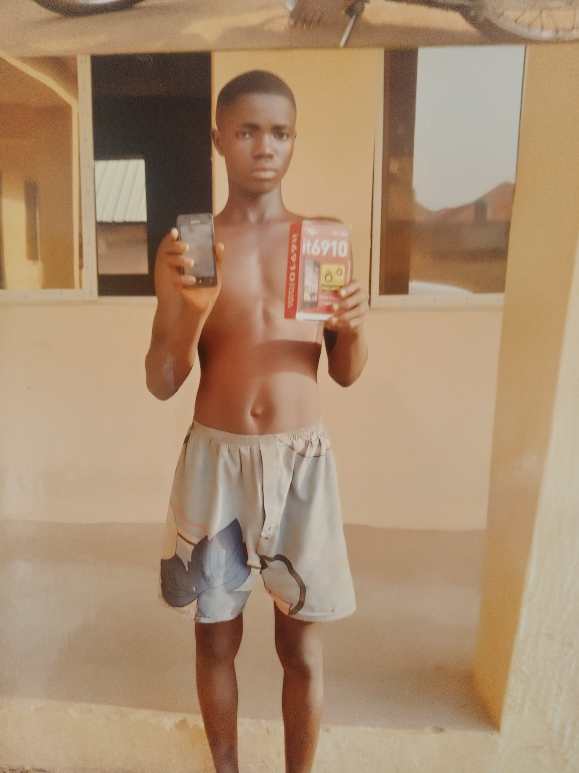

***Tersoo Tyoapine with stolen Itel Phone at Atonko, Mbatan, Mbayion, Gboko LG***

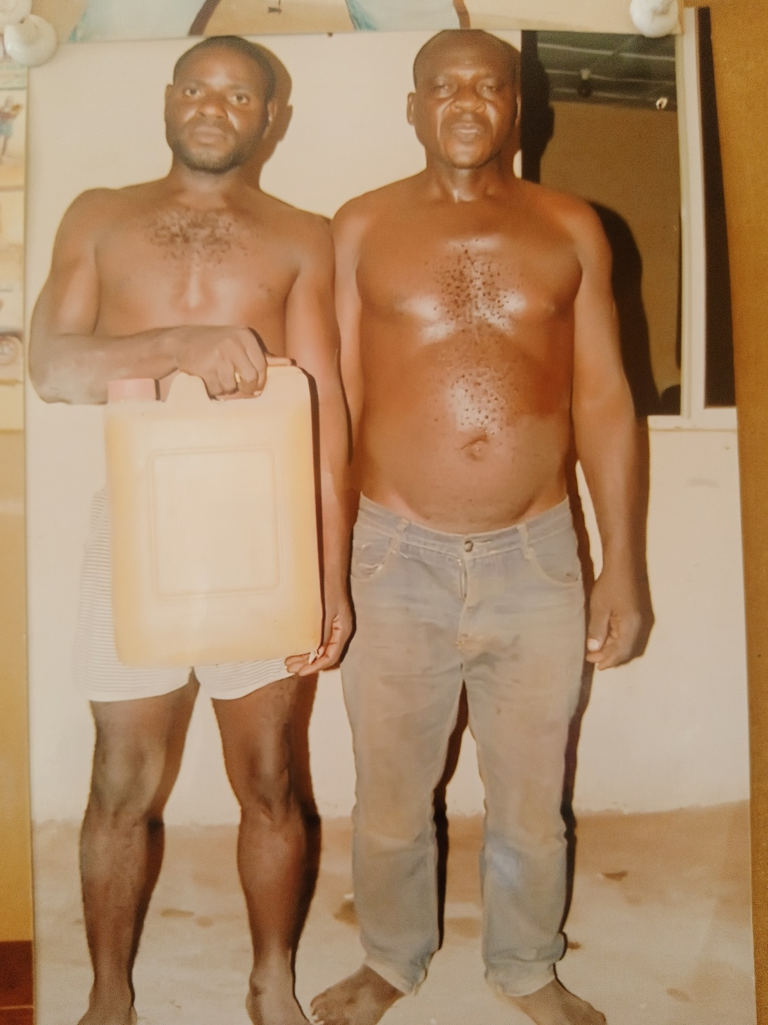

***Mr. Iorlumun Maga with Mbatserevde with their stolen gallon of Ogoroko dry gin from Luga, Mbatiav, Gboko LG.***

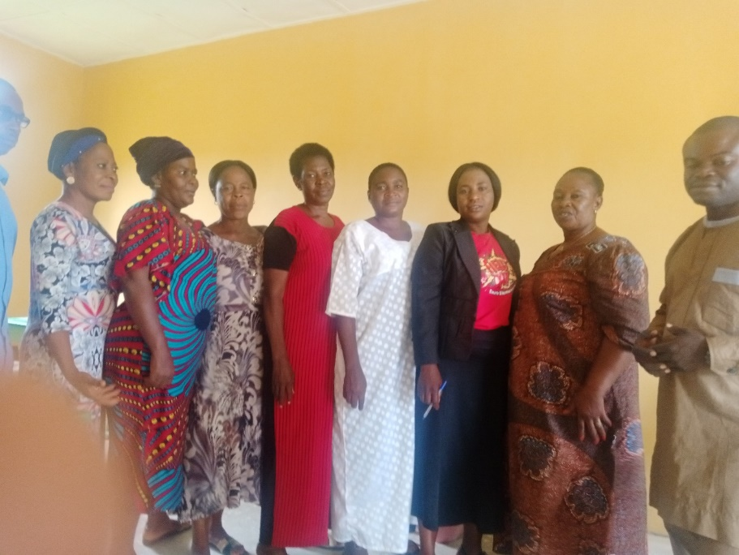

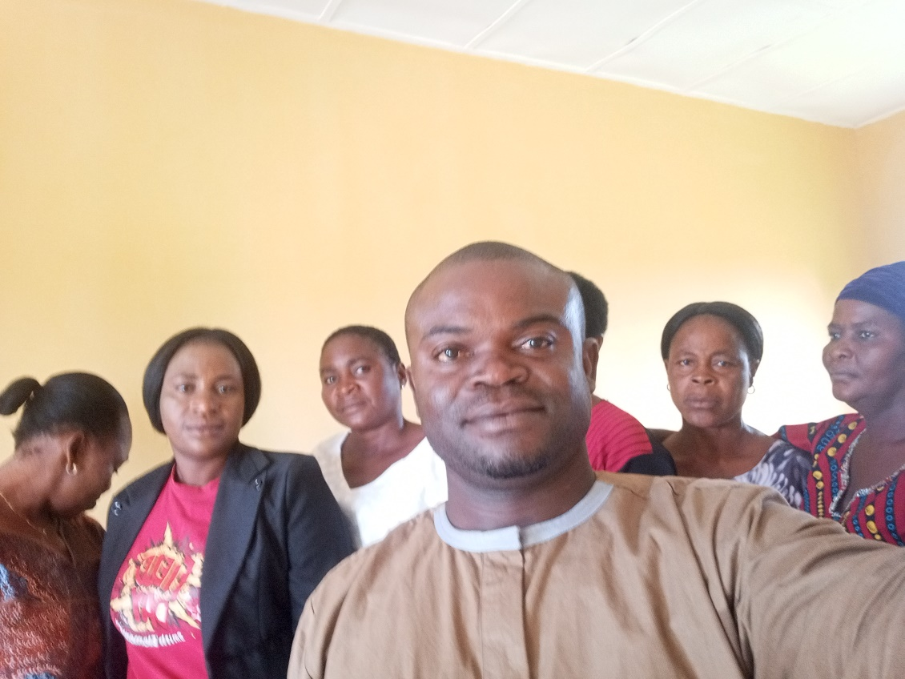

***The monitor of Gboko LGA Mr. Ugah Msonter Samuel with the teachers of NKST Primary School, Yua, Gboko West.***

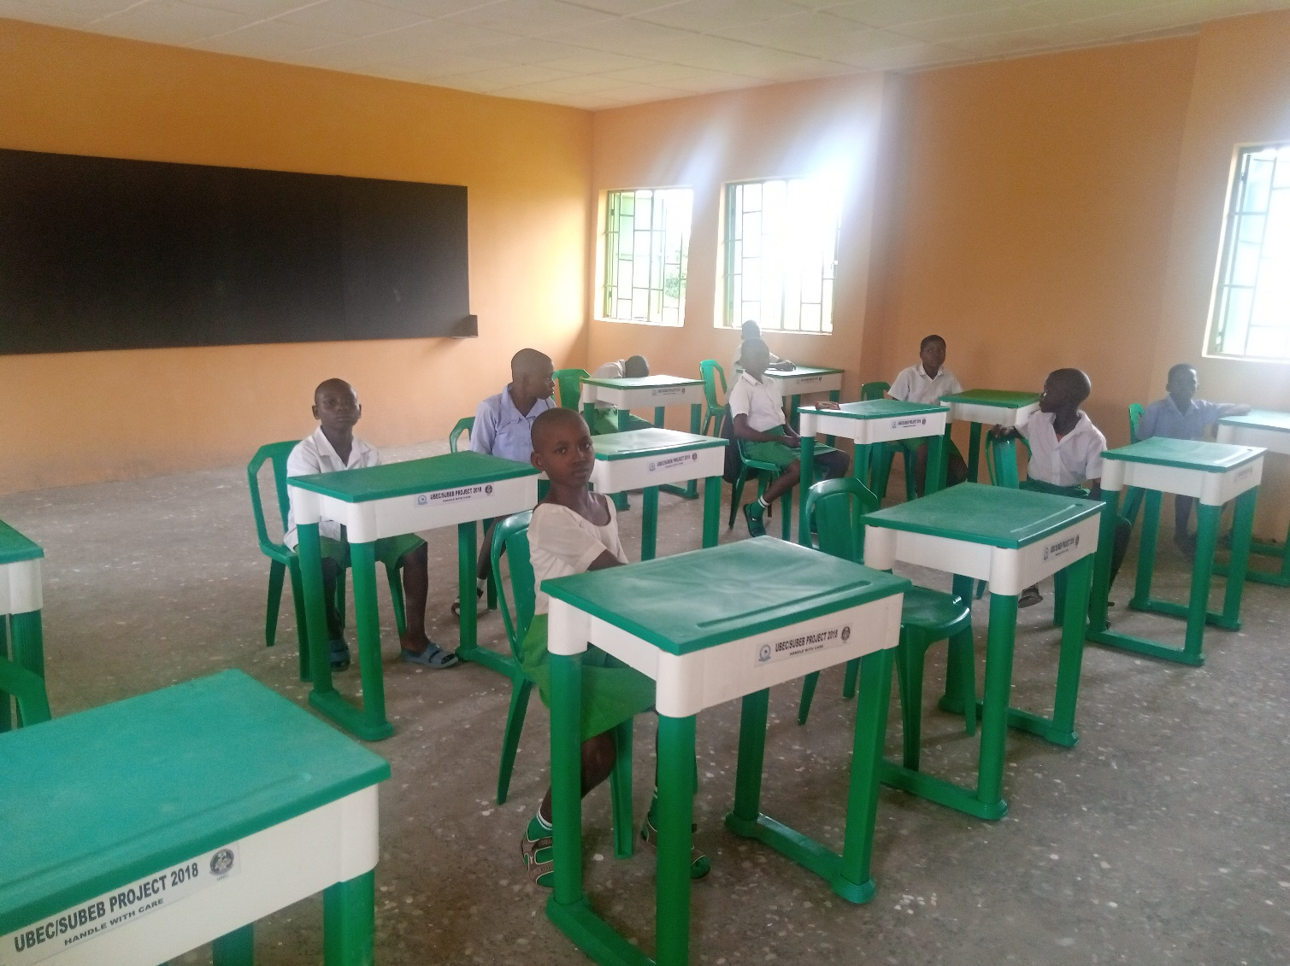

***The pupils of NKST Primary School Yua on their first week of resumption after covid-19 break***

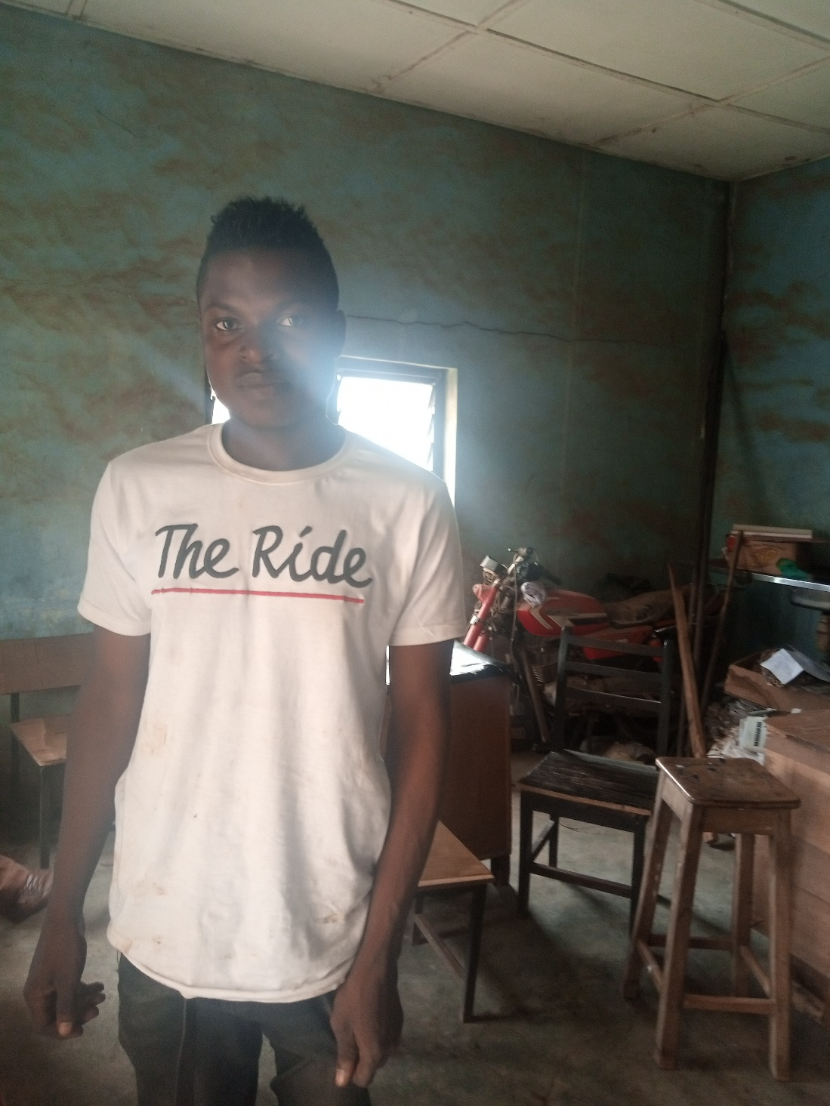

***Mr. Alema Daniel alleged vandal of electric cable at Mbausu Community, close to Tse-kucha, Mbayion, Gboko LG***

**GALLARY FROM GUMA LGA**

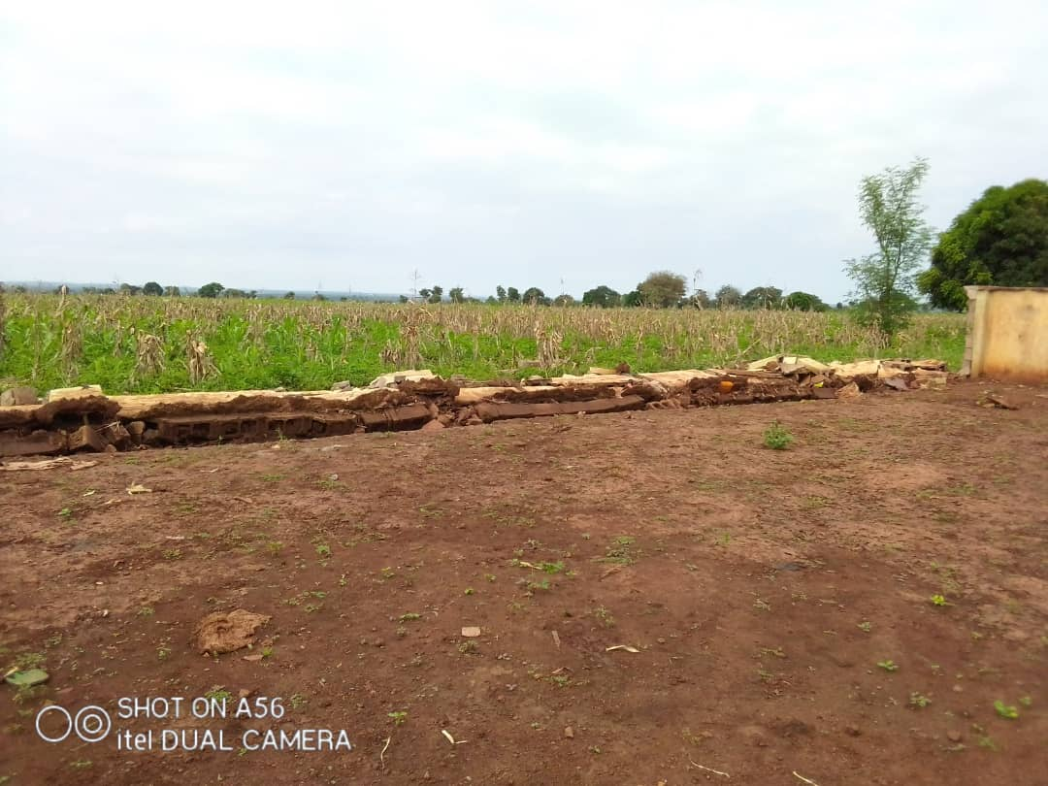

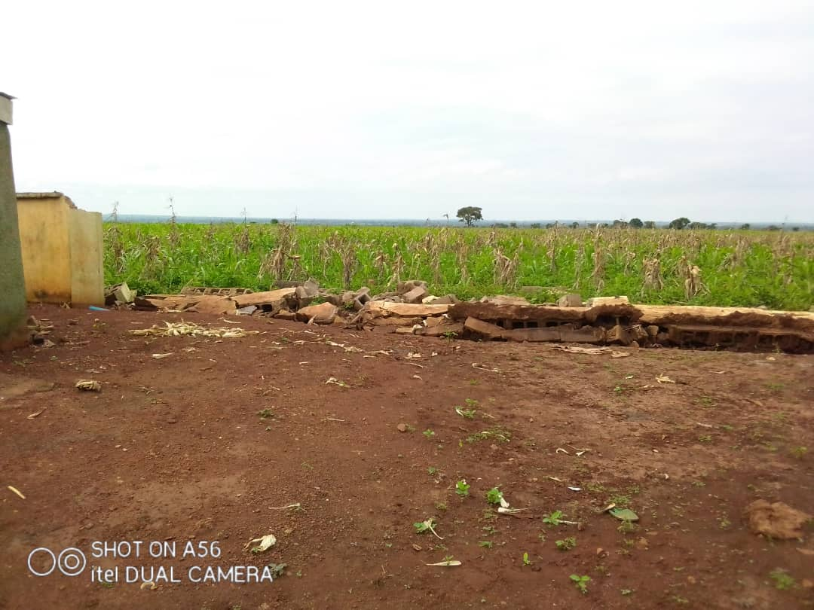

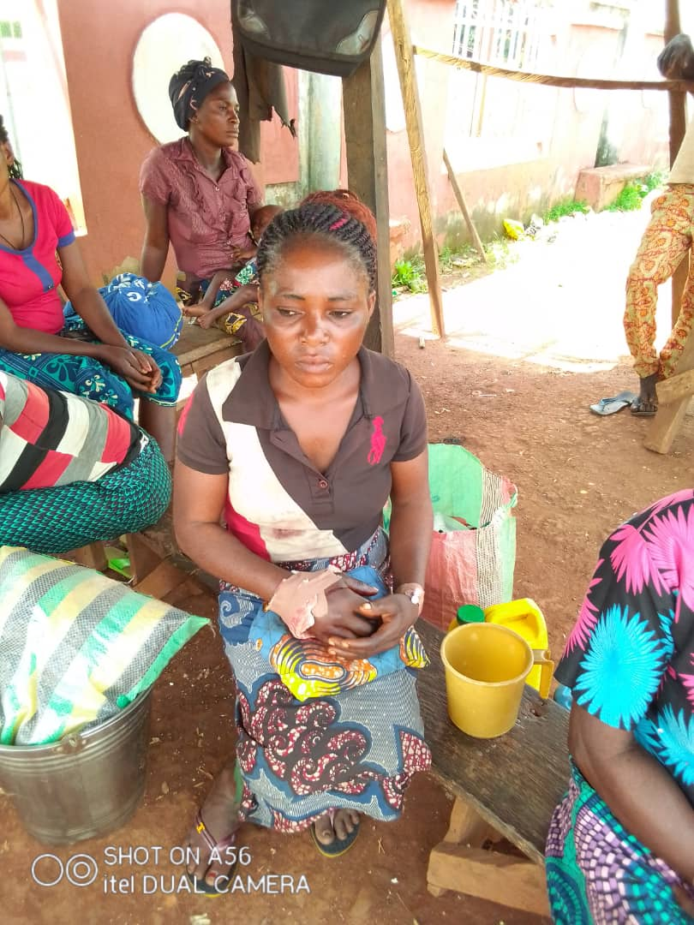

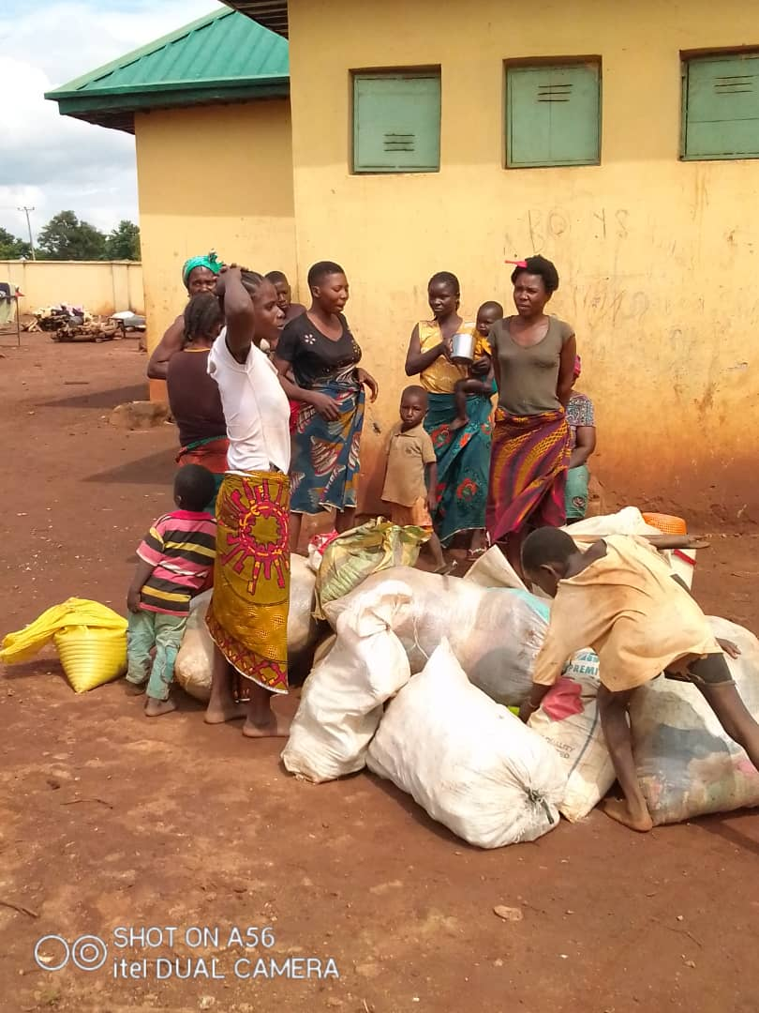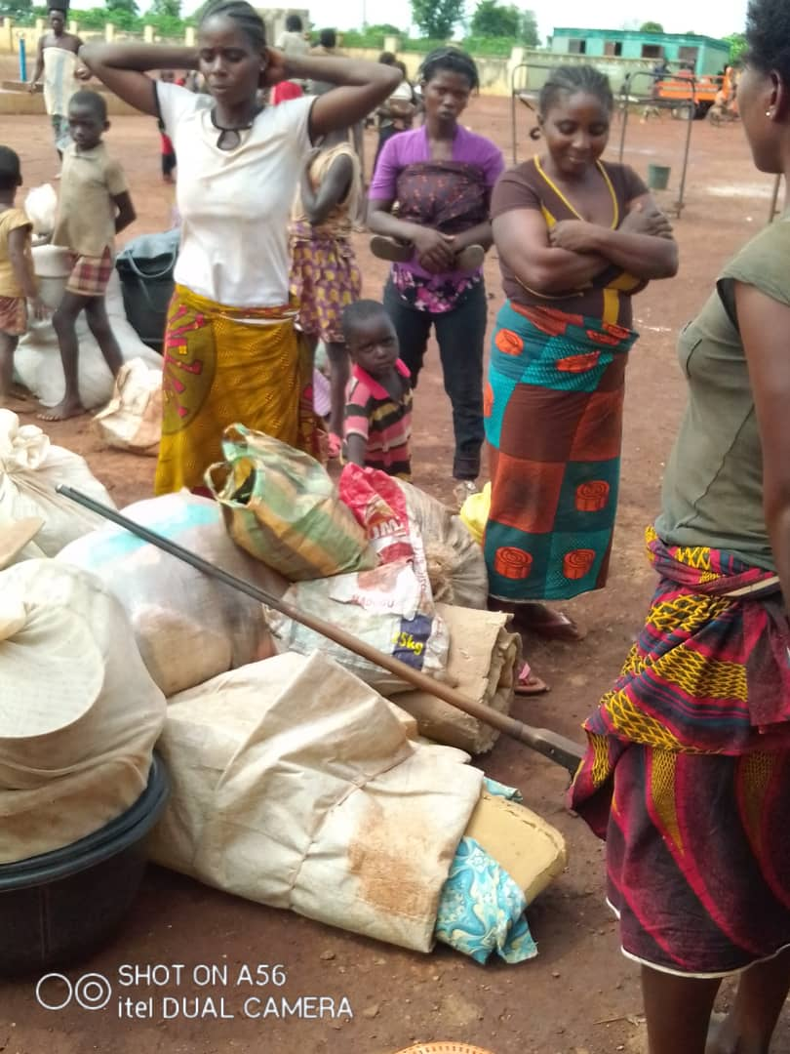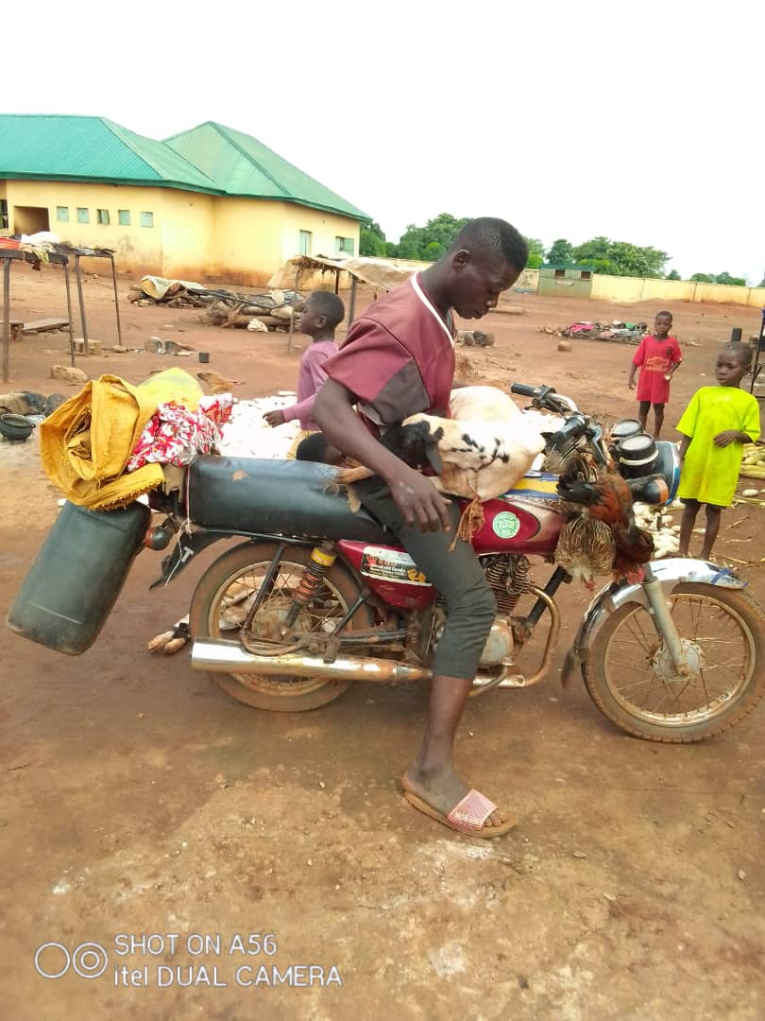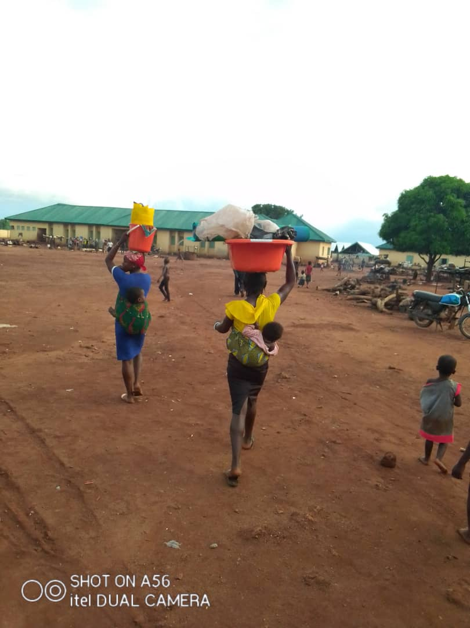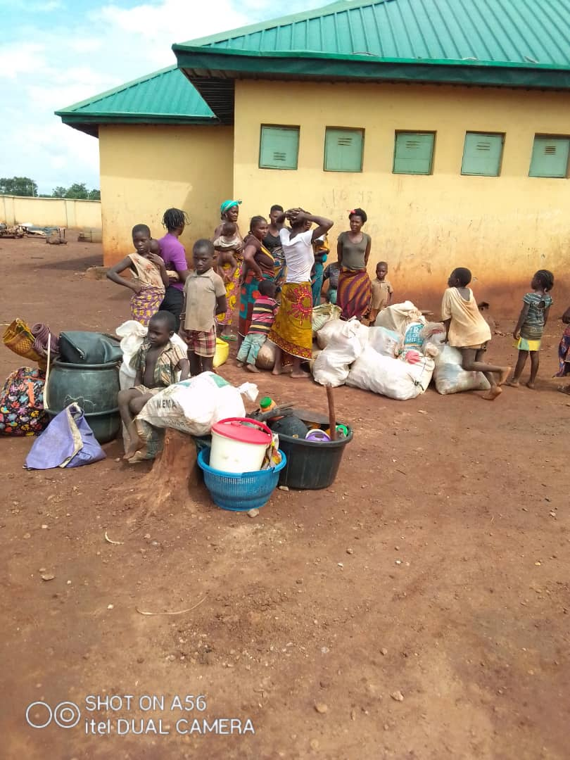

**OGBADIBO LGA WEEK 1**

**List of Female headed household**

|  |  |  |  |
| --- | --- | --- | --- |
| **S/N** | Name of female headed Household | Community | Phone number |
|  | Grace Akor | Ipole Iyiru |  |
|  | Agnes Stephen | “ |  |
|  | Mary Onogwu | “ |  |
|  | Alice Onogwu | “ |  |
|  | Maria Odinya | “ |  |
|  | Mary Alih | “ |  |
|  | Mary Michael | ‘’ |  |
|  | Blessing Oduh | ‘’ |  |
|  | Cecilia Obekpa | ‘’ |  |
|  | Janet Jacob | “ |  |
|  | Augustina Abraham | “ |  |
|  | Rebecca Abraham | “ |  |
|  | Comfort Idoko | “ |  |
|  | Mary Onoja | “ |  |
|  | Cecilia Onoja | ‘’ |  |
|  | Esther Onyirope |  |  |
|  | Theresa Oduh | ‘’ |  |
|  | Helen Alachi | ‘’ |  |
|  | Onyimowo Odiba | ‘’ |  |
|  | Cecilia Alachi | ‘’ |  |
|  | Paulina Igoche | ‘’ |  |
|  | Omojor Igoche | ‘’ |  |
|  | Unewoje Okoh | Opkadigbo |  |
|  | Maria Odeh | “ |  |
|  | Agnes Michael | “ |  |
|  | Faith Adejor | “ |  |
|  | Mary Idoko | “ |  |
|  | Titi Peter | “ |  |
|  | Ane Agbo | “ |  |
|  | Esther Oodo | “ |  |
|  | Bridget Ogwuche | “ |  |
|  | Cordelia Adoyi | “ |  |
|  | Regina Oodo | “ |  |
|  | Margret Onyirofe | “ |  |
|  | Alice John | “ |  |
|  | Maria Abutu | “ |  |
|  | Helen Agada | “ |  |
|  | Agnes Ajunwu | “ |  |
|  | Esther Onogwu | “ |  |
|  | Alice Iyaba | “ |  |
|  | Mary Agbo | “ |  |
|  | Rose Ameh | “ |  |
|  | Rebecca | “ |  |
|  | Rose Ameh | “ |  |
|  | Rebecca Edache | “ |  |
|  | Alice Edache | “ |  |
|  | Cecila Abah | “ |  |
|  | Maria Ogbe | “ |  |
|  | Maria Oche | “ |  |

**List of the Medically ill.**

|  |  |  |  |
| --- | --- | --- | --- |
| **S/N** | **Name** | **Community** | **Phone number** |
| 1. | Bathelomov | Ipole Iyiru |  |
| 2. | Mary Agada | “ |  |
| 3. | John Ohemu | “ |  |
| 4. | Juluis Agada | “ |  |
| 5. | Eberi Eneche | “ |  |
| 6. | Eta Anyebe | “ |  |
| 7. | Julius Agada | Okpadigbo |  |
| 8. | Unenwojo Okoh | “ |  |
| 9. | Onyeje Eneche | “ |  |
| 10. | Ekani Okpe | “ |  |

**List of Orphan’s**

|  |  |  |  |
| --- | --- | --- | --- |
| **S/N** | **Name** | **Community** | **Phone number** |
| 1. | Augustine Abutu | Ipole Iyiru |  |
| 2. | Blessing Abube | “ |  |
| 3. | Christopher John | “ |  |
| 4. | Godstime Ugwu | “ |  |
| 5. | Emmanuel James | “ |  |
| 6. | Ehi Michael | Okpadigbo |  |
| 7. | Ihotu James | “ |  |
| 8. | Theresa James | “ |  |
| 9. | Miracle Abutu | “ |  |

**Challenges observed**

**GALLARY FROM OGBADIBO LGA**

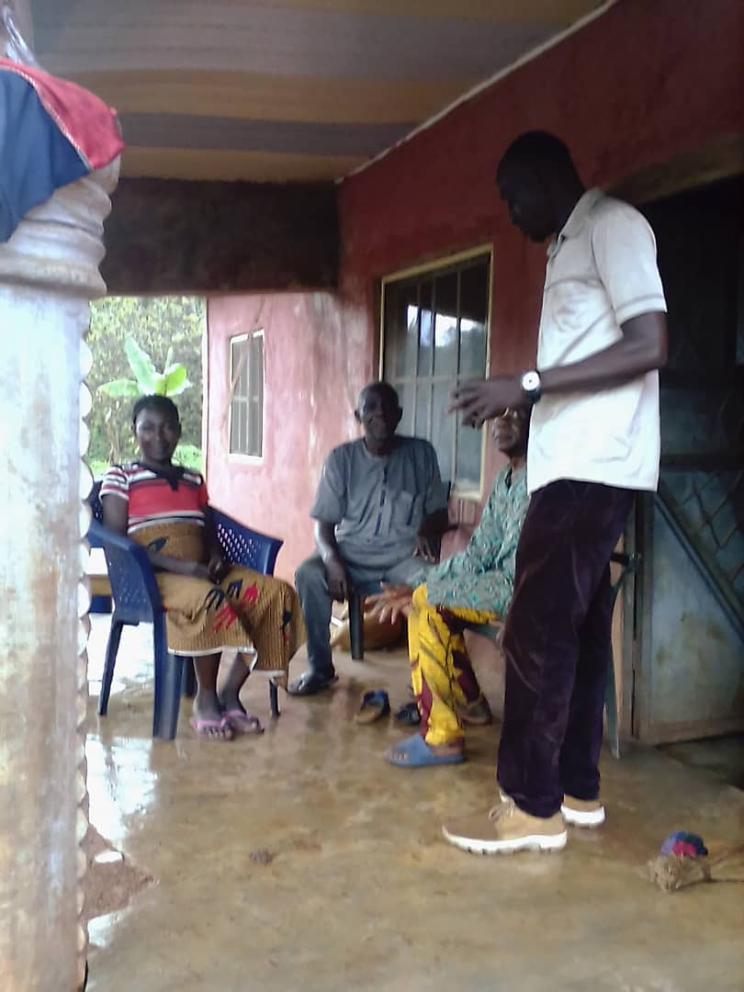 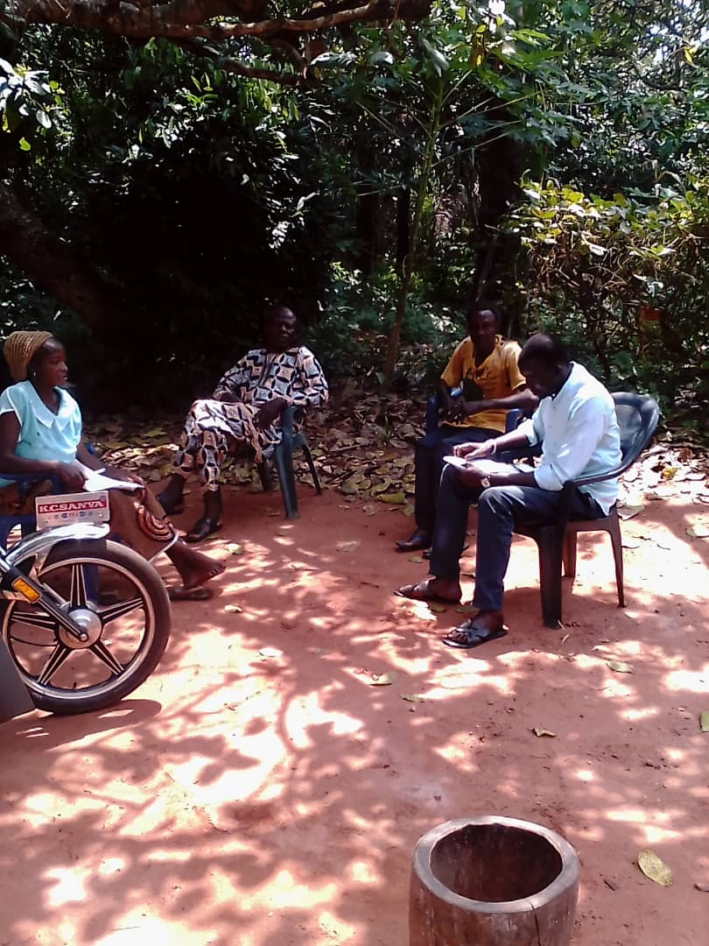

Monitoring and sensitization in Okpadigbo community of Orokam ward II

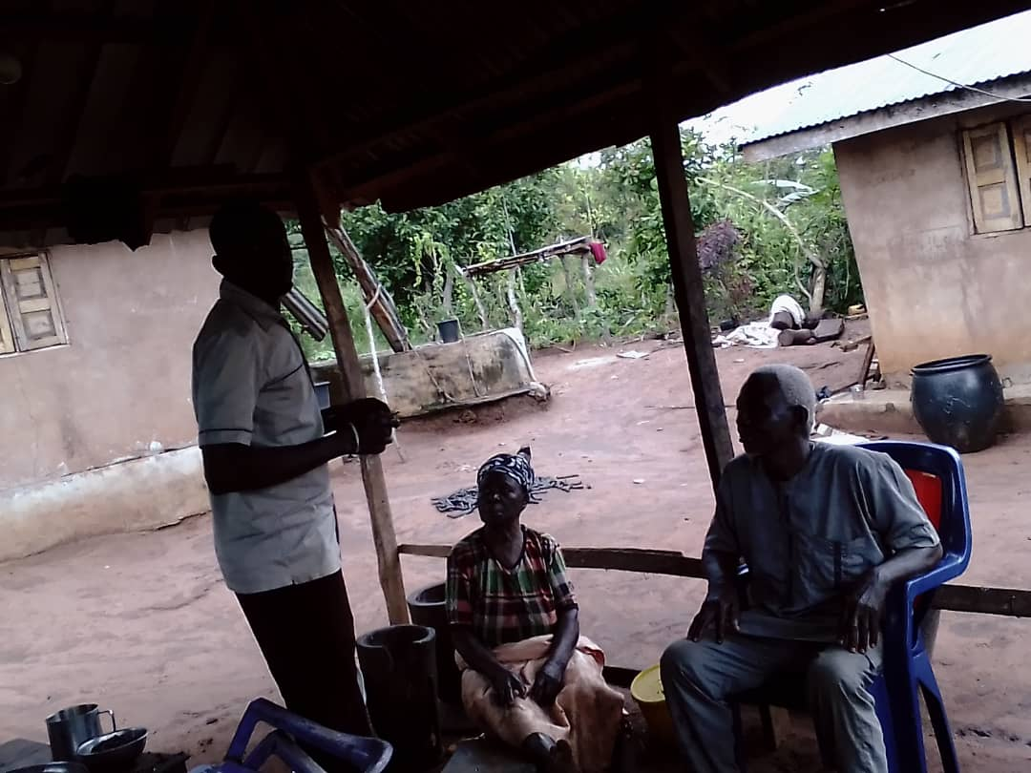 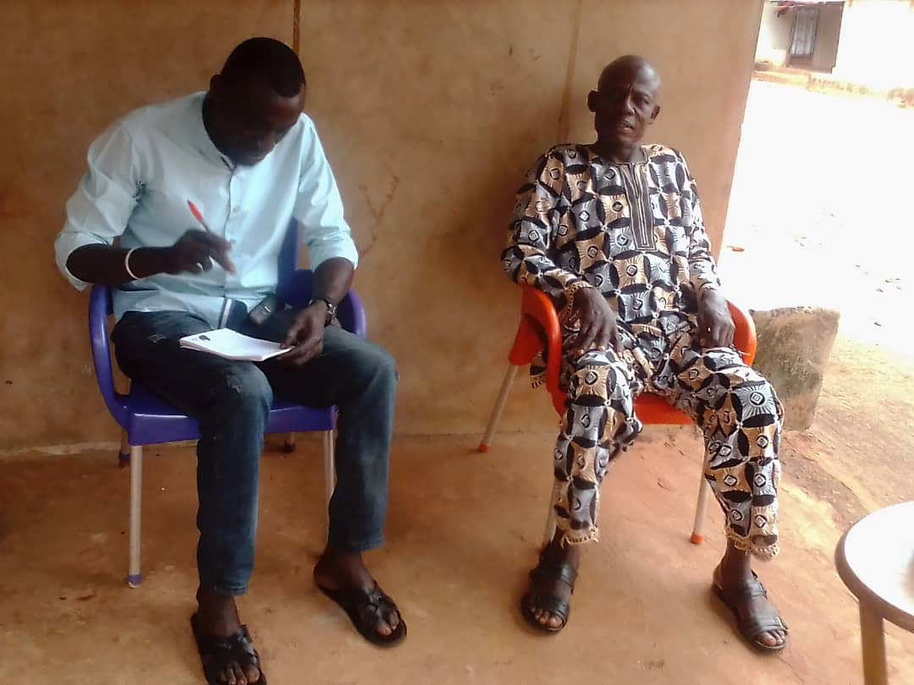

Monitoring and sensitization at Ipole Iyiru community in Orokam Ward II

**OGBADIBO LGA WEEK 2**

**List of Female headed household**

|  |  |  |  |
| --- | --- | --- | --- |
| **S/N** | Name of female headed Household | Community | Phone number |
|  | Mary Okoh | Imeyito |  |
|  | Erida Agbo | “ |  |
|  | Esther Adikwu | “ |  |
|  | Janet Obekpa | “ |  |
|  | Cecilia Onoja | “ |  |
|  | Ane Akor | “ |  |
|  | Enyikwu Obute | ‘’ |  |
|  | Janet Ocheme | ‘’ |  |
|  | Inyanme Ameh | ‘’ |  |
|  | Comfort Onogwu | “ |  |
|  | Janet Abah | “ |  |
|  | Paulina Onuh | “ |  |
|  | Titui Agbo | “ |  |
|  | Anthonia Godwin | “ |  |
|  | Janet Agada | ‘’ |  |
|  | Esther Ojile | Ocheje |  |
|  | Sarah Abah | ‘’ |  |
|  | Grace Okpeke | ‘’ |  |
|  | Ebiri Idoko | ‘’ |  |
|  | Cecilia Odoh | ‘’ |  |
|  | Cecilia Aaron | ‘’ |  |
|  | Kate Paul | ‘’ |  |
|  | Alema Itodo | ” |  |
|  | Onyowole Itodo | “ |  |
|  | Esther Onoja | “ |  |
|  | Enai Grace | “ |  |
|  | Veronica Abutu | “ |  |
|  | Cecilia Peter | “ |  |
|  | Janet Achangu | “ |  |
|  | Achetu Janet | “ |  |

**List of the Medically ill.**

|  |  |  |  |
| --- | --- | --- | --- |
| **S/N** | **Name** | **Community** | **Phone number** |
| 1. | Titi Agbo | Imeyito |  |
| 2. | Onyechi Onaji | “ |  |
| 3. | Comfort Ugwu | “ |  |
| 4. | Maria Anyebe | “ |  |
| 5. | Ujah Joseph | Ocheje |  |
| 6. | Anthonia Orokpo | “ |  |
| 7. | Edwin Okoh | “ |  |

**List of Orphan’s**

|  |  |  |  |
| --- | --- | --- | --- |
| **S/N** | **Name** | **Community** | **Phone number** |
| 1. | Patrick Ogwuche | Ocheje |  |
| 2. | Ikpoyi Onyeke | “ |  |
| 3. | Ladi Otene | “ |  |

Appendix

Pictures

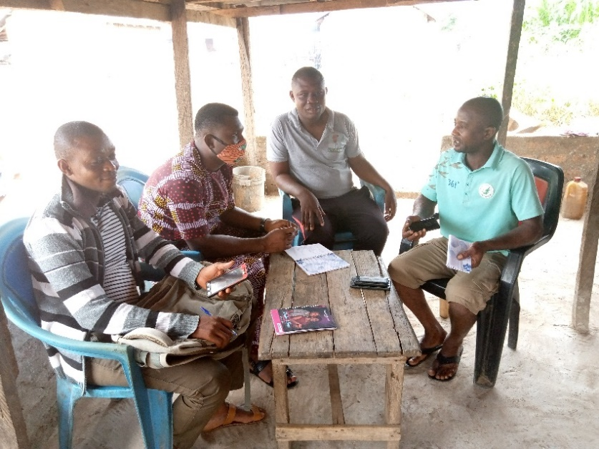 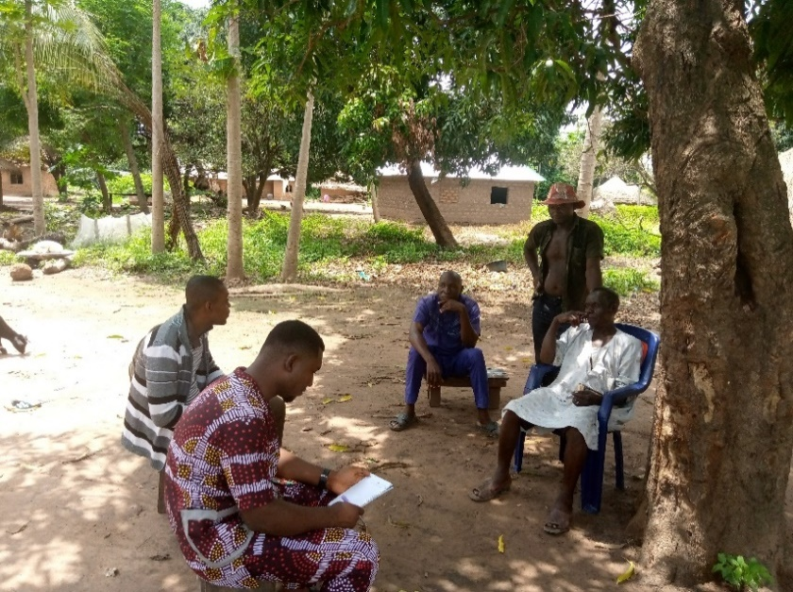

Monitoring and sensitization in Imeyito Community of Orokam Ward II

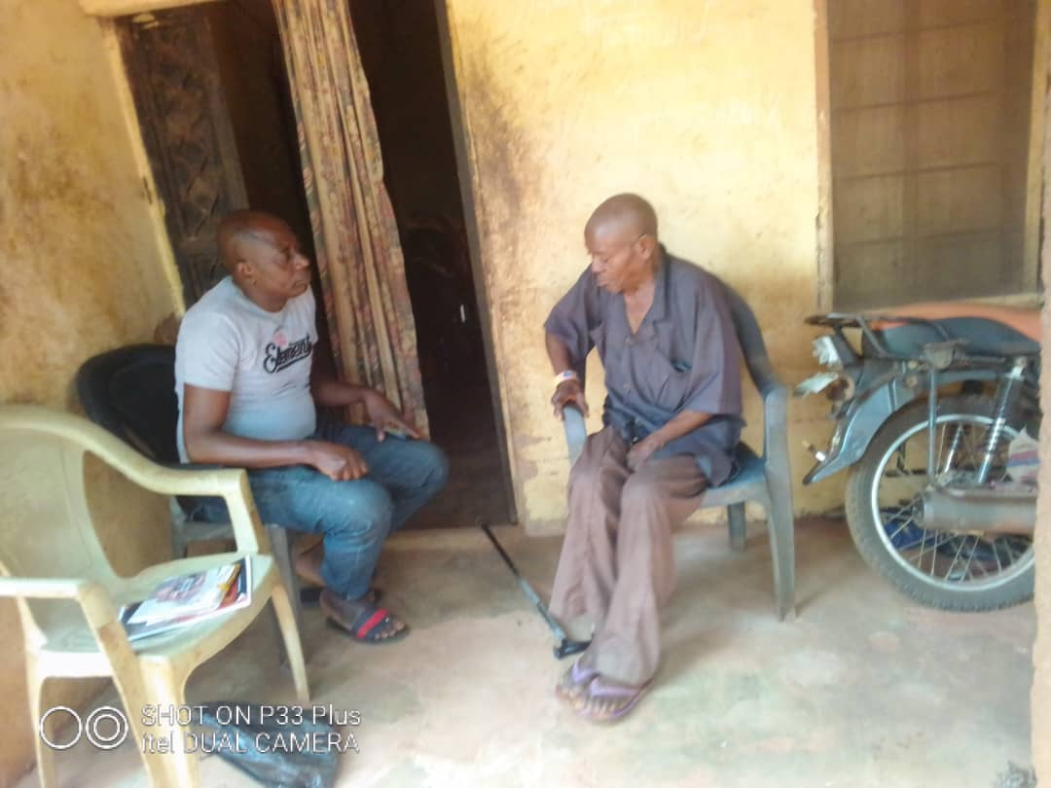 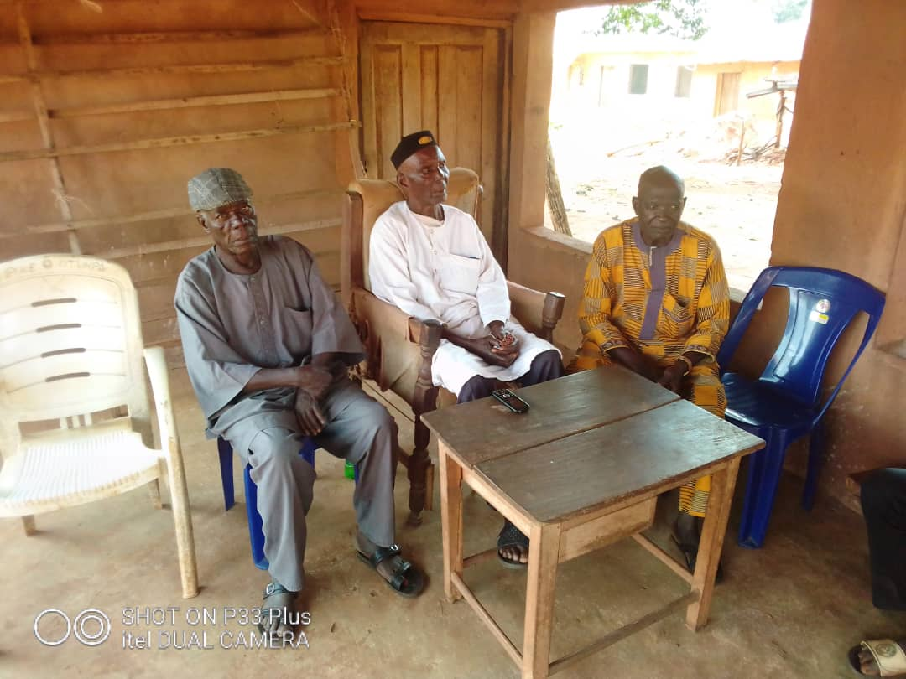

Monitoring and sensitization in Ocheje community of Orokam Ward II

**OGBADIBO LGA WEEK 3**

**List of Female headed household**

|  |  |  |  |
| --- | --- | --- | --- |
| **S/N** | Name of female headed Household | Community | Phone number |
|  | Aladi Owoicho | Orupu/Ipole Community |  |
|  | Juliana Ameh | “ |  |
|  | Maria Jacob | “ |  |
|  | Janet Okwute | “ |  |
|  | Rose Okwute | “ |  |
|  | Angelina Benard | “ |  |
|  | Helen Onoja | ‘’ |  |
|  | Regina Ayegba | ‘’ |  |
|  | Alice Ayegba | ‘’ |  |
|  | Egbi Ochigbo | “ |  |
|  | Cecilia Adoyi | “ |  |
|  | Onyiroko Agba | “ |  |
|  | Maria Apochi | “ |  |
|  | Paulina Okwute | “ |  |
|  | Kate Agbo | ‘’ |  |
|  | Maria Abah | “ |  |
|  | Oweifumi Enejo | ‘’ |  |
|  | Faith Jacob | ‘’ |  |
|  | Edugwu Jacob | ‘’ |  |
|  | Elizabeth Ameh | ‘’ |  |
|  | Ojoh Okpeke | Adum-Oko |  |
|  | Onyeneta Idoko | ‘’ |  |
|  | Grace Onaji | ” |  |
|  | Regina Onoja | “ |  |
|  | Paulina Ameh | “ |  |
|  | Margate Oneje | “ |  |
|  | Cordelia Eneje | “ |  |
|  | Mary Anthony | “ |  |
|  | Agnes Audu | “ |  |
|  | Aladi Ame Oko | “ |  |
|  | Caroline Ogwuche | “ |  |
|  | Kachua Onoja | “ |  |
|  | Grace Onoja | “ |  |
|  | Maria Abah | “ |  |
|  | Janet Ogwuche | ” |  |
|  | Fatu Agada | “ |  |
|  | Esther Agada | “ |  |
|  | Janet Okpeke | “ |  |
|  | Iberi Apochi | “ |  |
|  | Enechoje Clement | “ |  |
|  | Ojela Okpeke | “ |  |
|  | Onyachi Okpeke | “ |  |
|  | Hana Obute | “ |  |
|  | Iye Agbo | “ |  |
|  | Jane Edache | “ |  |
|  | Maria Apochi | “ |  |
|  | Esther Ocheni | “ |  |

**List of the Medically ill.**

|  |  |  |  |
| --- | --- | --- | --- |
| **S/N** | **Name** | **Community** | **Phone number** |
| 1. | Ede Owucho | Orupu/Ipole |  |
| 2. | Paul Oruwte | “ |  |
| 3. | Moses Enenche | Adum-Oko |  |
| 4. | Ugwu Adikwu | “ |  |
| 5. | Grace Onogwu | “ |  |
| 6. | Michael Okeda | “ |  |

**List of Orphan’s**

|  |  |  |  |
| --- | --- | --- | --- |
| **S/N** | **Name** | **Community** | **Phone number** |
| 1. | Patrick Aoyi | Orupu/Ipole |  |
| 2. | Okpe Adoyi | “ |  |
| 3. | Monday John | “ |  |
| 4. | Oyare John | “ |  |
| 5. | Aladi John | “ |  |

Appendix

Pictures

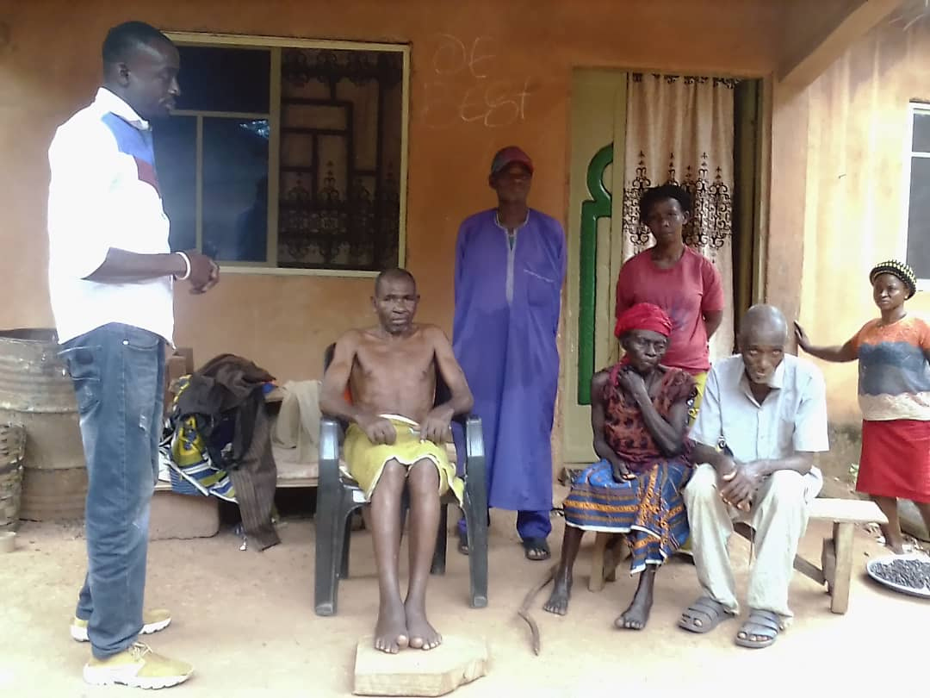 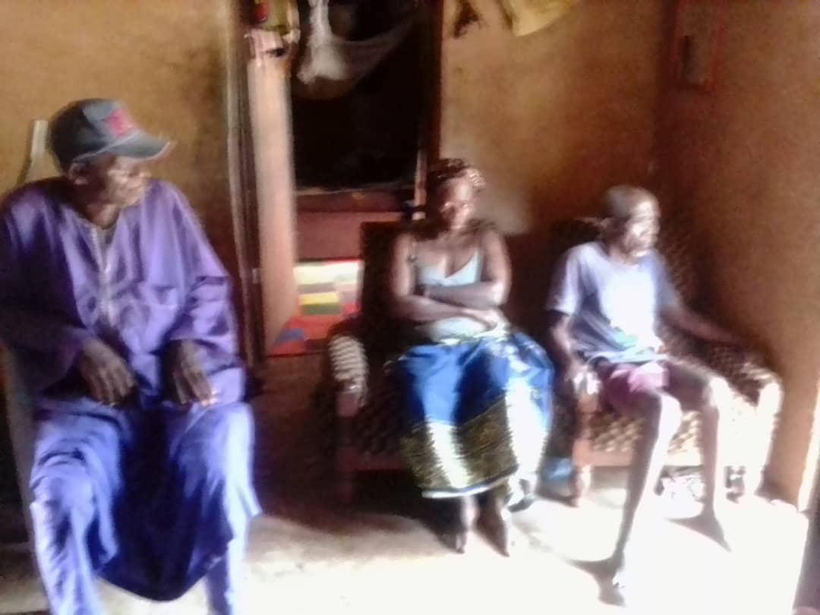

Monitoring visit at Orupu/Ipole Community of Orokam Ward II

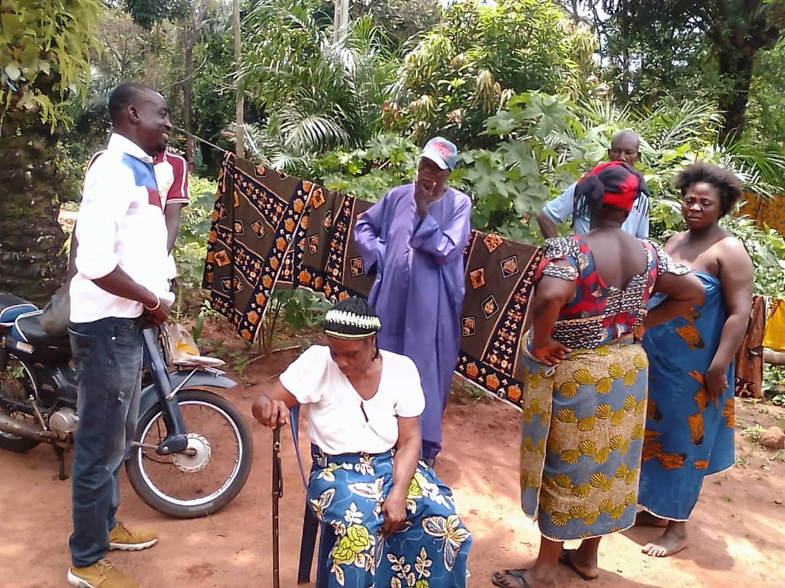 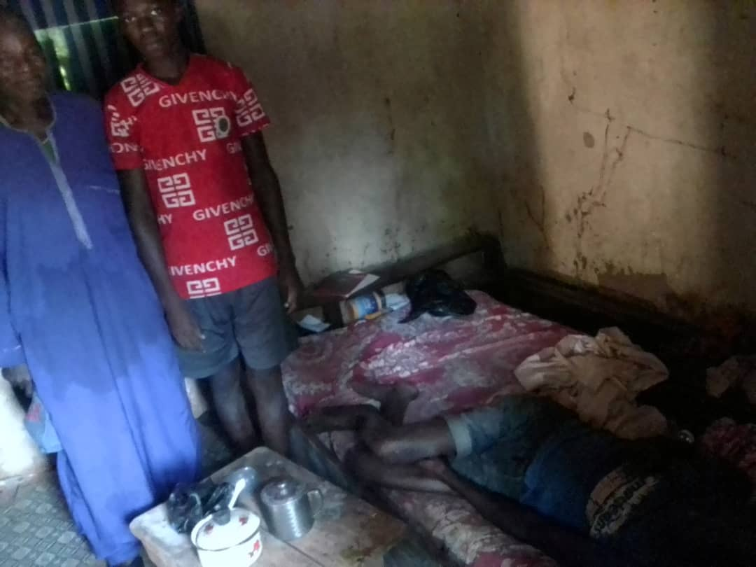

Monitoring visit at Adum-Oko community of Orokam ward II